Andrées de Ruiter and Prem Rai

Trekking in the Annapurna area along the new NATT-trails which avoid the road

A guidebook to one of the finest trekking
areas of Nepal and the world

NATT = Natural Annapurna Trekking Trail

The second Edition was written in August 2013 based on additional information gathered during treks in the spring of 2012 and December 2012/January 2013. It now also includes treks west of Tukuche, the Annapurna Panorama trek/Poon hill trek, the ABC trek and especially the new and beautiful Mardi Himal trek and Khopra Danda Trek which were marked and described in spring 2013 by Prem Rai

About the Authors

Andrées de Ruiter

Born 1956 in Belgium, he now lives in Germany. His first visit to Nepal was in 1981 while on a nine-month overland journey to Asia. His first trek was to Manang. Since then he has returned to Nepal more than thirty times. His favourite area is the Annapurna region, which he has visited several times. Andrées de Ruiter works as a freelance consultant for quality management.

Andrées has a large website with information about different trekking areas and especially of the Annapurna area: www.nepal-dia.de , email: namaste@nepal-dia.de.

Prem Rai

Prem Rai was born in 1975 in Sintup 7, a small hamlet in Tamku, Sankhuwashaba, in the north part of East Nepal. He grew up in a farming family. With his wife Maina and son Shyam he moved to an area north of Pokhara in 1997 and to Pokhara in 1999 when he started working as a porter/guide. In 2004 he obtained the Governmental trekking guide License. As well as guiding individual treks, he also organizes treks for larger groups in a wide range of trekking areas. Prem has a profound knowledge of the Annapurna area as he has taken an active part in finding and marking trails off the beaten track. It was his idea to call the new trail grid " NATT ", short for New Annapurna Trekking Trails. Later we decided that the Letter N in NATT could as well mean Natural. He has made several tours with Andrees de Ruiter. Prem will monitor changes in the new trails so that we can continue to keep the book updated. He and his wife run a massage therapy center in Pokhara named "Stairway To Heaven."
www.trekwithpremrai.blogspot.com/ , premmainarai@hotmail.com , premkulung12@gmail.com ,
Facebook: Prem Rai, www.facebook.com/prem.rai2

Second edition April 2013

Most of trekking guides books will give you a day-by-day schedule. As the Annapurna region is now more a grid of various trails we describe parts of the trail and give them a number. In this way you can choose and make a combination which is best suited for your time, schedule, and aspirations.

About the Authors
Foreword to the first edition
Foreword to the second edition August 2013
Painting the Himalayas
Trail Status January 2013
General facts about trekking
Trekking Seasons
Arriving in Nepal
In Kathmandu
Getting the Permits:
Life on the Trail
Porters and guides
Getting to the Annapurna Region:
Going first to Dumre then to Besisahar
Trail description with NATT trails
The trekking routes on the Manang side
Possible schedules
2. From Besisahar (810 m) to Bhulbhule
3. Bhulbhule –Bahundanda-Germupath
4. Alternative High route from Germu to Jagat high route 7 hours
5. Syange-Jagat on the road 2.5 hrs.:
6. Jagat – Chamje on the road 1:30 -2 hours:
7. Chamje to Tal: 3 - 4 hours
8. Tal to Dharapani: 2,5 – 4 hrs.
9. Dharapani – Bagarchhap- to Danaqyu on the road:1,5hrs..
10. Nice Side Trip: Dharapani- -Odar*-Bagarchhap
11. Dharapani to Danakyu on the left east side of the river 2h *
12. Danaqyu –Temang 1:45-2 hours:
13. Temang – Thanchouk–Koto- Chame (2670 m) 3-3.5 hrs..
14. The Naar Phu Trek
15. The former trail by Latamarang:
16. Chame - Bhratang–Dhukur Pokhari 5-6hrs.
19. Dhukur Pokhari – Lower Pisang, Humde. and the Lower Route to Manang:
20. Dhukur Pokhari – Upper Pisang and the High Route to Manang
21. (Upper) Pisang to Ghyaru 2-2.5 hours
22. Ghyaru – Ngawal 2 – 2.5 hours
23. Ngawal to Braka (Braga) 2.5 or 3.5 to 4 hours
25. Braka*** (Braga) 3470 m
28. Braka – Manang 35 min
31. Going directly from Khangsar to Yak Kharka
34. Going from the new Shree Kharka Lodge to Thorung La
Crossing Thorung La & the Dangers of Acute Mountain Sickness:
36. From High Camp over Thorong La to Muktinath 6-10 hours
40. Muktinath-Ranipauwa to Jomsom
41. Trek Ranipauwa to Lubra (Lupra) and Jomsom
Walk to Jharkot and from there over Lubra to Jomsom **
42. A wonderful day trip to the villages of the Muktinath area.
43. Daytrip – Muktinath/Ranipauwa& temple – Purang – Jharkot – Muktinath
44. Muktinath Ranipauwa-Chongur-Jhong to Jharkot (4-6 hrs.) Round trip back to Muktinath
Jharkot **
45. The Jharkot sightseeing tour ** with blue marks
46.From Jharkot to Ranipauwa/Muktinath by Purang
47. Jharkot to Lubra
50. Ranipauwa and the northern trail to Kagbeni ***
Chongur **:
Jhong **
51. Half-Day Trek Kagbeni-Tiri** m:2-3 hrs.
54. High route from Kagbeni to Jomsom ** 6-8 hrs.
Jomsom (2720 m)
Jomsom to Tatopani
Marpha ***
61: Marpha - (Tukuche) - Kokhethanti Eastern NATT trail
Tukuche:
63. Western Trail Tukuche -Khobang-Larjung (right riverside)
64. Western Kali Gandaki trail: Naurikot***
65. The two beautiful lakes below Dhaulagiri:
66. Climbing to the Dhaulagiri Ice fall (3-4 hours)
67. Roundtrip Larjung- Naurikot-Buddroso Lake- Sekung Lake
68. Kokhethanti to Kalopani or Kokhethanti - Titi Lake, Taglung - Kalopani
Kalopani / Lete
70. The forest trail from Lete to Ghasa* (4 hours-red /white marks)
Ghasa 2010m:
71. Ghasa to Tatopani (8 hours)
Dana
Tatopani – Pokhara by Bus or Jeep
72. From Tatopani to Ghorepani and Poon Hill ***
Part 2: Trekking South of Annapurna:
The Annapurna Panorama Trek/ Poon Hill trek clockwise (75-79)
75. Pokhara to Nayapul- Hille/Ulleri Ghorepani (1.5 to 2 days)
Ghorepani 2860 m:
Poon Hill *** (3193m + 7m tower! )
76. Ghorepani to Tadapani / Ghandruk 5-6hrs.
Old Ghandruk ***
79. Ghandruk – Landruk –Tolka –Bishok Deurali – Pothana –
The Annapurna Panorama Trek/Poon Hill Trek anticlockwise
81. Pokhara to Pothana
82. Pothana –Pitam /Bishok Deurali 2100m Tolka-Landruk
83. Landruk-Ghandruk***1940 m-Tadapani** 2654m
Ghorepani 2860 m:
92: Ghandruk- Chomrong 4-5h
94. From Tadapani to Chomrong. Total 5 - 7 hrs.
96. Dovan to Himalaya Hotel (2820m) to Deurali
97. Going back from ABC
100. The Mardi Himal Trek (written by Prem Rai)
101. Pitam Deurali – Forest Camp (Kokar) 2550m (5 – 6 hrs.)
104. High Camp – Upper View Point 4450m – High Camp (7 – 8 hrs.)
Khopra Trek clockwise
110. Day 1: Pokhara-Nayapul-Purnagaun (5-7hrs. including driving)
111. Day 2: Purnagaun to Lespar
112. Day 3: Lespar to Nangi 2260m. (6 – 7 hrs.)
113. Day 4: Nangi to Moharedanda 3300m. (~7 hrs.)
114. Day 5: Moharedanda to Swanta
118. Day
120. Day 10: Bayeli Kharka to Tadapani
121. Trekking the Khopra Danda Trek anticlockwise.
Pokhara ***
What to do in Pokhara?
Postlude

Foreword to the first edition

Once upon a time, the Annapurna Circuit was one of the most beautiful trekking areas of Nepal. It was even named the best long trek in the world. Then, as a result of a general national plan for developing Nepal, a road building program was started with the goal of connecting every district headquarters. The road building department started planning roads to Chame, continuing to Manang, and Jomsom.

Since Nepali people walk in the mountains to visit relatives or for business reasons and not simply for fun, they don’t mind at all walking along streets and roads as it is faster and easier for them. Travelling by motorized vehicle is even better, even if it is only by tractor trailer. Unfortunately, this practical view of new roads clashes with that of trekkers, whose view of how a trekking trail should be is quite different. No trekking tourist would really like to walk on a dusty road while being passed by honking trucks and motorcycles.

Quite a few lodge owners foresaw the problems, but there was a strong lobby of villagers who saw the many advantages. To them a new road means better opportunities to sell the products of their farms, thus increasing their incomes. At the same time goods brought in by the road are much cheaper than the same goods being carried by mule or porter. This result is a higher living standard as well as easier travel.

And so the road construction started but no one cared to plan alternative trekking trails. It was only when the road between Beni and Muktinath was finished that the highly negative impact on trekking tourism was finally understood and visible.

By 2010, many tour operators in Europe had already stopped arranging treks in the Jomsom area and on the Internet many individual trekkers said that trekking down the road was no fun and suggested just taking the bus after Jomsom or even arranging a jeep ride in Muktinath/Ranipauwa.
In 2006, ACAP (Annapurna Conservation Area Project) had already started to plan a complete alternative trekking trail, which avoids the road and since then they have been busy establishing new trails. We call them New Annapurna Trekking Trails = NAT and they were new when we started the survey but now the better name is Natural Annapurna trekking trails. Both the Manang and the Jomsom side can also be visited in a marvellous trekking experience just on their own without crossing the 5416 meters high Thorong La pass.
Nowadays the Annapurna area offers much more than just the classical Annapurna circuit with a few side trips. See it rather a dense network of many different trekking trails which you can combine in endless combinations. This makes the planning of your trek much more complex and difficult but also gives you the chance to compose the perfect trek for your personal interests and the time you have for your holidays. As well, it gives you the chance of enjoying the Annapurna region several times with each trek offering a different and new experience. While I have crossed Thorung La eight times, on each trek I discovered new trails to explore!

Why this book is published in EBook Format:

When I looked though the guidebooks on the Annapurna area, it appeared to me that they were all absolutely outdated. Most were printed long before 2009 and none had mentioned (as of 2012) the alternative trails. A printed book will always take more than half a year just to be readied for printing and then the publishers will want to sell the remaining stock before releasing a new edition. When I explored the new trails in the Annapurna region in August 2011, I realised that it is very important that this information should be made available to trekkers as soon as possible. This quick process is only possible with the system of books on demand, where only a file is stored and then the books are printed one by one only if someone orders one. The main advantage is that there is absolutely no stock and that the author can easily update the file. Unfortunately, the “book on demand” price is much too high in the United States and UK compared to the price in Germany. I hope that the future EBook edition will soften this issue. If there is enough demand, this book will probably be updated once a year based on the additional information Prem Rai is collecting from the field. This book cannot and does not want to rival with the bigger guide books. But it should help you to experience beautiful new trails you probably would have missed without it..

Foreword to the second edition August 2013

In March 2012 Prem and I went again to the Jomsom side and marked more trails. The focus was put on the villages between Tukuche and Kokhethanti on the right (western) side of the river. The main NATT trail now goes on the eastern side, but villages like Tukuche**, Kobang and Naurikot** are absolutely worth one more trekking day and detour. Together with ACAP we could mark and describe a beautiful trek.
We also tried to mark the trail from Tatopani to Ghorepani, which was very difficult, as a newly built dirt road was just bulldozered over many parts of the old trekking trail. Prem then explored and marked in June the Mardi Himal trek south of Annapurna. This very interesting new trek is now also described. Just when I wanted to edit the second edition in October 2012 the news spread that the road from Besisahar up to Chame was now open to traffic. Soon there were many jeeps driving up. So I decided to go back to see if there were already some more new alternative NATT trails on the Manang side. Prem and I had the help of ACAP- Staff members Brij Gurung and Keshob Tamang

Painting the Himalayas

With my Nepali Partner Prem Rai, I did the Jomsom trek route in December 2010 and we could walk nearly all the way to Tatopani along the separate pure trekking trail. I was very pleased, but we often had some problems finding the right trail at various junctions. Therefore, we approached ACAP in Pokhara and I explained the system of marking trekking trails in the European Alps by painting rocks or trees on the way. This is a much easier and much more economical and efficient way than only putting signposts. We proposed to use red/white marks for the main AC trail and blue/white marks for side trails.

ACAP liked this suggestion and so Prem Rai and I started in August 2011 with 5 litres of enamel bought in Besisahar. In the Kali Gandaki valley, we were joined by the Jomsom ACAP staff member, Mr. Rishi Ram Dhakal and two days later, we were also joined by Mr. Bel Bahadur Pun and the guide Mr. Hari Nepali. For the Tukuche & Dhaulagiri Region we were helped by Mr Man Prasad Thakali, who is the owner of the Dhaulagiri Icefall Lodge in Kokethanti . Later that summer he marked the Jomsom trail to the Dhaulagiri Icefall with people from ACAP. In December 2012 we were joined by Mr. Brij Gurung and Keshab Tamang

The markings:

In addition to the signposts, we marked the trail by painting marks on rocks, utility poles, houses and sometime trees. As long as the trail is obvious, we did not mark when the trail is following the road. In some cases, we had to add some arrows to explain the route, but often you just have to look around a little bit at a junction and you will see the next sign.
All of us from the Himalaya Painting Team hope that this painting campaign will make it easier for trekkers to follow the minor trails.

Map 1: The Annapurna Circuit schematic overview

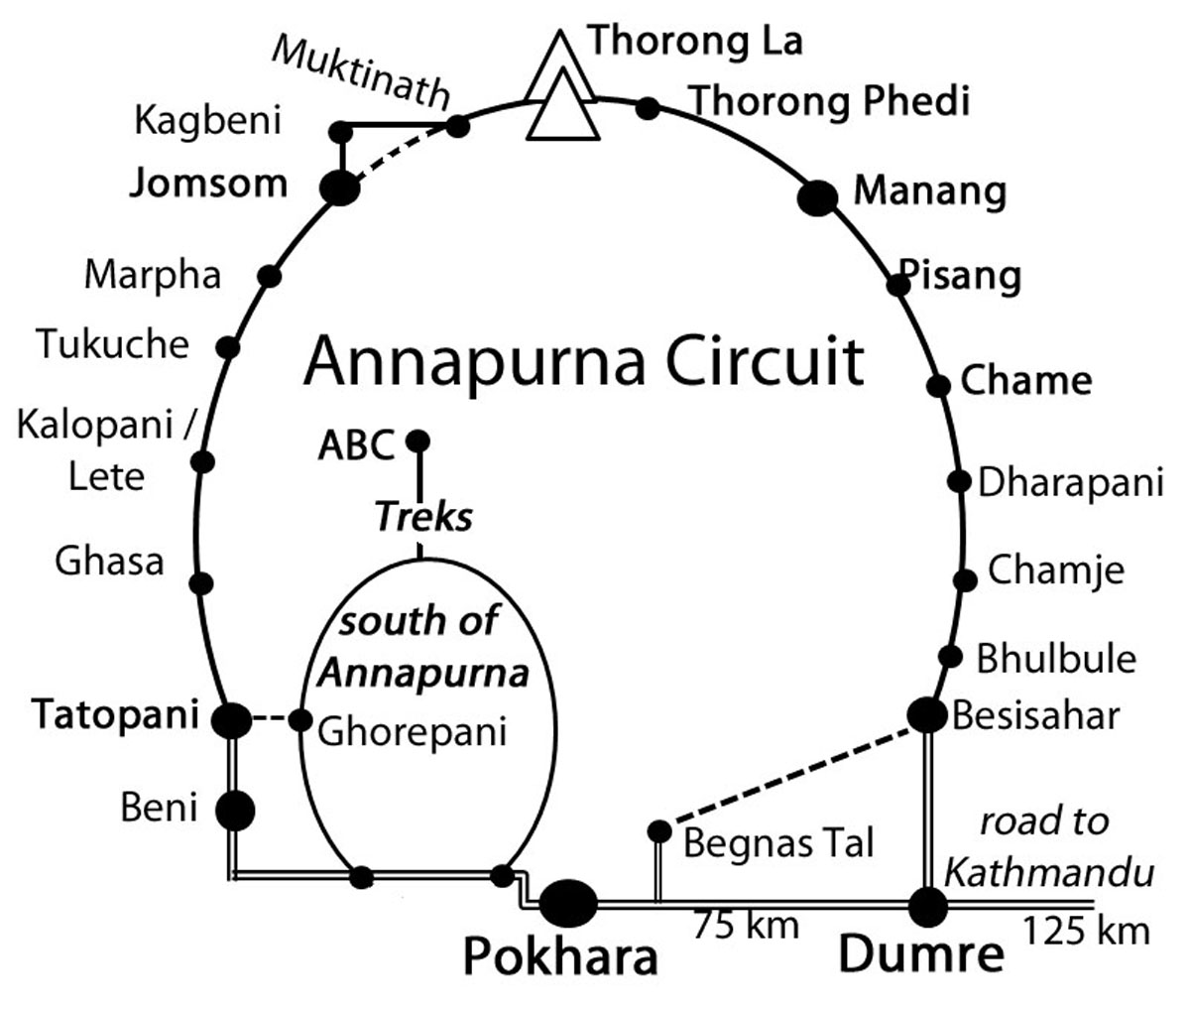

Trail Status January 2013

Manang side: Traffic on the road till Manang

Until October 2012 most traffic stopped at Syange and only a few jeeps a day continued up to Jagat. Buses still end at Bhulbhule (as of Jan 2013). However, in mid-October 2012 the road to Chame was opened for Jeeps. Immediately about ten Jeeps a day were making the trip to Chame. By December 2012 the traffic had increased to between 30 and 50 Jeeps! a day! This number will surely increase in the next years. Soon also busses and trucks will join them up to Chamje (near Jagat and not to be confused with Chame, which is three trekking days further up!).

We met the road construction supervisor responsible for the Chame-Pisang stretch and he explained that the missing link connecting Chame to Pisang and on to Manang would probably be opened in March 2013. This will have a very strong impact on the Around Annapurna trek and severely diminish the attraction of the lower part of this once wonderful trek. I am not the only one for whom the lower part between Besisahar and Chame where you trek though rice paddies and green hills is a very beautiful part of the Round Annapurna trek.

But going up to Chame takes around 5 days and one has to walk a part of it on the road. Actually there are already quite a few alternative NATT-trails so that the lower part of the Manang trek is still a beautiful one. From Besisahar to Manang you only will have to walk on the road for 10-11 hours in total, which is not so much as it is never longer than 4 hours at a stretch. And ACAP is busy planning to make yet more alternative trails. So it is still worthwhile to start from Besisahar, Bhulbhule or one of the next possible villages and enjoy a beautiful trek in the lower part.

Jomsom side:

There is a gravel road, which connects Beni to Muktinath and upper Mustang. In the winter season, several buses a day ride up to Jomsom. From there, jeeps make the connection up to Muktinath/Ranipauwa, carrying hundreds of Indian pilgrims to the temple area. As most of them have just arrived in the morning, the high altitude is hard and many of the tired elder pilgrims gladly ride on a motorcycles back seat, the young boys of Ranipauwa waiting already there for offering a return trip to the jeep parking place.

Fortunately, there is now the possibility to trek all the way down to Tatopani avoiding almost completely the road. So please, forget what some sources of information say, that it is not worth trekking down to Tatopani anymore. The Jomsom area is again one of the best trekking destinations in the world. In this second edition you will find also some trail descriptions for the Tukuche area, which offers also some great side treks.

General facts about trekking

Trekking Seasons

Fall: this is the most popular trekking season, starting in October and continuing until mid-December. The monsoon stops around the beginning or middle of October. But be careful; it can still be quite rainy in the first half of October, so I would suggest not starting before the 15th of October. Most of the times the sky will be very clear with good mountain views. In October, the fields and pastures are still green. October is still warm and sometimes people cross Thorong La in shorts. But be prepared in the mountains; it can always suddenly get very cold. Once I even had snow just above Manang in October!

In November, the weather gets much colder, but the mountain views are really crystal clear at this time of the year. Mid-November to mid-December is usually a very dry period. In the second half of December, winter storms start coming from the north and these can bring snow and rain. In November, I always have a very warm sleeping bag and a cosy down jacket with me.

Winter: Mid December to end of February.

This is the very cold season with temperatures sometimes going down to below -20° C on Thorong La and sometimes freezing temperatures in the sleeping rooms of the lodges. Definitely a down jacket will make your trek much nicer, as most of the lodges will not be really heated. Even in winter, most of the time a small foot track will be made by trekkers so that one can cross Thorong La. However, the crossing may sometimes be impossible for several days after a heavy snowfall.
Spring: March to June. This is a very nice season, with rhododendron trees blooming around Ghorepani. You will see many flowers. The weather is mostly clear in the morning, but soon gets hazy. The later you are in spring; the sooner in the day clouds will cover the mountains. Expect to have regular rain showers during the day. An umbrella is really a must during this season.
Summer = Monsoon: July to beginning of October. I have trekked twice during the monsoon season and it was very nice both times. In August 2011, during 23 days of trekking, I only used my umbrella for about 10 hours! Except for a few minutes, you will rarely see any mountain peaks as they are nearly always covered by the clouds. But beware; there will be enough sun to give you a bad sunburn! You will see many beautiful flowers and colourful butterflies - for people who have visited the area before so that they already know the mountain views, the monsoon period is a very interesting and rewarding trekking season. An umbrella is a must - as you would be roasting hot while wearing a closed raincoat.

Arriving in Nepal

Visa: Your passport must be valid up to 6 months after your planned departure from Nepal. You can get a 15, 30 or 90-day visa directly at the airport. If you want to extend it, you have to go to the immigration office in Kathmandu or Pokhara. There is no possibility to extend a visa in the trekking areas.

In Kathmandu

Buying Medicines: In crossing Thorong La (5416 m) there is a high risk of getting altitude sickness. While you are in Kathmandu take the opportunity to buy, as a precaution, the emergency drugs Dexamethasone (4 x 4 mg) and Nifedifine (also 4 tablets). These are the only drugs which help when you have severe high altitude sickness. The price is less than a cup of tea, but it could help you to go safely down or even save your life. You can just buy them at any pharmacy without prescription. Many people are only familiar with Diamox. This drug can help you to acclimatize faster and help you feel better, but when you are really in trouble (HACE or HAPE) it is simply not efficient.

Getting antibiotics like Norfloxacin for bacterial diarrhoea or maybe Cyprofloxacin for infection colds and Tinidazole to treat giardia is also prudent. In the Lonely Planet guide “Trekking in Nepal” you will find probably the best and most comprehensible medical information for Nepal, so if possible have a look at it.

Getting the Permits:
You need a permit for the Annapurna Conservation Area Project (ACAP), which costs 2000 NPR. In 2012 there were political discussions to end the responsibility of ACAP and to make the Annapurna region a national park but at the time of printing the second edition, there was no change.

You also have to register for a TIMS card. This registry system was designed and lobbied by the Trekking Agencies Association of Nepal (TAAN). It is supposed to help to find lost trekkers and speed up help, but in my view it is not working at all and is mainly aimed at constraining individual trekkers. The permit and TIMS card are checked on various check posts around the Annapurna circuit.
You can get both pieces of paper either through any TAAN affiliated trekking agency, which will charge you a small fee, or get them by yourself, which will take not more than an hour.

Getting the Permits in Kathmandu: Go to the Nepal Tourism Board (NTB) Tourist Information Centre which is east of Ratna Park about 15-20 minute walk from Thamel. You can get both permits there.

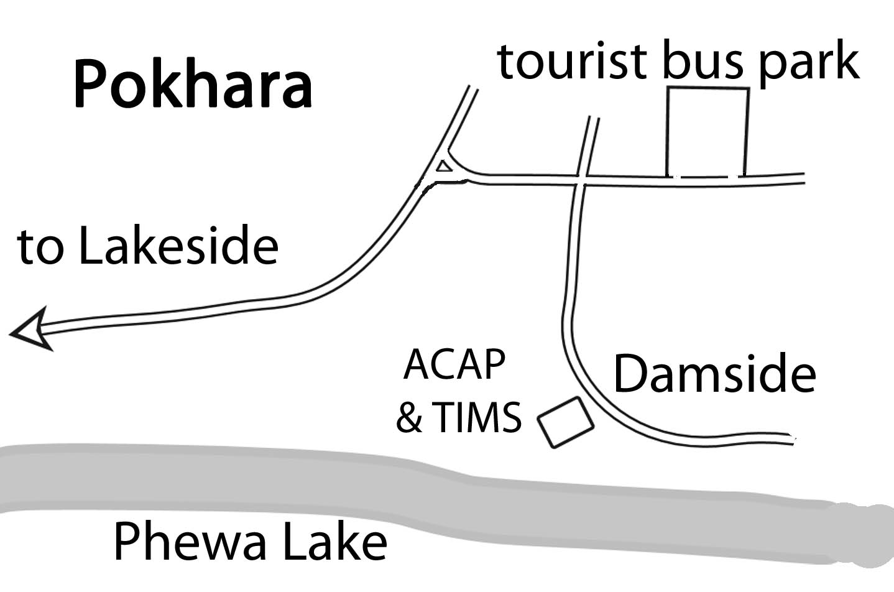

Getting the permits in Pokhara: When you arrive by bus, just walk about 100m from the Tourist Bus Park in the direction of lakeside (west) to the next crossing. Turn left and go down in direction of the Damside. There you will find the tourist centre on the right hand. It is less than a 10 min walk. To walk from there till Lakeside will take you another 25 min.

Buying or renting trekking gear:

There are literally hundreds of shops selling outdoor and climbing gear in Kathmandu, mostly in the Thamel “tourist ghetto”. This booming business started from selling used and surplus expedition gear and clothes given to high altitude porters as part of their salary. Then came the Chinese and Nepalese pirated products with clumsily copied “The North Face” logos, now the business has developed far enough to offer also genuine western products at western prices, and slightly cheaper high quality local brands, in addition to the countless counterfeits, which still form the majority of the merchandise. Simple products like fleece jackets and water resistant duffle bags are very usable and truly cheap, but important high tech products like boots and backpacks trekkers better bring from home.

Life on the Trail

Lodges: There is a long tradition of Nepali people trekking in the Himalaya, as it is very common for them to visit parents or relatives for various festivities. As the first roads were built in the seventies, it was the norm for people to walk for days. To provide food and shelter many families opened little teashops along the trails. At these places, one could get tea, dal bhat and at night you could sleep on the floor, on benches, or sometimes in beds, when available. When I first went to Manang in 1981, these teahouses were the standard and in remote trekking areas you can still find and use them.

The tradition of the teahouse was that you only had to pay for the food. For this reason, the price for accommodation was very low. But lodges would ask you not to eat in another place or you would have to pay a much higher accommodation price. Soon the standards started to improve a lot and on the Annapurna Circuit the lodges are excellent. Normally, you will have a small room with two beds and just a small place to put your backpack. Often the walls between the rooms are made of wooden planks. You will get a padlock from the lodge if you don’t have your own. While most lodges will provide some extra blankets, you should bring your own sleeping bag with you. It is much more hygienic to have your own bag to avoid getting the free bed bugs ;-).

On the Annapurna Circuit, it is usually not a problem to find a lodge place to sleep. Sometimes the first guesthouse you were looking at will be full, but you will always get some place to lay down for the night. As the general standard is rather similar, I don’t recommend any particular lodges like Lonely Planet does. Not only could I not check them all but in my experience the recommended ones are rarely much better than other ones. If anything, they are often much more crowded. It is not fair to the other lodges, as they should have an equal chance. For me, the most important criterion for choosing a lodge is the smile of the didi (Ladies older than you are addressed “didi”, meaning “elder sister”. Younger female is called “bahini”.). If I like it, I will be probably happy for the rest of the evening.

Food and drinks: There is a reason why parts of the Annapurna Circuit are called “the apple pie trek”. And in fact, the food is generally excellent. You will find a menu card with classic food like dal bhat (rice with lentil soup and curried vegetables) and many other items like pasta. More and more often, you will also find meat on the menu card. The choice for breakfast is also varied, from muesli or porridge to chapatti and eggs in any style you like. Tibetan bread is fried and delicious. If you are travelling with porters or Nepali guides, they will want to have a dal bhat around 11 a.m. to noon. Be aware that it may take 1.5 hours to prepare. Better have a noodle soup or fried noodles for lunch as it will be ready much faster. The wait will also be shorter if members of your trekking group all try to order the same thing.

There is a large choice of drinks: various teas, coffee and cold drinks. On the upper part of the Annapurna Circuit in the Buddhist areas ask for “souchia”, the Tibetan style salted butter tea. Don’t expect a tea but rather a sort of soup or bouillon. Well, it sounds also like a combination of sou(p) and Chia ;-) It is definitely worth trying! Another speciality typical for this area is the seabuckthorn juice. You will pass many of the little bushes. The berries are collected and syrup is made from them. Surprisingly, the prices are lower on the Jomsom side, even if the syrup is carried over Thorong La. You could just buy a bottle of the syrup and mix your own juice.

In many places on the Annapurna Circuit you will find safe drinking water stations. This water is purified and disinfected and much cheaper than the bottled one. This water is safe. Bring your own bottle to be filled.

Cigarettes, toiletries, candy: You can buy cigarettes, toilet paper or chocolate bars at every lodge, so there is no need to carry them from the start of the trek.

Money: You will need Nepali Rupees on the trek. While it is sometimes possible to get money with a credit card in Jomsom or Marpha, it is often simply not possible. So this means you should have enough cash with you. You can change traveller cheques or foreign currency notes at various places on the AC. But in the lodges, they will always ask you for Nepali Rupies.
The best place to exchange foreign currency is Kathmandu, where you can either change in a bank or with private money changers. In Thamel, the bank near Fire and Ice Pizzeria sometimes offers better rates than the private money changers. Also, the money changer in many ATMs in Kathmandu and Pokhara giving cash on credit cards. In 2011, no ATM in Pokhara was giving me Cash on my EC Card with Maestro system. This card is very common in Germany and I had a lot of trouble. Also EC-Cards with the VPAY sign are not accepted.

Life is getting more and more expensive in Nepal. Estimate at least 25 Euros/30 USD per day, converted into Nepali Rupees. If you don’t spend all the money during the trek you will need it anyway afterwards in Pokhara and Kathmandu. But it is really a big problem to run out of money during the trek. If you like to drink beer, be aware that a bottle will be around 300-350 NPR, which could increase your expenses substantially. Luckily the bottles are big!

Porters and guides: While guides and porters are not required by any law, many trekkers like to have at least a porter, or porter-guide to carry their gear. For first timers to Nepal a guide might also prove helpful. Others adamantly want to manage by themselves. There is no one right answer. If one wants to hire “trekking staff” it is best done from a trekking agency, as they both guarantee their personnel and provide them with the compulsory insurance.
Just be aware that if you hire a trekking guide from a Kathmandu-based agency he will often prefer to walk on the road and not bother with interesting or nicer side trails. Having seen the scenery many times, he may sometimes do what is convenient for himself and not bother to take the best trail for his clients. I have met many trekkers who arguments with their guides about which trail they should take. So make sure that the agency understands from the very beginning that you want to walk on the alternative NATT trails whenever possible. My website www.nepal-dia.de has a page with the names of many porters/guides recommended by other trekkers.

Getting to the Annapurna Region:

Going directly from Kathmandu to Besisahar/Bhulbhule:

The direct local buses start from the new Kathmandu Bus Station called Gongabu Station in the north of Thamel on the ring road. It’s a little bit hidden and first you have to pass by a shopping mall before you enter the bus park area. You will need a taxi drive to get there which will cost you nearly the same price as the bus ride to Bhulbhule! (Thamel - Gongabu 200-250 NPR in Aug. 2011). The station is rather confusing, but the tickets counters are all in a hall on the left corner at the end of the station. You should buy the tickets a day in advance. Travel agents can organise a ticket charging a small fee for this service.

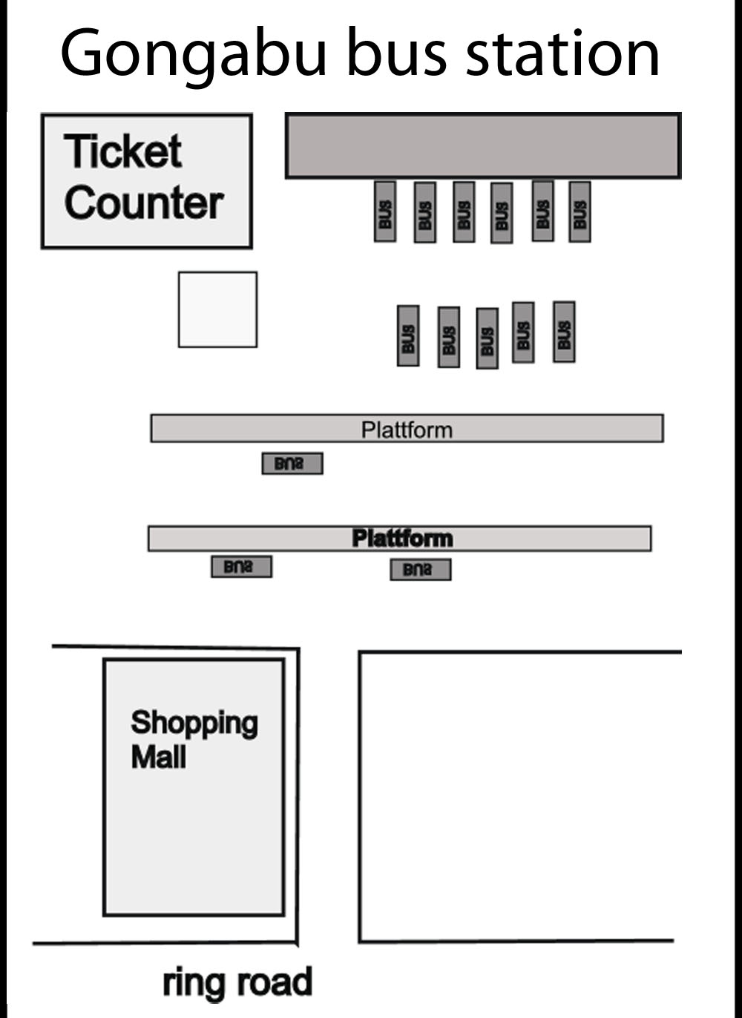
Going first to Dumre then to Besisahar: You can take a normal tourist bus in direction of Pokhara and jump out in Dumre. There you take one of the many busses or mini busses going up to Besisahar or Bhulbhule. The Tourist busses start every morning at 7 a.m. on Kantipath, which is just a 15-minute walk from Thamel. Every hotel can organise the ticket for you, even in the evening. This is the main advantage if you have little time. The bus ride is more expensive, but you eliminate the cost of the taxi ride to the northern bus station. It will sometimes take a little bit longer than the direct local bus if you do not get a fast connection. On other occasions your bus may actually be faster!

Starting from Pokhara: The bus from Pokhara to Besisahar leaves at 6:30 a.m. from the Pokhara Tourist Bus Park; you should be there 30 min early.

Trail description with NATT trails
Riversides: The riversides left/right are always defined looking from the source down the river.

The trekking routes on the Manang side

Possible schedules
You need to give your body time to acclimatize to the increasing altitude. It is absolutely necessary that you stay at least two, or even better, three nights in the upper Manang valley before you continue further up to Yak Kharka or Churi Ledar. Possible places are Ghyaru, Ngawal, Braka, Manang and Khangsar. Acclimatization will be helped by using the extra time to hike to a higher altitude during the day and then returning to your lodge for the night. Please make sure to include extra time for acclimatization as you plan your trek and its duration.

Note: Every day you have more on the trek will be a day of joy and pleasure

Normal pace: AC in three weeks
Day 1: Kathmandu- Besisahar–Bhulbhule
Day 2: Bhulbhule –Bahundanda-Ghermu
Day 3: Ghermu Chamje-Tal
Day 4: Tal-Dharapani-Temang-Chame
Day 5:Chame-upper Pisang-Gyaru
Day 6: Gyaru-Ngawal-Braka
Day 7: Daytrip to Ice lake or Milarepas cave, Manang
Day 8: Rest day in Manang or Khangsar
Day 9: Manang/Khangsar to Yak Kharka or Churi Ledar
Day 10: To Thorong Phedi or High Camp
Day 11: Crossing Thorong la-Muktinath
Day 12: Muktinath to Kagbeni
Day13: Kagbeni Jomsom-Marpha (you might fly back from Jomsom)
Day 14: Marpha to Kokhethanti
Day 15: Kokhethanti to Ghasa
Day 16: Ghasa to Dana or Tatopani
Day 17: Dana to Tatopani &hot spring
Day 18: Tatopani to Pokhara by Bus
Plan always at least two extra days for unexpected delays in your schedule

Fastest trek with Bus and Jeep rides
If you have only two weeks
Day 1: Kathmandu –Besisahar by bus, continue the same day by Jeep if possible. Only take a jeep if it is going up to Chame.
Day 2: Besisahar – Chame by Jeep. Stay one night in Chame, you need this absolutely for acclimatization
Day 3: Chame upper Pisang
Day 4: upper Pisang- Gyaru-Ngawal
Day 5: Ngawal Braka-Manang (taking the high route you don’t need any more an extra rest day in Manang)
Day 6: Manang –Yakkharka
Day 7 Yakkharka Thorong Phedi
Day 8: Thorong Phedi-Thorong la- Muktinath
Day 9: Jeep ride to Jomsom then bus to Tatopani
Day 10: Bus ride to Tatopani or flight to Pokhara
Day 11: Tatopani Pokhara by bus
Plan always at least two extra days for unexpected delays in your schedule
Flights from Jomsom are often cancelled for several days

From Tatopani you can continue to the trekking area south of Annapurna. In 3 Days you could for example climb to Ghorepani, have a trip on Poon hill and descend to Birethanti and take there a taxi.. I did several times the wonderful combination of AC with ABC. You need at least 4 weeks. See the chapter trekking south of Annapurna for more information

The trail descriptions:

1.Trekking from Begnas Tal: 3 extra days
This is a beautiful trek, which is chosen by very few tourists. Therefore, the lodges are still very simple. I liked it so much that I have done it three times already.

Take an early minibus from opposite the old bus park in Pokhara to Begnas Tal. In Begnas Tal take either the trail up to the ridge, which offers beautiful views of the Annapurna range above the lake.
Most people will take the bus to Karputar. From Karputar go to Syauli Bazaar, where amazingly you’ll find a Bavarian-style lodge!

Continuing to the east, cross the river and climb up a very steep hill and you will come to the beautiful village of Nalma. Continue along the ridge to reach the village of Baglungpani , which has one very basic lodge but which offers a fantastic dal bhat. Walking in the forest you will come to a branch off on the trail, take the left one.

While in Baglungpani make sure to be up on the ridge above the village for sunset. Your reward will be an incredible panorama of the Annapurna and Manaslu ranges bathed in the setting sun.

Continue from Baglungpani to the west and descent to the Marsyangdi River valley and you will reach Khudi, which is not far away from Bhulbhule.

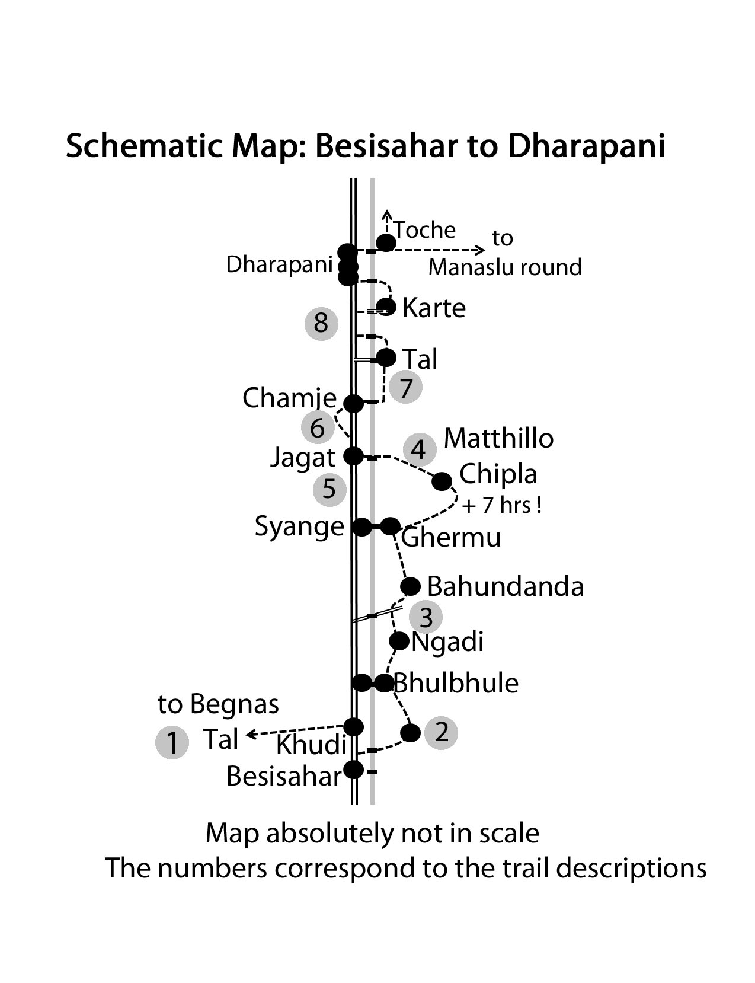

2. From Besisahar (810 m) to Bhulbhule

Many busses continue either their journey from Besisahar to Bhulbhule or even further. Otherwise on can take a bus in Besisahar to Bhulbhule or further or a Jeep. If you want take a Jeep to go further up be aware that they normally start already full in Besisahar. For this reason it is very difficult to later get a place along the road. Besisahar is probably the only place for westerners with long legs to get a front seat.

Walking from Besisahar to Bhulbhule**
But there is a very rewarding side trek through beautiful rice paddy fields from Besisahar to Bhulbhule, bypassing most of the road. Besisahar-Bhulbhule by side trail is 2,5-3-5 hours, 200 m climbing, 165 m going down. It is definitely a very nice alternative to a bumpy bus ride and those who have done it enjoyed it very much. For me, the beauty of Nepal is not only the high mountain region; the lower region has its own beauty and should not be missed!

When you come to the end of Besisahar the road plunges down to the river. Here on the right hand you can take a little shortcut trail leading directly to the river, which you can cross on a little wooden bridge.
After reaching the road, you follow it for approximately 30 minutes. On the way you can already see the suspension bridge going over the Marsyangdi River. Between a few road shops, the trail starts to the right; just watch for the red/white signs. Soon you will reach the bridge and cross the river. On the left, the trail goes up through the villages of Lete, Mulbazar and Simalchaur, a settlement named after the Simal tree, which flowers in spring with big red flowers. From there you still have to climb a lot to reach the highest point at 1030 m (200m above Besisahar). On the way down, you pass some houses and have a beautiful view of the Marsyangdi valley and the Manaslu range. Coming to Bhulbhule you pass a nice little Buddhist stupa. You reach Bhulbhule, where people coming by bus will join you crossing the Marsyangdi River on a long suspension bridge.

3. Bhulbhule –Bahundanda-Germupath
In Bhulbhule all buses will stop since trekkers have to go to the ACAP check post to register their ‘ACAP- and TIMS permits. Al the data are written by hand in huge books.
When all passengers have been registered some buses then continue to Syange or even Chamje..

The traditional trekking trail is on the left (east) side of the river and you cross the Marsyangdi River on a long suspension bridge. On my first treks, I had a fear of these bridges. On the way to Jomsom, I almost could not cross the bridge near Lete. Later I met two Australian girls and we came back together. Already two days before Lete, I started to get nervous. And I was amazed as the Aussies were really looking forward to being on this awful bridge, saying it was great fun! Okay. So I had to take a different psychological approach and crossed it first without my backpack while whistling a simple tune. And it worked! Since then I have liked crossing suspension bridges. Don’t be too stiff when crossing. Like dancing with a partner, you have to follow the movement to enjoy it. Feel the swing of the bridge when you make it sway and you will love it!

On the left side of the river, there are several lodges, most of them in the classic style, simple and perfect. It’s a wonderful place to spend the first evening listening to the gargling sound of the river.

Bhulbhule- Bahundanda 4 h: Start from Bhulbhule on the main trail, which is easy to follow. It’s not such a bad idea to continue from Bhulbhule the same afternoon if you have a few hours left since you will get to walk up the steep hill to Bahundanda earlier the next morning. Surrounded by green paddy fields, you pass by many nice garden lodges. First you will reach the little villages of Ngadi Bazaar and then Ngadi, where you cross on a huge suspension bridge over the Ngadi Khola, a tributary of the Marsyangdi Khola.

Continuing on the trail, you join the road again. When the road dips to the river, and you can already see the bridge, on which the road crosses again the Marsyangdi to reach Syange, you turn sharply to the right and take the road going up. This road is constructed for a hydropower project further up. Instead of taking the side road to the right, you just continue straight already seeing the houses of Bahundanda (altitude 1310m) , which are above on a high ridge. You will have to climb up to this ridge, and no matter what month you do it you will sweat a lot! So try to be there early in the morning, before the sun heats up the south slopes like an oven. The promise of a cold soft drink should keep you going! Once you are on the top you will be in a nice village with rewarding views. You will find five old-style basic lodges and 2 newer ones which are a little bit above the village. Most people like Bahundanda very much and it is a perfect place for lunch.

Bahundanda to Ghermu /Syange 2-2.5 hours: After Bahundanda you will descend on a very steep trail with some stairs, which can be very slippery when it is raining. You once again reach flat paddy fields and then the trail goes more or less on the same level through fields and forests and often high above the river.
The Handrails near Lili Bhir:
On the way to Germu you will come to the little hamlet of Lili Bhir. Bhir is the Nepalese Word for “cliff” and when you get to the outskirts of the village you will understand why it got this name. Here a section of the trail had to be carved out of a steep and high cliff just above the Marsyangi River. You will be happy that someone put some handrails there, especially if the trail is wet and slippery.

In the summer of 2001 the well-known Kathmandu-based journalist Mr. Kanak Dixit was trekking around Annapurna clockwise. It was monsoon and so the trails were often wet and slippery. Having passed Thorong La, he was on his way from Ghermu(phant) to Bhulbhule when he slipped on the small trail near Lili Bhir and felt down the cliff. He was just stopped some 150 m below by some bushes above the river but in his fall he broke three vertebrae and was unable to move or climb back up. His shouts were drowned by the roaring sound of the river so he tried to get attention by waving with a piece of plastic on a little stick. Unfortunately, nobody saw it. For three nights and four days he lay there, trying to survive by getting some rain water from the rocks and eating some grass. He even tried to eat some fruits which monkeys had thrown at him, but they were far too bitter. It is only at the fourth day when he was close to death that a porter named Lok Bahadur Lama from a nearby village spotted him. Lok organized his rescue and later the transport to Kathmandu by helicopter. The journalist made a full recovery and to this day is still active and renowned in his profession. A few years later he set up a drinking water project in Lok Bahadurs Village and also a project for bringing electricity to the village. Mr. Kanak Dixit also donated funds and organized the railings built on the stretch where he had his accident near Lili Bhir and now the trail is much safer. Let’s thank him for this! In the past several people had fallen down at this place. It is said that one of them was a French trekker named Lilly, which is how the cliff and the village got their names.

Ghermu: Finally you will reach Ghermu, which is sometimes called Ghermupath with several basic but nice lodges found along more than a two-kilometer stretch. Ghermu is a pleasant place to relax in the afternoon, as it is rather sunny. From the last lodge you will have a splendid view of the huge waterfall on the opposite riverside above Syange.

4. Alternative High route from Germu to Jagat high route 7 hours
Start point is Ghermu: There is a way to avoid walking the road up to Jagat by climbing up around 850 m to the villages Tallo Chipla and Mathilo Chipla instead. From there the trail will descend back to the river, which you can cross directly below Jagat. We marked this rewarding high route in Red/White, because we thought that it might soon become the main trail, avoiding completely the road to Jagat. This was perfectly acceptable for the trail to Tallo Chipla but when we continued to climb up to Mathillo Chipla, we realized that this trail was quite a bit more difficult to find and took much longer than we had expected. To summarize: it is an absolutely great route but with a demanding 850 m ascent. You have to count a full day of trekking. So if you are strong and love to trek in the green hills, this route will be a rewarding one. Trekkers will have to decide if they want – the scenic rewards of the high route or the easier 2.5 hour walk on the road with much less climbing.
The trail to Tallo Chipla starts at the end of Ghermu just before the Rainbow Lodge. Turn to the right up the hill until you reach a fountain where you take the main trail to the left. This trail will lead you through fields and forest. After about 1.5 hours you will reach the school of Tallo Chipla (1400m) and soon enter the village. From here you will have to climb a high grassy ridge 1750m) which offers nice views. On the other side of the ridge you will first see a huge landslide and behind it two villages which are both part of Mathillo Chipla. After the ridge turn right into the forest on several rather confusing little jungle trails leading gently down to two great waterfalls and a huge rock wall full of wild beehives (Nepali call it rock honey).
From this shanti place you have to reascend to the day’s highest point at 1850m. Finally you cross the big landslide area and descend until you reach the lower part of Mathillo Chipla. It takes around 4,5 hours from Tallo Chipla to Mathillo Chipla.
Pass through the lower village on a stairs trail till you reach at the bottom a little square. Turn here right and follow the trail through the fields. After some 100 to 200m the trail will descend to the left and go straight down. Follow this trail which will have more and more stairs and soon you will see the bridge of Jagat. After crossing it you will have to climb a steep set of stairs to reach the outskirts of Jagat. It is about an hour’s walk from the little square to Jagat. If you are late and the night is coming you can ask people there, they might offer you to stay the night.

5. Syange-Jagat on the road 2.5 hrs.:
At the end of Ghermu, descend to the river and, after crossing the long suspension bridge, you will arrive in Syange. Here you will find five lodges with a newer one a little further along the road on the left near a huge waterfall. The road fortunately bypasses Syange from above but you can still hear every jeep. If you came by jeep and want to stay I would suggest that you cross to Ghermu. It is only 15 – 20 minutes away and is much quieter and sunnier.

Follow the new road for 25 minutes to reach the settlement of Shrichaur with, which has two new lodges directly on the road. They advertise hot springs in 5 minutes, but one has to walk about 10 min, cross the river. The reward is hot water coming out of a tube but there is no pool. However, there are plans to build a proper pool on this side of the river by piping in the water.
The road later switchbacks its way to Jagat. You may try short cuts, but beware of falling rocks. You will pass by a little house perched right on the side the trail like an eagle’s nest. During the recent civil war, it was occupied by Maobadis who had from here a perfect view of all traffic coming up. From here you can already see the village of Jagat.

Jagat (1300m) is mostly a Tamang and Gurung community. There are many lodges and restaurants. The original plan proposed by the road and construction department foresaw the road bypassing Jagat. But some business people of Jagat protested saying all business also would bypass Jagat. So the road is going now through the village bringing noise and dust. But the jeeps don’t stop so there is actually even less business and many lodge owners are already thinking, that they will have to close.

6. Jagat – Chamje on the road 1:30 -2 hours:

After Jagat the dirt road continues to Chamje. Follow it for about thirty-five minutes and you will come to the two teahouses of Ghatte Khola and a small electric powerhouse. After passing the last teahouse walk up the hill to the left on a NATT-trail marked with the red/white signs.

This is the old scenic trekking trail, which passes through a beautiful and romantic forest. First you have to climb some 130 m until the trail becomes nearly flat. Then you reach the Rainbow Waterfall Hotel, which got its name from the big waterfall on the opposite side of the river. Another bonus of this trail high above the river is that it is quieter; you’ll be able to converse with your companions without shouting all the time.

The Rainbow Waterfall Hotel is at the same altitude as Chamje, so in the end the actual difference in climbing for the two ways is less than 30 m. Upon entering Upper Chamje you will find the first three lodges are much quieter than the ones right inside the village. If you want to stay in Chamje the upper part is definitively the better choice.
From Upper Chamje you have to go down a small path to the road and you are at the entrance of main part of Chamje. Here you will find some more lodges.

Doing the Annapurna Circuit clockwise: As you come to the outskirts of Chamje on your way to Jagat, watch out for a little path on the right side going up. It is marked with the NATT red/white signs. It is the scenic old trail leading to Jagat.

7. Chamje to Tal: 3 - 4 hours
Just after Chamje the road continues on the same side of the valley. Between some houses the trekking trail turns right and descends sharply. It is marked with red/white NATT signs and goes down to the river and over a suspension bridge. After the bridge, follow the trail past a great waterfall. After 1.5 hours you will reach the two teashops and the houses of Sattale (1525 m). The Thorong Peak Hotel offers six basic double rooms. Sattale might be a good place to stop for the night, if it is still early when you reach Chamje. This way you can start the walk up to Tal earlier in the morning when it is cooler. After some ups and downs you reach the steep climb to Tal, which has been formed by an enormous landslide blocking the whole valley like a dam. On the top you look down to the village of Tal with the waters of the normally very wild Marsyangdi being held in a pond so that the flow becomes a gentle one.

You can usually descend straight down to the river on the normal trail. Sometimes, however, this path is flooded and you will have to take the high route, which was built when a big rockslide destroyed the old path along the river some years ago. But also this trail is sometimes destroyed by rock fall. If you see small stones or tree branches laid by people to obstruct a trail, this is a warning that you should not take it.

Tal
Tal is a beautiful village, mainly made up of lodges, but there are also some old houses. Here the valley widens and it is an ideal spot for a lunch break or even an overnight stay. Behind the village is a huge waterfall, which will provide nice photo opportunities, especially when combined with the horses Tal is famous for. In Mid-December, it is the custom for the people of the higher Manaslu region to bring their animals to this region over the Larkya La.

Fortunately the newly-built road will be on the opposite side of the river and not pass through Tal, as some Nepali maps show. There is a side dirt road connecting Tal to the main road, but there is nearly no traffic.

8. Tal to Dharapani: 2,5 – 4 hrs.

Continuing on the trail alongside the river for 25 minutes, you reach 3 little garden lodges in Sirantal. From here you can see the dramatic section of road on the other side of the river. It was carved out of the rock wall.

At the end of the narrow gorge you climb up a little bit and then descend to a bridge which takes you to the other side of the river. Here you can walk on another stretch of the road. The ACAP had planned to reopen the old trekking trail between Tal and Karte/Dharapani, which was blocked by a landslide near Karte with the river washing away the trail below the cliffs. Unfortunately the contractor, having received 500.000 Rupees, worked a little bit and then disappeared with the money. The project will hopefully be started again in 2013; there is just a 100-meter section where a trail would have to be made.
Cross the river again at the village of Karte with its 4 or 5 lodges. Follow the river on a nice trail away from the main road until you come to the bridge just before Dharapani.

Dharapani
The Village of Dharapani stretches over at least 1.5 km with empty fields between the three village centres. First the police will want to check your TIMS Permit in Dharapani Bazar. Then the ACAP will ask to see your ACAP Permit in the last section of the village near Dharapani Bridge. This long suspension bridge leads into the valley going to Bimtang, which is part of the Manaslu Circuit trek. There are several lodges in all three parts of Dharapani. The classical trail used to continue to Bagarchhap and then to Danakyu but the trail has now become the road – complete with jeeps and motorcycles. There is an alternative! A new and beautiful NATT trail goes from Dharapani on the left eastern side of the river bypasses Bagarchhap und joins again the road 30 min before Danakyu.

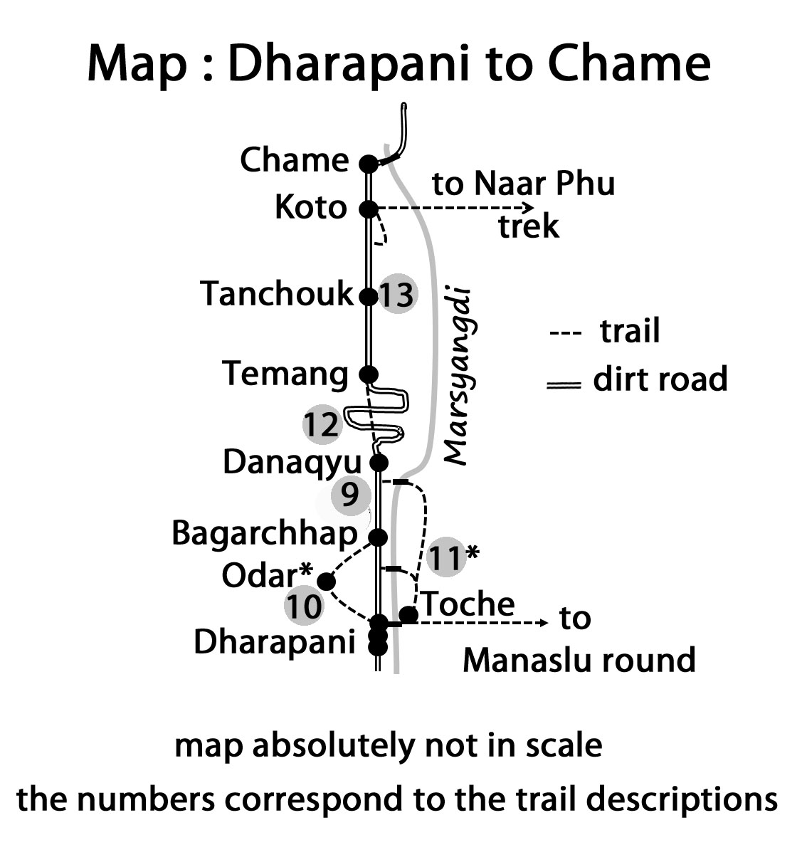

9. Dharapani – Bagarchhap- to Danaqyu on the road:1,5hrs..
You can either walk along the road, which will lead you in about 45 minutes to Bagarchhap. Various guidebooks suggest that it is only a 30 minute walk but it will probably take you longer. Bagarchhap (2160 m) has a few lodges and some nice old houses near the stupa in the center of the village. The Gompa is rather new. Bagarchhap has been devastated twice during the past 25 years by big landslides caused by heavy rains and some trekkers have died there. Therefore, I would avoid staying there if there are heavy rains.

To continue through Bagarchhap beside the gravel road look to the right side of the road. Starting near a little stupa there is a parallel foot trail (marked with red/white NATT sign) which you can follow for around 20 min before you join the road again. Also, some 150 meters after you pass the three houses of Dunche, for 500 meters you can walk on the old trail found on the right side below the road.
Map

10. Nice Side Trip: Dharapani- -Odar*-Bagarchhap Blue/ white 2 hours
If you want to skip the narrow gorge of the lower Marsyangdi Valley you can take a nice side trip through the village of Odar on the way to Bagarchhap. Odar is situated on a plateau around 200 m above Dharapani and it provides views of wide fields and beautiful mountains. Odar offers homestays in very, very basic private houses, but it can be an unforgettable experience and a nice change from the rather luxurious lodges of the Circuit. In any case it will be a very peaceful stay. Start from Dharapani on the road to Bagarchhap- a few hundred meters further the trail goes up directly behind the Three Sisters Lodge. Climb about 200 m on a good trail often with perfect stairs. Soon you forget that there is a dirt road just below you. When you reach the plateau, you can admire the many terraced fields and see the village of Odar. Cold soft drinks may not yet be available but we did have a tasty tea.
To continue, go down to the village until the gate and then turn up to the right. You will have to climb another 50 meters and then descend to the village of Ghelanchouk (2075m). Pass it by and descend 80 m on the stairs you descend right into the old center of Bagarchhap. Set aside 2 hours for this side trek but it might take even longer as you may end up strolling around in the village with your camera at the ready. I liked it very much.

11. Dharapani to Danakyu on the left east side of the river 2h *

Instead of using the road for this stretch, there is a beautiful NATT alternative . Cross the suspension bridge in Dharapani which leads to Manaslu area, but directly after the bridge turn left and enter the beautiful village of Thoche (one lodge). On the right side of the trail you will see a 100 year old little Nyngma-Gompa** which is absolutely worth visiting. Ask the old nun to open it. It has a very special atmosphere.

From there just continue on a natural trail leading through fields and pastures and bushes till you reach another suspension bridge. Here you could cross the Marsyangdi if you wanted to stay in Bagarchhap for he night. Climb to the road and soon you will be passing by Bagarchhap’s entrance chorten. Otherwise you climb up to the right and follow a little foot trail along the hillside. After crossing a little river, which should not pose any problem in dry season (and I hope that ACAP will soon build a small bridge for all seasons) you have to climb up a little slippery slope. Continue till you reach the little powerhouse. Above it the trail continues into open fields. The main trail weaves through the middle of the fields and will lead you to a house with a shining metal roof. It was just under construction in December 2012 and will eventually open as a lodge. Just after this new house the trails descends from the plateau. Don’t take the suspension bridge which you see; instead, cross on the little wooden bridge. The trail will then lead you to the second big suspension bridge spanning over the Marsyangdi River. Cross it and climb up to the road by a lodge. Soon you arrive in Qunche/Quinche and 100 m further you can again take the old trail just below the road. 500 meters further the trail joins the main road again.

12. Danaqyu –Temang 1:45-2 hours:
Danaqyu is a long village stretched over more than 1 km with several lodges. Be aware that the next lodges after Danaqyu are in Temang, almost two hours further and requiring a steep ascent of more than 350 m. Follow the trail to the river and walk over a little wooden bridge. Soon a trail on the left side will steeply climb up in the forest. On the way you will cross a few times the zigzagging road- always look for a foot trail going rather straight up. When you reach two small teashops you will know you are almost in Temag, where they are in a frenzy building huge lodges. Obviously they think that with the new road hundreds of guests will jump out of the busses to stay there, but I rather think the bus passengers will just pass by and trekkers will not want to stay directly near the busy road.

13. Temang – Thanchouk–Koto- Chame (2670 m) 3-3.5 hrs..:
After you reach the top of Temang the trail goes with little ups and downs to the village of Upper Thanchouk (1hr). From there it is another 20 min to the main part of the settlement. Thanchouk is a beautiful old village built on a ridge and is worth seeing. So turn to the right and take the time for a little sightseeing tour. There is one lodge in the village along the main trail and two other lodges 10 minutes after the village. Follow the road trail for about 1hr to reach the old village of Koto (2600 m) with some nice old-style wooden houses.
Koto is also where Naar-Phu trek begins.

Twenty minutes beyond Koto you will already be approaching the first lodges of Chame-Trichyunggaltha. But it is another 10 min walking till the main village of Chame begins. Located here is the headquarters of the Manang district with a bank, police headquarters, district administration.. Chame also serves as a big bazaar for all the surrounding villages and it is a place where you can buy many things including medicines. There are many lodges in Chame, many saying that they have broadband internet. Just after the bridge there are on the right side a few very quiet lodges not far from some little hot springs on the riverbank. A solid bridge over the Marsyangi Khola will probably be constructed in April 2013 and then vehicle traffic will be possible up to Manang. If you took a jeep all the way up, it is absolutely necessary to stay the night in Chame for acclimatization. Even the trekkers in a terrible hurry should finish here the jeep ride and start walking. Not only you will need the days in altitude, but soon you will come into one of the best sceneries of the Annapurna round trek.

14. The Naar-Phu Trek
More and more People choose this side trek which will bring you to the traditional Tibetan-style villages of Naar and Phu(gaon). You need a special permit which is only issued in Kathmandu for at least two persons supported by a trekking agency. It is normally a tent trek which will takes around 4 to 5 days. But already you might find some shelter in Teahouses or basic lodges or homestay. The starting point is Koto and you return to the Marsyangi Valley over the high pass Kang La (5312m). A typical itinerary would be as follows: Day 1: Koto to Meta (3630 m) , Day 2: Meta to Phu (4065 m), Day 3 Phu to Mahendrapul(3500 m) or Naar (4190 m), Day 4: Naar over Kang La (5312 m) to Ngawal (3680 m). One can easily spend an extra day in the vicinity of Phu.

15. The former trail by Latamarang: On many maps you will still see a trail leading along the river and passing by Latamarang. In fact this trail is actually closed, as the construction of the road with blasts and falling big rocks makes it an absolutely “no go” area. Even the locals living there had to leave. In the past this was a beautiful trail with a small hot spring in Latamarang and a lovely trail above the river. In 2012 we went there with a guide from the ACAP and realised that this trail is not passable because of many landslides which have occurred in the last 6 years. Also many bushes and little trees have already started to grow on the trail. Therefore, don’t try it but take the route up to Temang. My guess and hope is that in a few years the trekking trail will pass again along the river by Latamarang.

16. Chame - Bhratang–Dhukur Pokhari 5-6hrs.

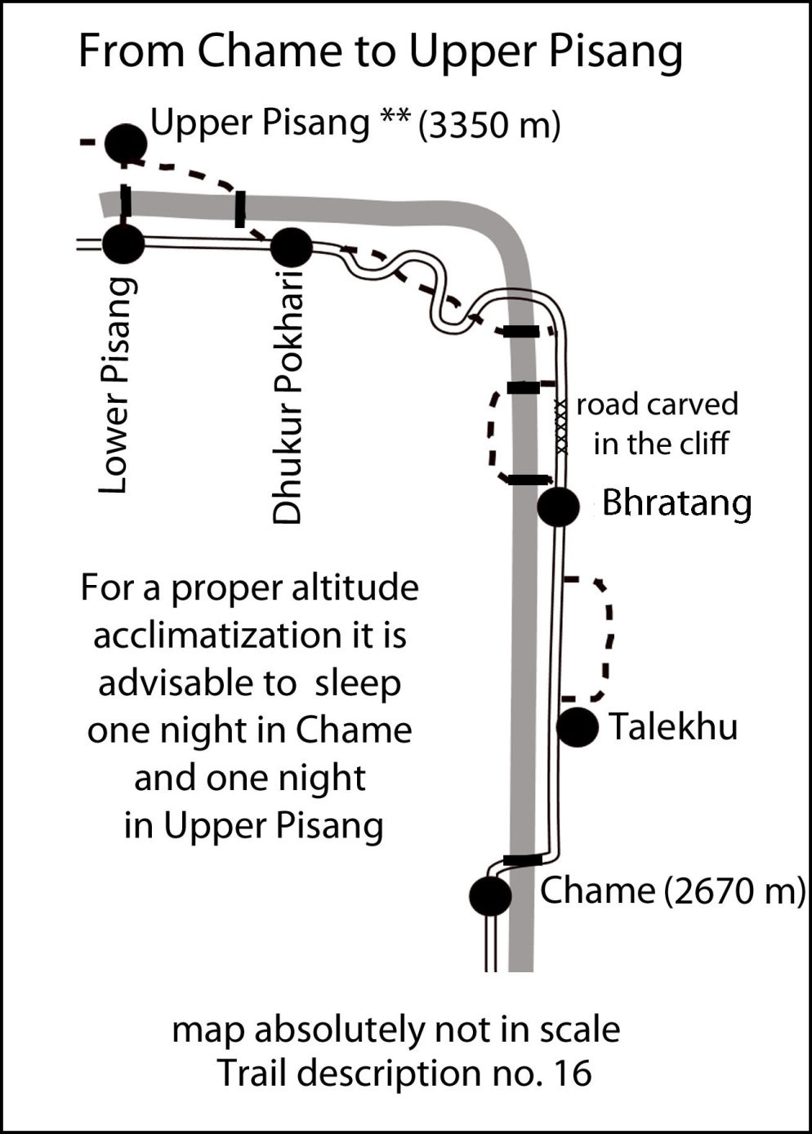
Chame-Bhratang: 2-2.5 hours: After the bridge you turn to the left into old Chame. The Gompa on the left side is not extraordinary but situated in a very shanty courtyard, which is worth looking at. People interested in Gompas can ask the people of the surrounding houses for the keys. Don’t forget to give some donation for the Gompa and a tip to the person showing it to you.

Continuing through nice a pine forest, after 25 min you reach Talekhu (2710 m).

Alternative NATT-trail: Just a few minutes after Talekhu a trail turns to the right into the forest. It is difficult to find, as the road was lowered and you first have to climb to the old trail beside the road. Look out for the red/white NATT sign. This trail is just marvellous, leading through a dense pine forest and some meadows with often nice views to the opposite side of the river with some breathtaking waterfalls; it is also much nicer to walk on the soft forest trail than on a hard road. After three kilometres you re-join the road and reach after 30 min the lodge settlement of Bhratang, which is surrounded by apple orchards. Apples can't grow in the warm areas; they need some frost in winter and feel much more comfortable up here. They are grown near Chame and mainly on the other side of Thorong La in the upper Kali Gandaki valley; I prefer the apples of Kali Gandaki, which get more sun and taste better. Bhratang (2800m) has only one lodge left.

Bhratang - Dhukur Pokhari: 3h
For more than 20 years the trail beyond Bhratang was carved out of a vertical rock wall high above the Marsyangdi River. This was rather spectacular, but crossing with a mule caravan could be rather dangerous. With the new road being in construction and a lot of blasting going on, an alternative trail had to be found. Also, it is obvious that soon Jeeps will be taking this route.
As a result, on the other side of the river the ACAP has built an excellent trekkers’ trail which bypasses this carved road. Soon after Bhratang take the red/white marked trail which will lead you down to the river and cross on a beautiful wooden bridge. Be careful not to choose the provisional temporary caterpillar trail along the river but climb up on a little plateau with nicely-scented pine trees. Follow the gentle trail and take in the spectacular view of the carved road stretch on the other side of the river. After a while the trail plunges down to the river again and this time you will cross the Marsyangdi Khola on two connected wooden bridges. Climb up till you reach the road and turn to the left.
The valley turns to the left in a sort of polished enormous rock wall, which I call the soup bowl. The local people call it Swarga Dwari or “Gateway to Heaven”, as the souls will have to climb up here to reach heaven. There are many grave markers by the trailside, as this is an auspicious place to be buried.
Cross the river on a suspension bridge and climb up through a dense forest. The trail on soft pine soils crosses once the road to join it later, there are some red/white marks. An hour’s walk after the bridge you reach the long stretched lodge settlement of Dhukur Pokhari.

19. Dhukur Pokhari – Lower Pisang, Humde. and the Lower Route to Manang:
You can follow the road trail, which will first lead you over a pass to Humde (also called Ongre) and the airport there. As already suggested, the upper High Route is the more scenic choice but you might prefer the lower route because it is a bit faster. On the other hand, it provides less altitude acclimatization so that you are not really gaining a lot.

Just follow the road. In August 2011 they were busy enlarging by 30% the airstrip in Humde/Ongre. Until now this airport has been notorious for cancelled flights and with just very few flights a week no one could rely on it. I was told that there will be more flights in future but the approach is very difficult and dangerous so in 2013 there were still very few flights.
There are many lodges in Humde. Follow the road trail to Munji Milarepas Cavewhere you will also find some lodges and continue on the road trail to Braka (Braga).
I personally strongly recomend the high route described in the next chapters.

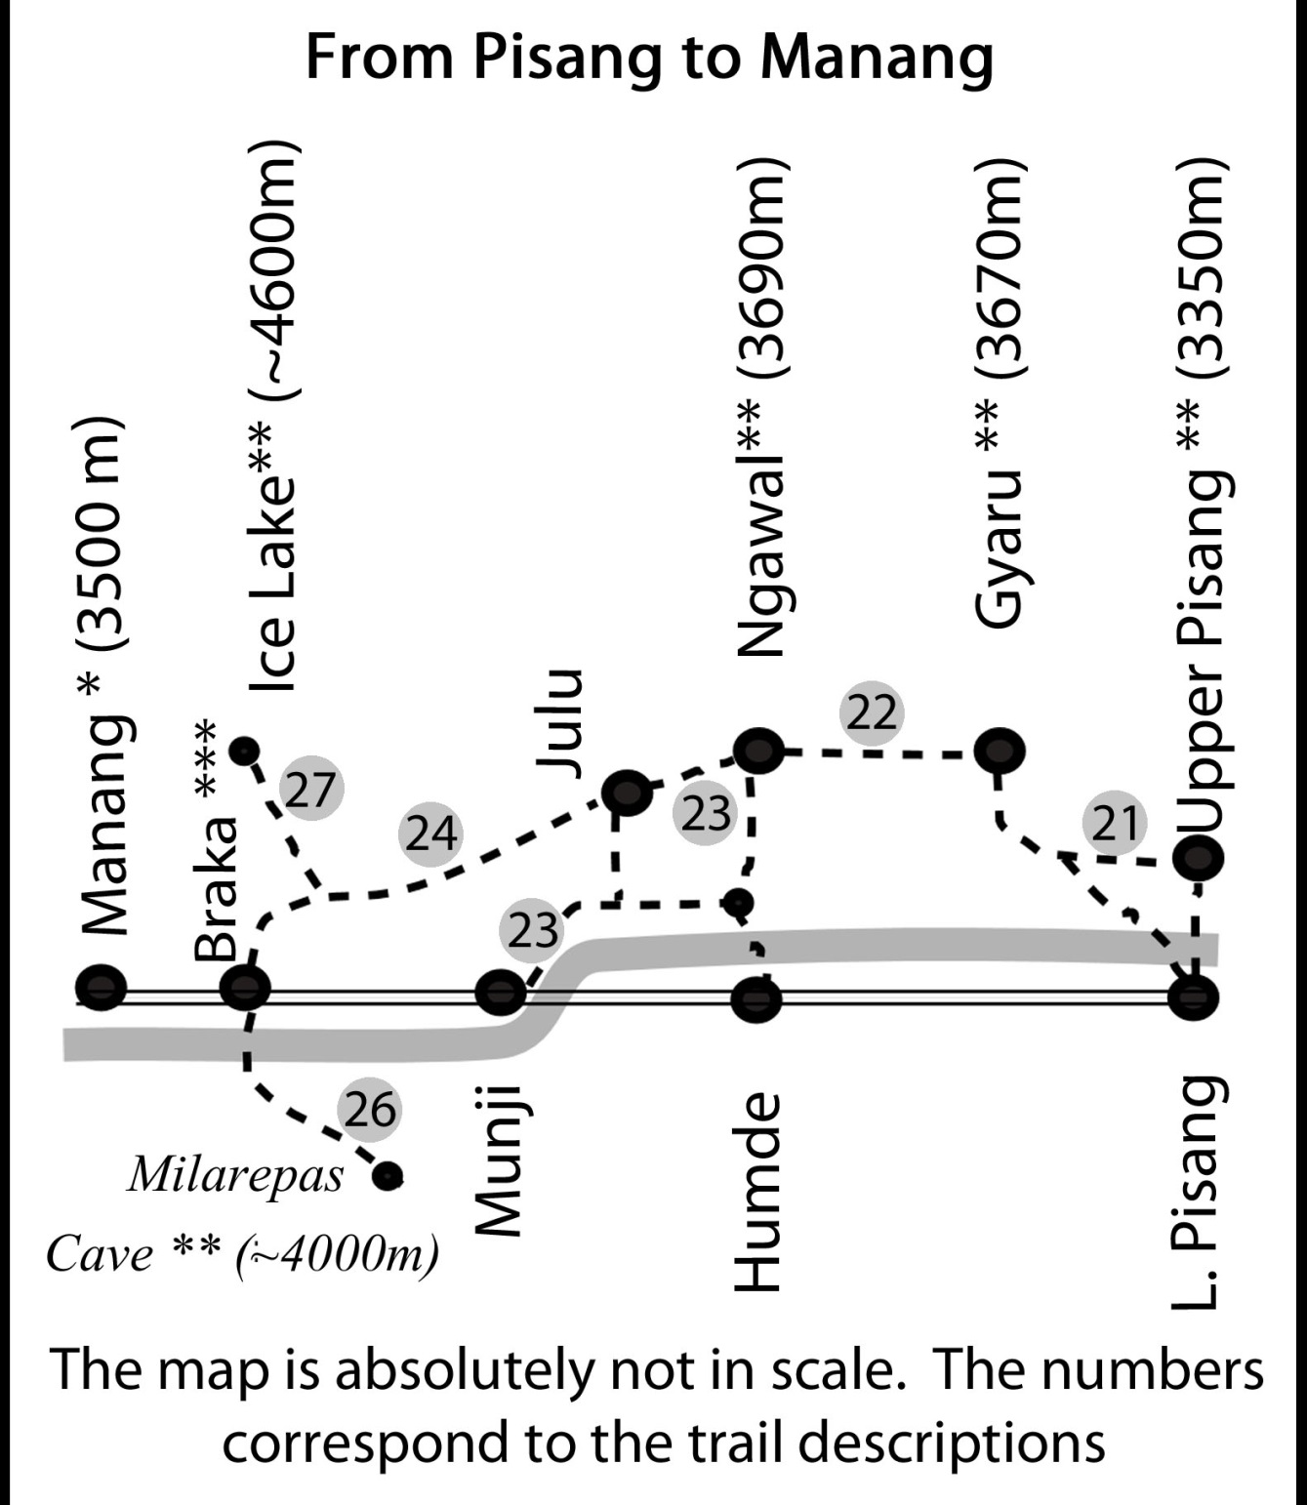

20. Dhukur Pokhari – Upper Pisang and the High Route to Manang
The high route offers breathtaking panoramic views of Annapurna II, IV and III and is highly recommended. It goes through Upper Pisang – Ghyaru – Ngawal to Braga high above the valley. As Ghyaru is already higher than Manang it offers a far better acclimatisation than the low route by Humde. In fact I never have met anyone having problems at Thorong La, who had taken the high route. ACAP has also chosen the high route as the standard new route.

Dhukur Pokhari – Upper Pisang At the very end of the village after a Mani wall you can either take the left road going to Lower Pisang with its many lodges or you can take the recommended NATT trail** on the right marked with the red/white signs. This trail is far more beautiful and leads to the old village of Upper Pisang. Follow the trail to the river and cross it on one of the two bridges then turn left. It will first be rather flat and pass through meadows and by the football field of the Pisang Youth Club. Then the trail gently but steadily climbs up to Upper Pisang.

Upper Pisang** (~3350)m:
This old-style village is typical for the Manang area and has a large prayer wheel wall in the centre. Just opposite of the valley is Annapurna II in all its splendour and marvellous views of the mountains can be had. High on top of the village is a new Gompa worth visiting, but for Gompa lovers the 250 year old Gompa**, just opposite the Annapurna Lodge is a much more rewarding place to visit. Ask in the upper Gompa if someone has the key and if they could show it to you. From the outside it looks like it is falling apart but the inner Gompa on the first floor is still in use.
There are only four lodges in Upper Pisang (2012), so it might be difficult to get a room in the high season. In this case, you might have to walk the ten minutes to Lower Pisang.

21. (Upper) Pisang to Ghyaru 2-2.5 hours: The trail starts at the west end of the big prayer wheel wall and leads through the entrance chorten of Upper Pisang. The trail is quite obvious and is marked with the NATT red/white signs. After 30 min you will pass above a beautiful small emerald green lake. The alpine-style small mountain path leads mainly through small pine trees and shrubs and is not to be compared to walking on a large road. When you finally reach a long Mani wall turn to the right and take the long suspension bridge over the river. From here you can see some flags of Ghyaru high above on the hill. You now have to decide if it’s really worth climbing up all that way! Well, it definitively is - so up you go on the trail with its seemingly endless switchbacks near the electricity poles, which go up in a direct line. Your goal is the last of the fourteen poles! .

Ghyaru** (3670 m ):
Overlooking the valley with perfect views of Annapurna II, IV and III, Ghyaru is a typical village with most houses having flat roofs. Many of them are not inhabited anymore as the people have moved to Pokhara and Kathmandu.

Ghyaru is surrounded by many fields, mainly of barley and buckwheat. It has also a nice Gompa*. Ask the people nearby who have the keys. From here the people with trekking peak permits for Pisang Peak start their climb.

Ghyaru has only three lodges: right at the entrance is the Yak Ru, which means Yak horn, with trekkers lodge standard and 22 beds (mob: 9841422829), a few meters further the Gorkhali Hotel also with 22 beds but rather basic standard (tel: 019442002/mob: 9846229850). Near the Gompa is the Annapurna Lodge in an old house with very basic standard. It has three double rooms and the most beautiful view over the village. The toilet is outside. For people who want to experience the genuine but very basic lifestyle of the people living here, this would be a very interesting and nice place to stay. In August 2011, the mattresses were hard, but the owner promised to buy new ones before October. Annapurna Lodge mob: 9849523309.
As there are only 50 beds in Ghyaru, in the peak season I suggest that you ask someone in Pisang (perhaps a restaurant owner) to make a phone call to check if there is a free room which you could reserve before you climb all the way up there.

22. Ghyaru – Ngawal 2 – 2.5 hours: The red/white marked NATT-trail starts from the chorten at the western entrance of Ghyaru and goes past barley and buckwheat fields. These two crops are alternated every year. Climbing up the trail you will pass several Mani walls to reach a viewpoint with a big stupa and a beautiful view of Ghyaru and its many fields. A little further below you can see the ruins of Ghale Dzong, a fort used by the Ghale family when it ruled this part of the valley seven to eight hundred years ago. If you take the trail leading to the ruins, then take the trail leading west from there and it will rejoin the main trail. Descending through an aromatic pine forest you will pass some meadows to climb again to an even bigger stupa with an excellent view over the entire valley. In the trekking season there is a little teashop. Continuing from there above many fields you will reach two other stupas and see around the corner the village of Ngawal.

Ngawal ** (3680) m:
There are five large lodges in Ngawal spread from one end of the village to the other. The famous Gompa is well-kept and from there one has a breathtaking view of the east face of Annapurna III. It would even be nicer without the electricity pole, which has been placed on exactly the best spot to ruin photographs! The Naar-Pho Valley trek ends here after crossing Kang La from the north. You will also see a large signpost prohibiting trekkers to cross the pass without a permit.

23. Ngawal to Braka (Braga) 2.5 or 3.5 to 4 hours: You have two possibilities: a shorter way descending directly to the main valley which takes around 2.5hrs. A better choice is the scenic high trail which passes by the Lophelling Monastery and Buddhist boarding school and the village of Julu, this will take you around 3.5 hours.

1) The direct trail. Take the trail near the big tree in the middle of the village to the left and follow the trail through the western entrance gate. Soon it will descend to the valley. Down there, you come to the lovely little village of Paugba/Bensi. In the valley this "secondary" trail is marked with blue white signs. After a half-hour you will rejoin the main trail with its red/white markers.

2) The high trail, which offers beautiful views and is definitely the first choice, is indicated with red/white signs as the chosen main NATT-trail. It starts just opposite the Ngawal Gompa and leads through some nice meadows with a little stream. After climbing a ridge you will find yourself on a plateau with the old Gompa to the right. Notice too the many abandoned individual houses of the monks; they have moved to the new Lophelling monastery and Buddhist boarding school, which is on the other side of the plateau. While there you could ask someone if they could show you the old Gompa, which is still in use and looks rather different with its statue of Chenrezig and many Chinese lampions. Both monasteries are of the Kagyu sect. After the Gompa you have to descend a very steep trail. Soon you can see down to the charming little village of Julu (Chulu) near the river. In Julu you can again choose between the lower and high trail.

The classic trail Julu to Braka on the lower route 3.5 hours: Further left (west) you can see in the forest a place with a chorten and many prayer flags. Cross the river and go through the lovely Julu and continue in the direction of the main Marsyangdi valley. After about 20 min you will reach the place with the prayer flags. From there the trail descends to the west through a sparse pine forest. Finally you reach two huts with three big wooden benches for the porters. This is the junction with the lower trail from Ngawal Bensi / Paugba.
The trail continues for about 45 minutes through sparse and dry forest with small pine trees and prickly scrubs. Descending a big meadow you come to the lodges of Munji and join the big road trail at the Namo Buddha Lodge. Climbing up a little bit you pass a very colourful big chorten.
After walking about 10-15 minutes look for the NATT red/white mark houses of Braka village with a splendid view of the main village and the famous Gompa of Braka, which you absolutely should not miss.

24. Julu to Braka on the high route * 4 hours
If when you reach Julu you still have 4 hours left until the evening you can choose the high route between Julu and Braka. This route offers spectacular views but takes around 1 hour longer than the normal lower trail. You will also have to climb an additional 250 m. But you will be recompensed with absolutely great views of the valley below and the full range of Annapurna II till Tilicho peak. This trail is not yet marked and is a little bit confusing in the beginning, but soon it will be rather clear to follow. Start in Julu just after the entrance chorten gate and climb up the hill on various little trails. As long as you are climbing up the hill they are the right ones. When you reach the ridge of a larger plateau you will see more clearly trails going west in the direction of the main valley and soon it becomes an obvious trail. The plateau is rather flat but still you will have to climb a little bit. At the end the plateau gets wider with extended pastures and some herders’ huts. At the end you will see a chorten made to be framed by all photographers. From there the trail will steadily descend to Braka and soon you come to the junction where another trail goes up towards the ice lake. From there on the trail is indicated with the NATT blue/white marks and leads you directly to the upper part of the fantastic old village of Braka.
Braka to Julu clockwise: 3.5 h. If you want to do this trek from Braka to Julu follow the first part to the ice lake trail but then continue straight at the junction. After some time you will see two big trails on the plateau, the left leading to the hill side and into the forest and the right going rather straight forward. Take the right one. When you reach the edge of the plateau you can already see Julu down in the valley. Find and follow some small trails to descend.

25. Braka*** (Braga) 3470 m
For many years I thought that the name of this village was Braga, as this was the spelling on the German Schneider Map. But the landlord of Braka bakery told me that it should be pronounced as “Braka”.
Braka is a perfect place to stay overnight. It is just 45 min to Manang and it has nearly the same altitude. There are 5 lodges along the main trail and the Braka bakery has a wood-fired oven and makes delicious cinnamon rolls and other bakery items.

In common with other villages of this area, many of Braka’s old houses are not inhabited anymore as the people moved to warmer places. During the harvest season there are even not enough locals for the fieldwork and day labourers from other parts of Nepal are brought here.
The villagers decided in 2011 that they wanted to keep the village in the old style and there are plans to improve it.

Visiting the Braka Gompa *** (1 hour): This is one of the finest Monasteries I have seen in Nepal and you absolutely should make a visit! This is not so easy, as there are no permanent monks there and you have to find someone with a key. The people at the lodge may be able to help you, or you could just go up to the monastery and start to shout: “Gompa ko chabi chha?” (Is there someone with a key?) or just “Gompa Tourist, Gompa tourist!” In 2012 the village committee decided that it would charge a little fee for the visit and that they would use this money to improve the gompa and the village. This decision has made it much easier to get someone to guide the gompa visit. The visit is definitively worth the fee! If you go there take a torch (flashlight to North Americans) with you, as there are many beautiful statues in the dark back room.

The Braka Gompa has two main attractions to see.
The main prayer hall: First you will visit the big prayer hall with plenty of beautiful masks and thankas. For ceremonies up to 40 monks will come and pray on the small benches on the side. The protector god in the entrance will repel any bad spirits and ghosts. Take the torch and have a look to the back part of the hall. Hundreds of statues are lined up on the wall. Some date back more than 500 years. Please leave some donation in the donation box.
The big Buddha: On the right side above the prayer hall a high white building leans on the rocks. After passing by two fierce protector gods you will see a beautiful huge golden Buddha several meters high.
There is a third important place with a powerful goddess. But the village committee decided in 2011 that it would no longer be accessible to tourists.

After the visit, please give also a tip to the person who took her time to show you the Gompa. Set aside at least an hour for your visit but you may, like some people, take even more time. After the visit of this outstanding Gompa you can visit the village, strolling through the small village lanes.

Side trips from Braka
As Braka is situated nearly at the same altitude as Manang, you could stay one night in Braka, make an excursion to Ice Lake or Milarepa cave the next morning, and then continue in the afternoon to Manang. In this case you wouldn’t need a second acclimatization day in Manang and could start the next around 10 in the morning from Manang to Yak Kharka (or Churi Ledar if you have taken previously the high route over Gyaru and Ngawal)

26. Milarepa’s Cave ** ~ 4000m 3 - 3.5 hours: blue/white markers
This side trek is also very worthwhile. The famous monk and singer Milarepa is said to have stayed here for meditation in a little cave below Annapurna III and a small little Gompa was later built near the cave. It is a very pleasant walk through a forest into a side valley below Annapurna III with good views of Pisang peak.

How to get there: Go east (Direction to Mungji / Pisang) for about 300-500 m and cross the river on the bridge. After the bridge turn right (west) for about 50 m until you reach a small trail with blue /white marks leading to the hillside. Follow it to the left (south) until you reach the forest and climb up the trail. The owner of Braka bakery has marked the trail in blue/white. You will reach a place with a nice Stupa and many prayer flags. Continuing you will get out of the forest and climb up the valley until you reach the little Gompa. The cave is about 15 min further up. I’m sure that after this excursion you will love some fresh cake or a cinnamon roll in Braka! Like Ice Lake, Milarepa’s Cave is a perfect exercise for better acclimatization and one will enjoy much more the crossing of Thorong La a few days later. It might be a good idea to leave your backpack at the lodge while you walk up to Milarepa’s cave. Pick it up on your return before you continue that afternoon to Manang.

27. Ice Lake ** 4 -5 hours: blue /white NATT marks
The Ice Lake is situated north of Braka at an altitude of ~4600 m. This makes it a perfect half-day destination for acclimatization and you have from there a marvellous and breathtaking view of the whole Annapurna and Tilicho ranges.

There is a small trail starting from Manang, but it is rather difficult to find. Some years ago, ACAP installed some signposts, but the people of Braka were upset and said that the Manang people were trying to take all the business so they removed the signposts which were on Braka community ground. Therefore, most people will climb up from Braka on a very clear and well-marked trail. This trail begins just above the village.. When you reach it, turn to the right. After a while you will come to a junction where the trail branches up to the left ascending to Ice Lake. There should be signposts. There are two separate lakes. The first is smaller and you have to continue some 10 minutes to reach the larger one. They are rather close, but you will be aware that the air is much thinner above 4500m! Normally the lake will not be icy in October /November but it may take till March to melt again.

28. Braka – Manang 35 min:
From Braka just follow the broad dirt road trail. Fortunately there is not yet much traffic till now, just sometimes a single tractor.

Manang * 3500 m
Manang is situated on a large sedimentary bed, which had been filled up in former days. Meanwhile the Marsyangdi Khola has dug a deep riverbed into it on the south. When you are on the way up to Thorong La, if you look back you can see how Manang is perched above cliffs. On the other side of the valley to the south there is the enormous mountain chain of the Annapurnas with Annapurna III and Gangapurna right above Manang with the fabulous Gangapurna glacier falling down nearly vertically for some hundred metres.
Coming from Braka you will pass under the Manang welcome arch. After a short gentle climb you pass the entrance chorten. All the hotels are situated in Malang’s newer section as you first enter the village. Accommodation is plentiful and only in the high peak season will you have problems finding a room.

As indicated before, it is essential to stay two, or even better, three nights at an altitude of 3500m or more before going up in direction of Thorong La. If you have taken the high route via Ghyaru and Ngawal and slept there, you already have one night. In this case you might just stay one night in Manang. Otherwise, you absolutely should stay two nights here. One can also stay one night in Manang and go the next day to beautiful Khangsar, which is even a little bit higher.

All the hotels are situated at the beginning of the village. There you can also find many little shops selling warm clothes, sun cream and other trekking items. Check to see if you might have to buy anything. On Thorong La, the sun burns down and you will absolutely need sun blocker. Once a guy went up in shorts. He only realised in the evening that the sunrays are also reflected from below by the snow when he got a bad sunburn under-neath the shorts, where he forgot to put sun cream :-)

There are a few video halls showing English films in the afternoon. There is also the local museum and an ACAP post. An interesting place is an old lodge with three big prayer wheels. In the restaurant you can get the normal items, but they make a very tasty chhyang, the local brand of a light and turbid beer. As it is made with boiled water I don’t hesitate to drink some. The new part of town ends near the new stupa. Old Manang is absolutely worth exploring with its small lanes and flat roofed houses. Going west in direction of Thorong La you first pass a prayer wheel wall with a fountain. (This is the place to turn right to pay a visit to the “100 rupee monk”). After a beautiful old chorten turn to the left and continue down till you reach another big prayer wheel wall. (The next day you will take the lane to the right) Gompa lovers will find someone with the key here. Otherwise it’s a beautiful old area and you can make some very nice pictures or even go down to the river.

Day hikes from Manang:
Many people stay two nights in Manang and if you don’t just want to relax for a day there are many possibilities.

Visiting the “100 Rupee monk” in Praken Gompa **(3945 m) 2 hours.
Praken Gompa is a small hermitage perched like an eagle’s nest on the rocks above Manang where the old monk Deshi Lama has been living for many years and giving his blessing to visitors. He is now much older than 90, but in August 2012 he was still alive and giving Pujas. If your lodge keeper tells you that he is still there, don’t hesitate to visit him; it is really a great experience you will never forget. After murmuring prayers he will bless you and wrap a thin thread around your neck. I have never met anyone who did not keep it at least until having crossed Thorung La. From Praken Gompa you also have beautiful views of the Annapurna and Tilicho ranges. To go there: turn to the right near the fountain and big juniper tree in old Manang. This trip is also perfect for acclimatization and you will definitely know that you are climbing up in thin air ;-).

The lake below the Gangapurna glacier: Crossing the Marsyangdi River, it is a 45-minute walk up to the lake. There is also Chongar viewpoint above the lake with good views which is decorated with many prayer flags. Once there was a rubber dinghy on the lake, but I don’t know if it is still there.

Hike to the Ice Lake: The trail to ice lake from Manang is much more difficult than going from Braka so I suggest that you go first back to Braka.

Bocho Gompa: This old gompa is situated just a short way back to the trail to Braka (15 min). It will be appreciated by anyone interested in the local culture and offers nice views with the juniper trees around it. Inside you can see the statue of a former king now said to be protecting the Manang area.
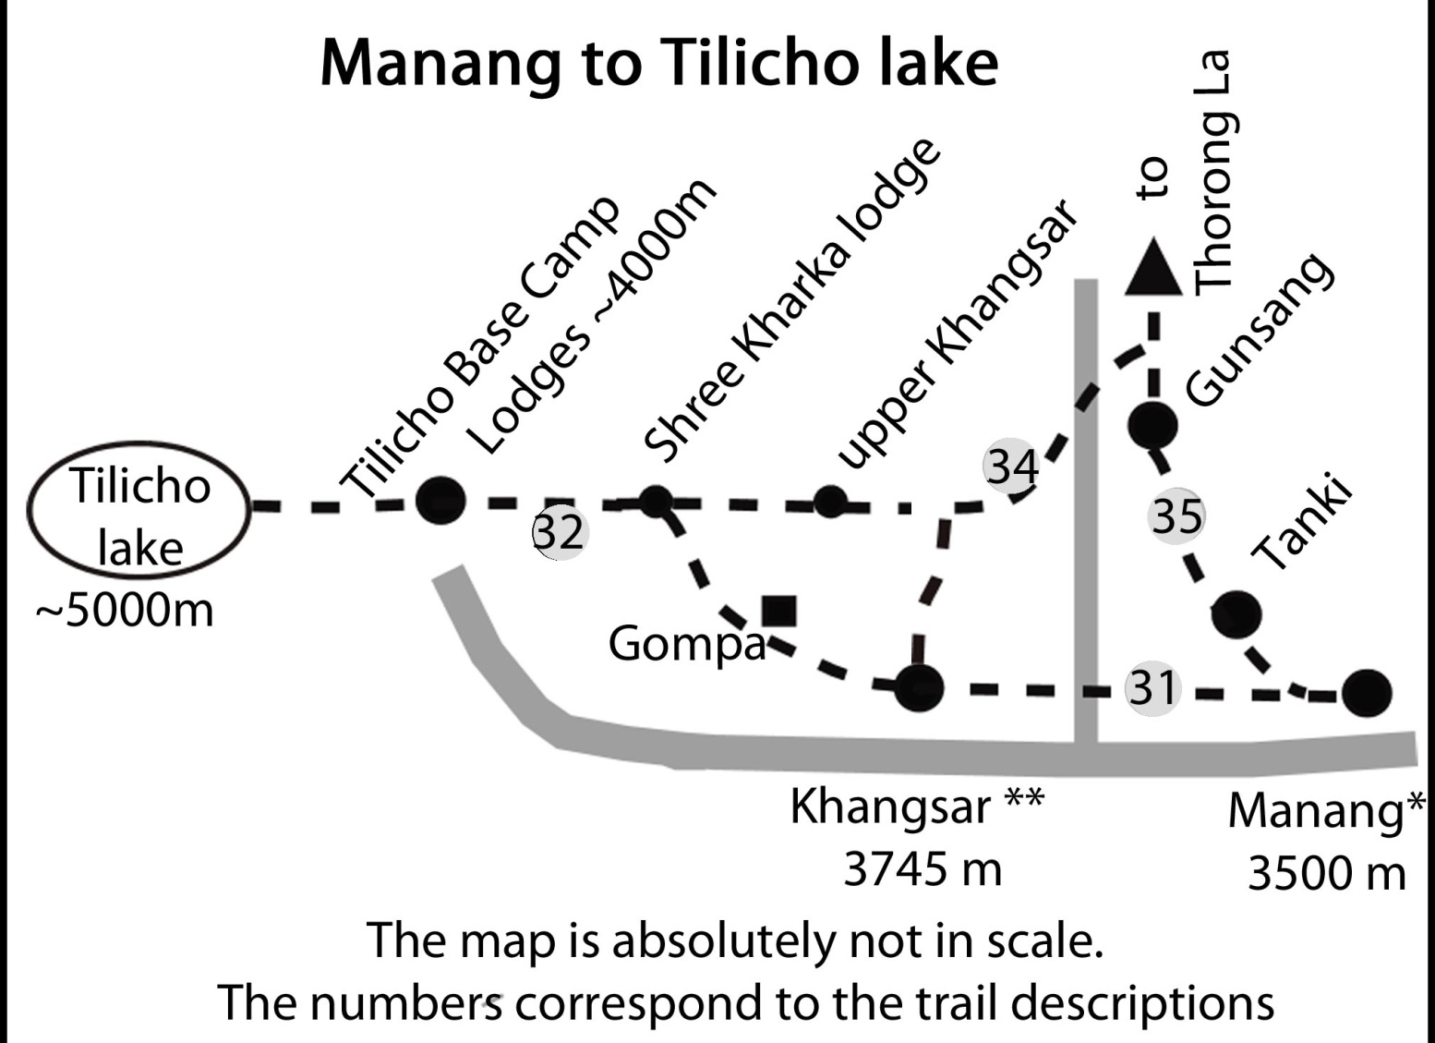
Map : Manang to Khangsar and Tilicho Lake

30. Side Trek to Khangsar, Grande Barriere and Tilicho Tal (Lake)
Tilicho Lake is one of the best experiences in this area. It is a magic place with the blue lake at around 5000m and the huge rock wall of Tilicho peak just above it. Even the sight of the enormous “Grande Barriere” is unforgettable. If you don’t want to all the way to Tilicho Lake, a side trek to Khangsar is highly recommended. Khangsar is a beautiful old village and there is a direct trail going up to Yak Kharka. So you might choose to stay the second night in Khangsar and even gain better acclimatization as it is 200 m higher than Manang.

Manang to Khangsar 2 hours: Take the trail going to Thorong La west. Around 200 m after the end of the Manang village you will pass a little prayer wheel wall. Turn to the left here (you will notice two blue/white marks at the beginning of the trail). Follow the trail going west and cross the bridge over the Thorung Khola, which comes directly from Thorung Phedi. Climb up the hill and you will reach Khangsar and its entrance chorten.

Khangsar **(3745 m): There are now several lodges in Khangsar. Khangsar is a very traditional old village and a highlight of this area.

The “Grande Barriere” ***: This huge rock wall stretching from Khangsar Khang (Roc Noir) was named Grand Barriere by Maurice Herzog in their attempt to find a way to climb Annapurna in 1950. Lacking a good map of the area in those pre-Google years, Herzog relied on the Indian military map where it looked as if there was a possible way from Tilicho Lake to the north side of Annapurna I. So he and a companion went up to Tilicho Lake. To their great disappointment they realized seeing the Grande Barriere that there was no possibility at all to pass this tremendous icy rock wall. They then went down to Manang, hoping to get some food there, but the inhabitants were so poor that they could not sell any. So all but starving they had to return to Tilicho Lake and rejoin their expedition. The Grande Barriere is still an unbelievably huge, breathtaking view.
In 1960 King Mahendra visited Manang by helicopter and was so touched by the poverty of the villagers that he granted special privileges to them. They could import goods without paying the huge import taxes. So soon Manangis were travelling to Hong Kong and Bangkok and Singapore and most of them became rich traders. Most of them live now in Kathmandu.

31. Going directly from Khangsar to Yak Kharka:

From Khangsar you don’t have to go back to Manang as there is a direct trail towards Thorung La. Sometimes the little bridge over Thorung Khola is destroyed by monsoon floods, so ask in Khangsar if it is passable before starting.

A) Going directly from Khangsar: 4-5 hours. If you started in Manang in the early morning you can have lunch in Khangsar and continue that same day to Yak Kharka. In fact this is a very nice alternative to the way going directly by Gunsang. Ascend the hill at the little Gompa at the end of the village. After some climbing you will reach a trail and some little houses of upper Khangsar. Continue going up in an eastern direction and you will reach a perfect viewpoint overlooking the whole Marsyangdi valley with Manaslu at the end and your first view of Khatung Kang and Yakawa Kang, the mountains forming Thorong La.

At the viewpoint, look for the trail first going down more on the right (south) side, than one would expect. The trail will turn below the viewpoint in the direction of Thorung La. Go down through a birch forest and finally cross the Thorung Khola on a little wooden bridge, climb up and join the main trail leading up to Thorung La.

B) Going a longer side trek with perfect view of the Grande Barriere, 6 - 8 hours:
If you stayed the night in Khangsar you could take this longer but absolutely rewarding route. Take the trail going west to Tilicho Lake. First you will pass little Tare Gompa and have the feeling that you can almost touch the Grande Barriere. Continue climbing up the trail and you will reach a newly-built lodge. Have lunch here and then turn to the right to the west at the junction near the lodge. Following the trail, you will first pass a high village and then reach some houses of upper Khangsar. Continue until the viewpoint

Doing the AC clockwise, Thorung Phedi to Khangsar/Tilicho 5-7 hours: If you want to go to Tilicho Lake coming from Thorung Phedi, turn right down to the river after Yak Kharka on an area with a huge payer wheel wall and many prayer flags. You may already have seen the little bridge crossing Thorung Khola. Cross the river and climb up the other side of the valley. You will see the viewpoint. 20 - 30 min later you can either decide to descend to Khangsar or continue on the high route in direction of Tilicho Lake.

32. Going to Tilicho Lake ***
The side trek to Tilicho Lake will take a few additional days but it’s an unforgettable experience. With the new lodges it is also much easier than before. Before starting ask in Khangsar which lodges are open as they might be closed in the off-season. As the owners are from Khangsar they might even go with you to open it. There is a difficult part of the trail passing along a steep gravel slope above the river. On this part of the trail there is quite often heavy and very dangerous rock fall. It mainly starts when the sun is heating up the rocks above and increases greatly after mid-day. For safety reasons it is advisable to pass this area only in the early morning. This is now possible, thanks to the new lodge called Shree Kharka (3900m) between Khangsar and Tilicho Base Camp Lodge.

A possible schedule would be: Day 1: stay one night in Manang. Day 2: Manang – Khangsar – Shree Kharka. Day 3: Shree Kharka –Tilicho base camp lodge - Tilicho Lake – return to Tilicho base camp lodge - Day 4: Tilicho Base Camp Lodge –Yak Kharka. Weather may present a problem, since it is often stormy with cold winds in the afternoon at Tilicho lake.

The other possibility would be; Day 1: stay in Manang; Day 2: go to Khangsar; Day 3: start early from Khangsar to Tilicho Base Camp Lodge; Day 4: go up to Tilicho Lake and have a wonderful day and return to Tilicho Base Camp Lodge. Day 5: start early in the morning and go directly to Yak Kharka or Churi Ledar. After being at Tilicho Lake you will be able to walk over Thorung La perfectly acclimatized and whistling a little tune!

Going from the new Shree Kharka lodge to Tilicho base camp lodge, 2.5 hours: Follow the main trail. You will have to pass along a very steep gravel slope with amazing rock statues on it. And all the while you will have the breathtaking Grande Barriere before your eyes. Be careful about falling rocks and always keep some distance between one trekker and the next. If there are rocks falling it is easier to avoid them if there is space between the people. Once a fist-size rock fell just one meter behind a friend of mine; it could easily have killed him! After a while you turn around the hill and you see the two lodges of Tilicho Base Camp at 4000 m in marvellous surroundings with big glaciers coming from the Grande Barriere.

Tilicho Base Camp lodge to Tilicho Tal and back 4 hours: Walk up the big side moraine. Tilicho Lake freezes in December/January and will be frozen over till April – mid-May. It’s an absolutely magical place. Be prepared for the very cold winds and storms in the afternoon so bring sufficient warm clothes with you.

On the Nepalese maps, you will see a trail going around the lake, very often on the south side below the Tilicho peak and on the north side along the lakeshore. This is absolute nonsense, since the south shore is directly exposed to the many avalanches coming down from Tilicho Peak and on the northwest shore the cliffs are reaching right into the lake.

33. Crossing Tilicho Lake to Jomsom
This is a full expedition and you will need a tent, stove and food, at least two nights of camping is required. After reaching the lake you will first have to walk around high above the big rocky hill on the north side as you cannot pass along the shore. There is a pass (altitude 5099m) which needs to be crossed just to get around the hill. There are two passes giving access to the Kali Gandaki valley. One is the Mesokanto La, marked iShree Kharka lodge (3745m)3600m393900Yak Kharkan all the maps but fairly difficult. The ACAP has also put up a signpost. Prem Rai crossed this pass in 2011 and found it difficult and dangerous. The trail down to Kali Gandaki follows the south side of the valley passing an abandoned army camp. The other “Tourist Pass” Mesokanto north at 5300 m is further north/east and much easier; the trail from here leads down the north side of the valley to Thini (Thinigaon). Have a look to my website www.nepal-dia.de to find a more detailed description and a map.

34. Going from the new Shree Kharka Lodge to Thorung La
Instead of going down again to Khangsar just continue straight on the same level. You will pass the summer village of upper Khangsar and later some yak houses till you reach the viewpoint. At the viewpoint, look for the trail first going down more on the right (south) side, than one would expect. The trail will turn below the viewpoint in the direction of Thorung La. Go down through a birch forest and finally cross the Thorung Khola on a little wooden bridge, then climb up and join the main trail leading up to Thorung La.

Crossing Thorung La & the Dangers of Acute Mountain Sickness:
Trekking in Nepal can take you to altitudes where the body needs to make many physiological adjustments. Above 3500 m not only oxygen but also CO2 will diminish and therefore one not only has to breathe faster and deeper, but also the acidity of the blood has to be regulated and there is even an impact on the cell membranes. This adaptation will take several days and if you climb up too fast your body might have not enough time to adjust. This can lead to very serious and sometimes deadly problems. In my view, it is totally irresponsible to spoil a vacation just because one neglects to follow some well-known precautions. As written above, Acute Mountain Sickness (AMS) is caused by physiological responses and not by a lack of fitness. Super-fit people may even have an increased risk as they are inclined to go up faster and are used to suffering to achieve their goals.

Planning: Be aware that you will have to trek slower that your legs are willing to go. The general rule is that after reaching 3000m one should not sleep more than 500 m higher than the night before. My experience is that you can sleep up to 700 m higher for one night but you should not do it on consecutive days. It is essential to have more than one day above 3500 m before starting the ascent of the valley leading to Thorung La. If you plan to do the AC clockwise, acclimatization is even harder as Muktinath is still below 4000 m. In this case you should plan to spend at least 3 nights there. I have seen many very sick people who had climbed too fast. Planning a schedule with enough time for acclimatization is the most important thing for ensuring a successful and enjoyable trekking tour.

In Kathmandu: Buy some tablets of the emergency drugs Dexamethasone and Nifedifin. They are amazingly cheap and could help a lot if you have serious acclimatization problems. Diamox is useful as it helps you sleep better but it will not help you if you are in serious trouble.
What is normal at higher altitudes? When you reach above 3000 m you will realise that you are out of breath faster and are walking more slowly. By the next morning you will already be stronger. So day by day your body adapts itself to the higher altitude. At night you will sleep much lighter, sometimes being awake for hours. But the next morning you will be rather well-rested. Sometimes it will take you 2-3 days to have a good sleep. But on the way down you will sleep like a log. It is also common that you wake up in the middle of the night, gasping for air and with your heart beating like a heavy metal drummer. Don’t panic, it’s just the breathing regulation which was not yet perfectly adapted during the sleep when you normally breathe more slowly. Soon you will be OK. Light headaches also often occur and one may notice that fingers or even the face is slightly swollen.

AMS or Acute Mountain Sickness: symptoms are light headache, loss of appetite and light nausea. Realise that this could be the beginning of much more severe symptoms. Stop going up or have a rest day till that you feel better. If you have stronger headache or nausea you even should go back to the last place where you felt fine. Diamox may help you as it speeds up the acclimatization process.

HACE High Altitude Cerebral Oedema: Your brain is floating in a liquid, which is permanently produced and drained away. As an effect of bad adaptation brain cells will hold more liquids, which leads to a higher pressure in the skull. This in consequence leads to a poorer supply of oxygenated blood and your brain will not work properly any more. The symptoms are a strong headache, loss of balance, vomiting and possible sight or hearing problems. People sometimes behave like they are badly drunk. This includes a refusal to accept at all that they have a problem.

As soon as you are not able to walk a straight line properly anymore, you have a serious problem. It might just take another half- hour for you not to be able to walk by yourself at all. The only cure is to descend as fast as possible. Do not continue. The emergency drug Dexamethasone (initial dose 8 mg then 4 mg every 6 hours) can have a dramatic positive effect helping you to go down on your own. Sometime people feel completely relieved, but this effect is dangerous and deceptive as Dexamethasone does not help with acclimatization. If you are just below Thorong La, you might be tempted to cross it as the descent is much faster on the other side. However, go back down and give your body the time it needs at lower altitude. I have met people who had to turn back from Thorong La because of horrible headaches and vomiting and could cross it the next day without any problems! Don’t spoil one of the best experiences in your life by pushing too fast.

HAPE High Altitude Pulmonary Oedema: As fetus, you didn’t need strong blood circulation in your lungs. As an energy-saving measure, the pulmonary circulation is minimized by tightening the pulmonary blood vessels. Unfortunately the responsible sensors remain and suddenly think because of low oxygen/CO2 levels in your blood that you are again unborn and tighten once more the pulmonary blood vessels. Your heart will be still able to pump the blood into the lungs but the exit is too tight so the blood will fill up the lung. The effect is disastrous: The lung membrane will swell and the oxygen exchange will be diminished. There will be less oxygenated blood going to your body and the vessels get even more tightened. At the end, the pressure in the lung is so high that liquid is infiltrating the lung. Main symptoms: in the beginning you feel weak and slow and out of breath. The problem is that these symptoms are absolutely normal at high altitude; you might have HAPE if the symptoms get worse even after you have rested for 10 min. In this case you must immediately descend without hesitation. An initial 20 mg dose of Nifedipine can be helpful but it does not help with the acclimatization. You must go down to a lower altitude.

Summary: The most important precaution is to allow your body to adapt to altitude. If you are in distress because of severe symptoms of HACE and HAPE, the emergency drugs Dexamethasone and Nifedipine can help you to descend immediately on you own. If you have strong symptoms but are not sure what type of altitude sickness it is you might take the so called Margarita cocktail (8 mg Dexamethasone, 20 mg Nifedipine and a tablet of Diamox which was developed at the Swiss altitude Research Station in the Margarita mountain Shelter. In any case, going down is the only real and safe cure!

35. Manang to Thorong Phedi or high camp
Plan 2 days because of the need for proper altitude acclimatization. Even when it is possible to reach Thorong Phedi from Manang in a long day, you should absolutely pass one night either in Yak Karkha or Churi Ledar and a second night in Thorong Phedi or high camp. Otherwise you might have a higher chance of altitude problems

Map: Manang to Thorung la

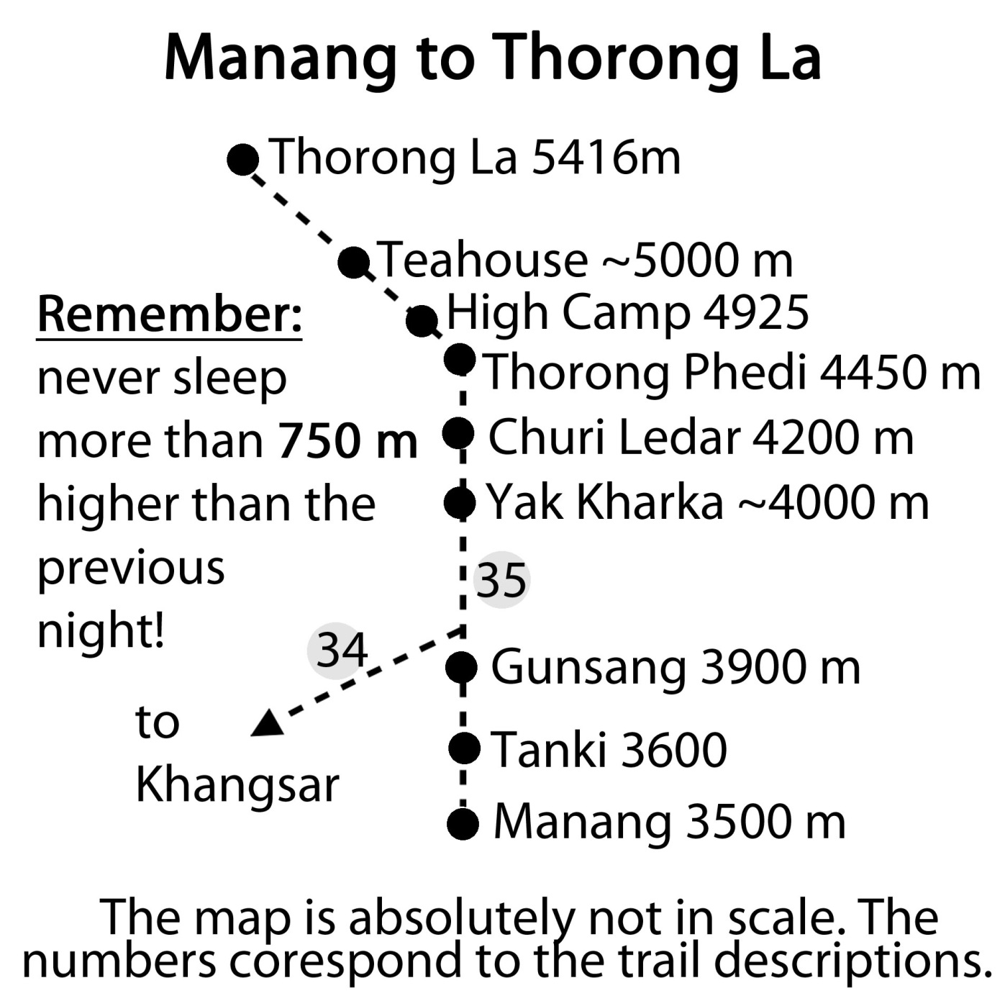

Manang to Yak Kharka or Churi Ledar 5 - 6 hours: Walk through the village of Manang to the western end. The trail is clearly visible and on the hill you see a big new white stupa and the upper village of Tanki Manang. Descend till the Mani wall; here the trail to Khangsar turns to the left (there is just one blue/white mark at the beginning). Continue going uphill following the red /white marks and go through the village of Tanki Manang, which has one lodge. Continue on the very clear trail till you reach the two lodges of Gunsang (3900m). After Gunsang cross the bridge and continue. You will reach a shelter and an area with big stupas and a big Mani wall. Here the upper trail coming directly from Khangsar rejoins the main trail, so that you could also easily come from Khangsar to Yak Kharka or Churi Ledar in one day.

From Gunsang to the next settlement of Yak Kharka you will need around 2 hours. Yak Kharka (~4000m) has 5 big lodges, with the first 4450 m mand the last one being separated by a 25 min. walk. The other three lodges are in the middle part. It will take you another 40 min to Churi Ledar (4200m). Here you will find only two lodges and a teashop. For people who have absolutely no problems with altitude-related symptoms it makes sense to continue to Churi Ledar (instead of stopping for the night at Yak Kharka) as they will sleep 200 m higher. This makes the next day to Thorong High Camp (4830m) an easier one. Instead of an 830 m altitude gain from Yak Kharka, you would only gain 630 m, which is much closer to the recommended maximum 500 - 600m per night.

If you stayed in Yak Kharka, it would be best if you stay the next night in Thorong Phedi at an altitude of 4450 m. If you have come by the high route via Ngawal and stayed one night in Braka/Manang and one night in Khangsar, you can go to Churi Ledar and should not have any problems.

Churi Ledar to Thorung Phedi 2 hours red/white marks: Just go up the trail (red /white NATT marks) with some up and downs above the river till you see a trail on the other side of the river. At the junction choose the left trail with the NATT signs; the right one will stay on the same side of the river, climb high above Thorong Phedi to descend in a dangerous or risky path. It was built several years ago to avoid the dangerous landslide area on the other side, but then it was realized there were many more serious accidents on this new trail they switched back to the old one.

Soon you will see a suspension bridge. Even when the main trail seems to continue straight on, take the trail left leading down to the first suspension bridge. On the old trail you would have to descend to the wooden bridge through a slippery landslide area with frequent and dangerous stone fall.

Cross the river and climb the trail passing by two little teashops. From here you can already see at the end of the valley the houses of Thorong Phedi. About 20 minutes after the teahouse you will have to cross for 15 min a landside and stone fall area, which begins after the signpost. This is really a very dangerous stretch and several people have been injured here by falling stones and a least one person has been killed.

I'd recommend, therefore, that you be very cautious and alert while crossing the danger zone! Always look and listen for potential rockfall. As a second and important safety measure you should keep at least a distance of 20, or better yet, 30 meters between each person. In this way it is much easier to quickly find shelter or a safe place behind a rock. And if someone is hit the rest of the group can help the victim.
After this landslide stretch the trail continues at about the similar level for 15 min until you reach the two lodges of Thorong Phedi at 4550m. In 1981 there was not even one single shelter between Manang and Muktinath. At Thorong Phedi there was just a little shelter for shepherds with only half a roof left as someone had taken away a part of the roof for firewood. Recognizing a business opportunity, this situation prompted a visionary local named Michung Gurung to build a small lodge. In time it grew into a full complex of sleeping rooms with a huge dining hall.

Thorong Phedi 4450 m
A second lodge is now at the same location. In the high trekking season they even make such delicious things as cinnamon rolls. As many people leave as early as 2 a.m., the lodge will ask that you settle your bill right after dinner.

While many groups set off between 2 and 5 a.m., this is not really necessary. You can easily cross Thorong La even when you start at around 6 am. Especially in the winter months, starting too early can be very dangerous as it is still very cold and the risk of frost injuries (frostbite) is high before 5 a.m. A German trekker I met one December left the lodge at 2 a.m. with an organised group. On the way up to Thorong La he realized that he had cold feet but later in Muktinath he had swollen feet like an elephant and both were frozen! Fortunately after a few days in a Kathmandu hospital bed, he recovered but it was 6 weeks before he could wear his normal shoes.

Climbing up to High Camp 4925m:
It’s a hard climb up and it takes around 1-1.5 hours. All the lodges in High camp are now owned by one landlord. Unless one is well acclimatized it is not recommended to stay here for the night, as the possibility of developing AMS is higher than when staying at Thorong Phedi. Behind the lodge there is a long ridge with an awesome view at the top. Not only you can see Thorong Phedi deep below the rock wall, but you have a perfect view on the Chulus, the Annapurna Range and on the very right corner of the panorama you can even see Annapurna I. It will take you 20 min to go up and return.

36. From High Camp over Thorong La to Muktinath 6-10 hours: The trail climbs gently behind High Camp and after around 25 min you will reach a little iron bridge. Look to your left side to the mountain; nearby you will see a glacier coming down. After the bridge you have to climb a ridge, on the top of which you can see also Annapurna II. 25 min after the bridge you will come to a teahouse situated at about 5000 m. From there the trail continues steadily, but not steeply going up in seemingly endless turns. The trail up is marked with several black poles. Many times you think that you are already near to top of the pass, as you only see blue sky in front of you. But there are many false passes to fool you. I counted 14 during one crossing I did! Finally you will see some prayer flags and, shortly afterwards, piles of stones with many colourful prayer flags. You are there! . Watch as the wind blows the prayers off the flags and into the world from this high spot! Most people will have a photo taken of themselves and the brass plate with “Thorong La at 5416 m” written on it. Buddhists will throw a stone on the pile and shout “la so so” thanking the gods that they allowed a safe passage.

There is a little teahouse at the pass selling tea or noodle soup and even dal bhat. (Beware – even noodle soup may take 45 minutes to prepare!) Allow yourself at least 30 min at the Thorong La as it is a wonderful place to enjoy your achievement. In any case, you want to have some pictures from this vantage point.

The descent to Muktinath is long and exhausting. The trail is now very clear and marked with black poles. It descends on barren dry and rocky terrain. Be especially cautious in the cold winter months. The afternoon sun will melt the surface snow and ice on the western slope. When it freezes again overnight, you have very slippery ice sheets in places so a fall or two can be expected. I once slipped seven times during a single descent in December and afterwards had a pretty coloured bum :-( .

Descending on the left side you will once see the trail apparently continuing very clearly on a ridge to the middle. In reality the trail makes a sharp turn to the left slopes. The new red/white markings should help people to avoid this ridge trail. As everyone who takes the wrong path has to return the same way, it looks very used, and many people have lost a lot of time, trying in vain to find a way down directly from the ridge.
Descending you will reach a big pasture making a perfect camping site around 4700m with a new water fountain and some 50m lower another pasture with some ruins. After these pastures the trail descends in sharp turns steeply down to the five teahouses at around 4200 m. They offer also some basic accommodation which is highly recommended if you are crossing Thorong La from the Muktinath side. Spending a night here will help you for acclimatization.

A new big road is built just nearby. I was told that some rich man from Taiwan was very sick on Thorong La and later gave a large sum of money to have this road built to facilitate faster rescue. A better solution would have been to take enough time for acclimatization. Fortunately their project was stopped later by the ACAP. From the teahouses, it is another long hour and a half walk through pastures till you finally reach the temple area of Muktinath.

Your lodge will be another 15-30 minutes further in the lodge settlement of Ranipauwa, depending on the section of Ranipauwa in which it is situated. In the centre of Ranipauwa there is a big old pilgrims’ house where the police checkpoint is now located; you will have your ACAP permit checked here. Just before the ACAP Centre you’ll find the safe drinking water station and the ACAP Information Centre.

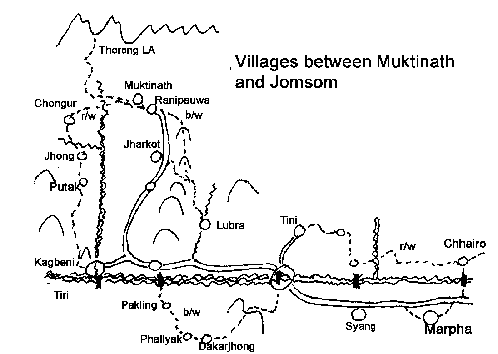
The trails on the Jomsom Side:

39. Muktinath ***
Muktinath has been a pilgrim site for about 3000 years. There are two main reasons. Firstly, from a small earth fissure water and natural gas pours out, the latter burning in a little flame. On this site all the four elements - earth, water, air and fire - are united in a natural way. You can listen to the gurgling water and see the tiny little flame still in the Dhola Mebar temple***. Secondly, many ammonites (called saligrams or salagrams by the locals) are found in the Mustang region. They are already described in the Hindu Vedic texts and are not seen as stones, but rather as a true and direct manifestation of the Hindu god Vishnu himself.

The temple area of Muktinath ***
The whole area is now surrounded by a big white wall. Coming from Ranipauwa you will pass the red arch and climb to the main gate of the temple area. Like many temples in Nepal, Buddhists and Hindus share the area and even many temples.

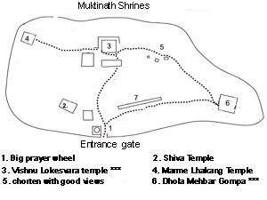
Just after the gate you pass by a huge prayer wheel (1). Ascend the path passing by at some little temples. In a small stand of trees you will reach the famous Vishnu Lokhesvara temple, donated by Queen Subarna Prabha in the 18th century. She also donated the big pilgrims’ house which gave the name Ranipauwa (Queen’s Pilgrim’s house) to the village.

The main purpose of the many Indian pilgrims, many coming from as far as south India, is to bathe in the two pools near the temple. They will also walk past the 108 holy fountains behind the temple(?) and often take some holy water back home in plastic bottles. The temple area inside the wall is restricted to Hindus and you are not allowed to take photos inside the shrine.

The Indian pilgrims are an experience in itself and worth seeing. They fly to Jomsom, often stay there first night, and then drive the next morning by jeep to the parking lot on the outskirts of Ranipauwa. After walking to the Muktinath shrines, many of them will be so tired that they choose to drive back on a motorcycle to the parking place. As a result there is a lot of motorcycle traffic in the morning. Many of the young guys of Ranipauwa make a fortune driving the Indian ladies back.
From the Vishnu temple go to the south to visit the Dhola Mebar Gompa with the eternal flame. In fact, don’t be disappointed when you see it, since it is just a very little bluish flame like that of a dying lighter. Not only Buddhist pilgrims come here to pray but also Hindus. Listen to the gargling soft sounds of the water mixed together - if you are lucky- with the prayers of the nuns. There are three more temples in the area, but for most people Vishnu Lokhesvara and Dhola Mebar Temple will be the main interest. No one should miss these two exceptional places.

Ranipauwa ~3770 m
ACAP and Police checkpoint, Safe water drinking station
Queen SubarnaPrabha also donated at the same time as the Vishnu temple the big pilgrim house which gave the name Ranipauwa (= Queen’s Pilgrim’s house) to the village. Actually it is a fast growing lodge settlement with many new big lodges under construction.
As already mentioned, the police check post is inside the old pilgrim house and the ACAP office is just before it. There are many lodges in Ranipauwa. In the last 25 years I have stayed in 5 different lodges and have all to be quite acceptable. So it does not make sense to recommend a particular one. Ranipauwa is stretched out over a kilometre and during the day many local women will on the edge of the main street weaving colourful scarfs with their traditional looms for the tourists. Besides some souvenir stalls there is not very much to see in Ranipauwa apart from the great views of Dhaulagiri.

Map: Treks around Muktinath

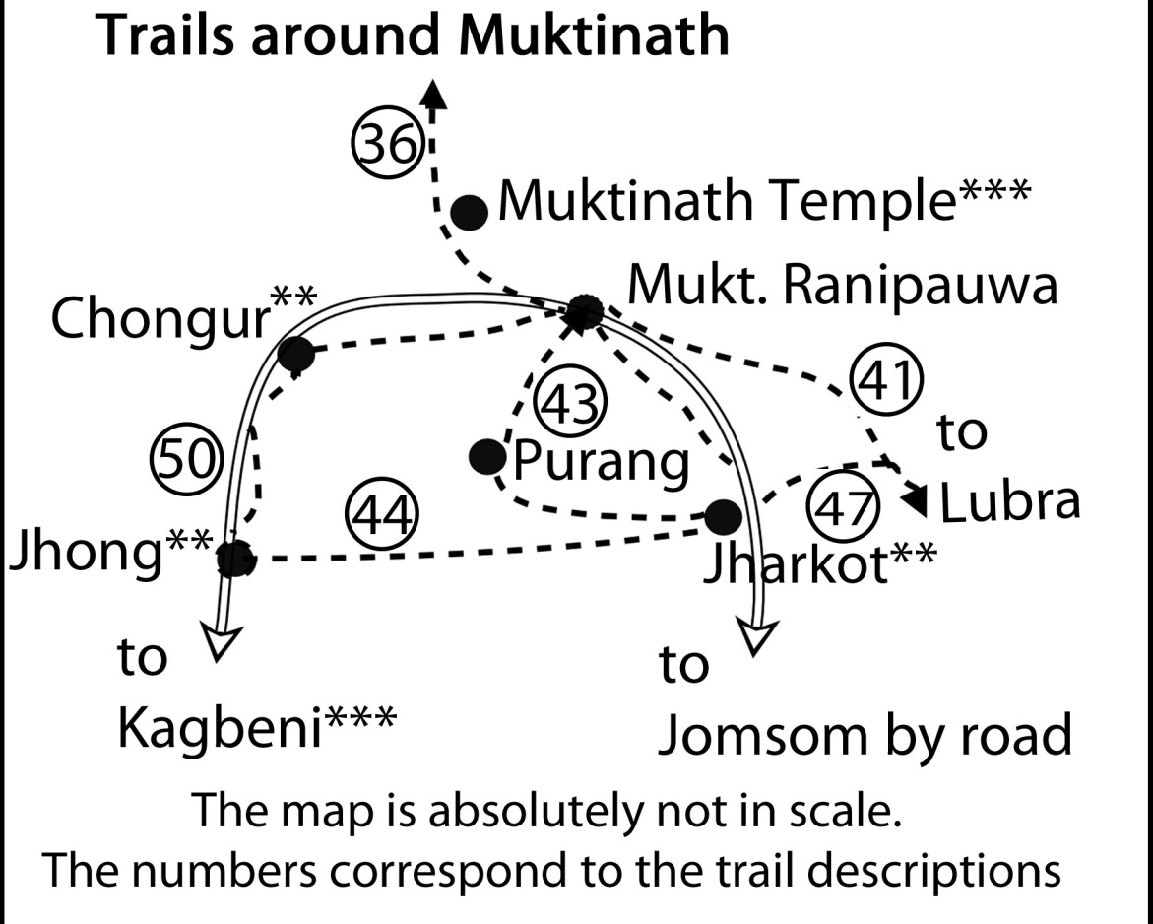

40. Muktinath-Ranipauwa to Jomsom
From Ranipauwa you have a number of possibilities as you continue:
you could take a Jeep to Jomsom; walk along the road to Jharkot , Khingshar and then Jomsom or Kagbeni; walk to Lubra and then to Jomsom *; walk to Jharkot and from there over Lubra to Jomsom **; or take the northern trail to Chongur-Dzong to Kagbeni ***

1. Going from Ranipauwa to Jomsom by Jeep: At the end of Ranipauwa you will find the jeep parking lot and the counter for the ride to Jomsom. The first ride is at 9 a.m.; normally there should also be one at noon and one at 4 p.m. But this might change depending on the season. I’m rather sure that one can get a ride till the afternoon but I cannot guarantee it. In 2011 the ride was 200 Rupees. The jeep will be packed completely full so you might feel like you are in a sardine can even though you are in the Himalayas.

41. Trek Ranipauwa to Lubra (Lupra) and Jomsom:
Marked with blue/white signs, 5-6 hours.
Go to the jeep parking lot and follow the road for about 150 m. Turn left at the sign post indicating Lubra. You can already see the trail going up the hill in the direction of Lubra. The trail climbs gently through large pastures and is easy to follow. On the higher section it offers splendid views of the valley and the villages. Reaching the ridge, the trail continues just a little below it. Soon you will reach a point, where you have a superb view towards Lupra village and the mountains, including Dhaulagiri.

Lubra Pass to Lubra: On the pass, there is a stone pile and nice views of the Muktinath valley can be had. You can also climb up to a viewpoint marked with a stone pile and prayers flags but it does not really offer a much better view than from the pass itself. Once, on continuing on the ridge, I had hoped I would have a panoramic view of the whole Kali Gandaki valley but returned unsuccessfully after an hour. From the pass turn left to the wide visible trail going down south to Lubra. The trail will turn right after passing a big apple orchard and descend to the river. When you reach the river, you can already see the trees and fields of Lubra on the other side. There is actually no big bridge over the river, so it might be impossible to cross it during monsoon season. Cross the river and you will see a beautiful red chorten in the attractive village of Lubra.

Walk to Jharkot and from there over Lubra to Jomsom ** 6-7 hours. If you have some interest in the Mustang culture the little detour and visit of Jharkot is highly recommended. It will take you about one hour longer, as you first descend 200 m, which you will have to climb again on the way to Lubra Pass.

Walk to Kagbeni, then to Jomsom. There are several possible ways to go to Kagbeni, with one going via Jharkot and Khingsar is now a dusty dirt road. For a few years now trekkers are officially allowed to walk on the north side of the valley avoiding the road and passes through an awesome Tibetan-style village. This route is preferred, and outlined below. There is also a new scenic route from Kagbeni to Jomsom, which goes high on the west side of the Kali Gandaki River.

42. A wonderful day trip to the villages of the Muktinath area.
Muktinath/Ranipauwa & Temple – Chongur - Jhong - Jharkot - Muktinath
If you are not going to Kagbeni this day, a day-long circuit gives you an excellent opportunity to see most of the very interesting Tibetan-style villages. You start in Muktinath/Ranipauwa with visit a visit of the temple area of Muktinath. Then go to colorful Chongur and Jhong. From Jhong you can take the trail to Jharkot and return to Muktinath. You can start this trip from any one of the villages. The next day you can continue directly to Lubra and Jomsom or take a jeep.
If you are planning to go to Kagbeni I would suggest that you spend the day after crossing Thorung La with a rather easy half-day trip. After visiting the temple area of Muktinath, you can do the round trip to Purang and Jharkot in the morning and, after good lunch back in Muktinath, continue in the afternoon to Jhong to stay there the night. This would enable you to reach Kagbeni around midday the next day with some wonderful memories of the Tibetan style villages.

43. Daytrip – Muktinath/Ranipauwa& temple – Purang – Jharkot – Muktinath
Go down to the new but very beautiful nunnery Choling Gompa at the northern end of Ranipauwa. On the lower part of the premises there is a door opening to a dirt road. Follow this road marked with the blue/white NATT signs for about 200 m and you will get to one of the best photo points of this area. It is a lake with a white chorten, some houses and in the background a snowy mountain range. Walk around the lake to the houses, which you will pass on the left side. Continue straight down till you reach the village of Purang. It's a beautiful village still in traditional genuine Mustang-style and so different than the touristy lodge villages like Ranipauwa.
Follow the blue/white signs to the lower end of the village and you will see soon the village of Jharkot with the ruins of an old fortress and the red gompa. So even if you miss the main trail, you will always find a path leading in the right direction. On the marked trail you will come to a gate with Jharkot and the Dhaulagiri in the background. Putting your head through the big hole in the door can make a very funny photo. The trail leads east to the upper end of Jharkot.

44. Muktinath Ranipauwa-Chongur-Jhong to Jharkot (4-6 hrs.) Round trip back to Muktinath
This side trail leads you to Jharkot for a round trip or if you want continue with a jeep ride directly to Jomsom. Begin this beautiful trek by following the northern trek to Kagbeni via Chongur to Jhong (see trail description 50)
The blue/white marked NATT trail begins near the Stupa at the beginning of the long prayer wheel wall and just below the trail going up to the monastery. Descend into the little forest and follow the trail which soon will be in the open again just below the slopes of the monastery hill.
It then descends in serpentine fashion to a steel bridge. After the bridge turn left and after around 100 m turn right onto the trail going up beside a long wall protecting the fields from wild animals. Continue on this trail till you pass a little gate. Since you can already see Jharkot in the distance you will easily find a way to reach it and it doesn't matter much which path follow. Don’t miss the chance to make a tour of the beautiful village of Jharkot.

Jharkot **
This beautiful and interesting traditional village is situated 200 m below Ranipauwa. In the old days a huge fort stood in the middle of the village, but now only some ruins remain. Coming down from Ranipauwa you see the village stretched out on a ridge, which extends into the main valley. Take the direct trail straight at the end of the Ranipauwa near the jeep parking lot and descend. When you reach Jharkot cross a little meadow and enter the village on the left side. You will soon come to a long prayer wheel wall. Remember to pass on the left side! Next up is a beautiful old stupa. Many trekkers just
bypass this extraordinary beautiful village, probably because they just started 20 min earlier, but they miss a very interesting place. Take about 20 min for a sightseeing tour and you will not regret it!

Map: Jharkot

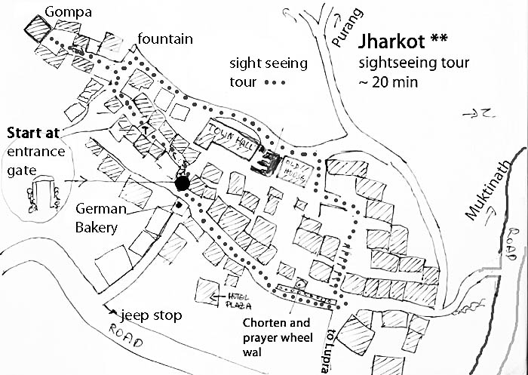

45. The Jharkot sightseeing tour ** with blue marks
Pass the long prayer wheel wall and continue on this lane till the main trail which goes down to the left at the German bakery. Continue straight for about 20 m and then turn right to the entrance arch and the two protector statues which clearly are recognizable as a man and a woman ;-). Pass the arch and then turn to the left another ~20 m later into a sort of tunnel below the houses. Continue after the tunnel for ~100m and though a second tunnel beside the white houses of Jharkot. Sometimes you will see a protecting ghost trap. Bad spirits don’t like right angels and the ghost traps are made with many wool threads wound up exactly in this way so they will not dare to come near this door or harm the inhabitants. After a while the lane turns up to the right and after a few houses a lane leads to the left to the monastery of Jharkot. This Gompa is absolutely worth a visit. It is perched at the end of the Jharkot ridge and is a landmark in the Muktinath valley. After visiting the gompa go back to the main lane and turn left and walk up to the fountain.
Follow the trail on the north side of the village with a beautiful view of the Muktinath valley. In a side lane you will find the house of the amchi, a Buddhist doctor who used to practice in the gompa. Buddhist amchis are excellent at treating colds with local plants and medicines! His treatment was much more effective than the Strepsils I had used when I had a bad sore throat and the pain disappeared within 30 min. Pass the village on the north side below the houses. You will come to a sizable new wall supporting the newly-built village hall. Soon you will see a lane going up to the right. Take this lane and you will reach the central part of old Jharkot with its old flat-roofed houses. Continue finding a way a little bit on the left side and you will descend down to the main trail which you join near the prayer wheel wall.
Taking a jeep from Jharkot to Kagbeni or Jomsom:
Jeeps will only leave from Ranipauwa as soon as they are completely full so it will be difficult to get a seat in one of the later villages. It is therefore advisable ask some restaurant owner to make a phone call and a reservation for you. The jeeps will then pick you up about 100 m below the German bakery on the main road.

46.From Jharkot to Ranipauwa/Muktinath by Purang
Go to the upper eastern end of Jharkot and turn to the left at the corner. Then go down to the fields. The trail straight down leads to Jhong. The trail to Purang and Ranipauwa is a little bit difficult to see. Go up a little bit to the right till you see the gate. The trail is then marked with blue/white signs to Purang and later to the Choling Nunnery just below Ranipauwa.

47. Jharkot to Lubra(With Blue /White NATT signs till Lubra Pass): You can see the trail going up to Lubra Pass from Jharkot on the opposite hillside. The trail going to Lubra starts at the beginning of the big prayer wheel wall and turns at the fountain to the left (south). Follow the general direction. Pass by some houses and you will reach a road but leave it again after about 40 meters. Continue in the same general direction. The trail passes through fields and pastures. On the right you will see a little village with four houses. Finally you come to a large pasture where you just follow the electric lines till you reach some former governmental bungalows. Continue here to a door in a stone wall which surrounds the fields. After the door go along the wall on the outer side till you are under a little white stupa. Continue for ~ 50 m till you see the trail going up diagonal on the left. This trail leads up to the Lupra Pass. Lubra Pass to Lupra: see section 2) on previous page.
Lubra ** (also Lupra)
This picturesque little village is of special interest as it has a Bonpa Monastery. The Bon religion was the ancient religion of Tibet and greatly influenced the development of Tibetan Buddhism, especially with its many shamanistic traditions. At the same time Tibetan Buddhist philosophy also influenced the Bon religion. Even when Tibetan Buddhism was the state religion in Tibet, the practice of Bon continued. In 1977 the Bon Religion was recognized by the Dalai Lama as a regular line of Buddhism. There is one visible difference: while members of the other Tibetan Buddhist sects always turn the prayer wheels clockwise, the Bonpa do it counter-clockwise.
The Gompa of Lubra is absolutely worth visiting. Ask in the village for the person who has the keys and don’t forget to leave a donation and a tip. Typical for Bonpa is the use of blue colour so many of the statues have blue hats. This is the only Bon Gompa in this region but further up in the Dolpo region Bonpa is dominant. Dolpo is probably the most authentic Bon area since the Chinese invasion of Tibet and the destruction of Buddhist and Bon monasteries and the killing of many monks and nuns.
Lubra is a very small village so you can explore it in a few minutes. The hillside consists of coarse-grained absolutely black sand. You might climb up the hill to a new little temple but it is a tough ascent and I would not do it a second time.

Lubra to Jomsom 2 hours: Walk around 45 min along the riverbed till you reach the main Kali Gandaki Valley. In the afternoon you will have a strong wind blowing sand and little pebbles right into your face.

50. Ranipauwa and the northern trail to Kagbeni *** 5-7 hours, red/white NATT marks: This trail is one of the highlights of the AC and one of my favourite days and areas. If there is a possibility to do it you should! The trail on the northern side of the Muktinath valley offers awesome views of the Nilgiri and Dhaulagiri mountain ranges and YES, you can see perfectly the Thorong La on the way!!! This beautiful trail passes through the very nice Tibetan-style villages of Chongur, Jhong and Putak. Although it follows for quite some way a little dirt road, it doesn’t matter really, as this road is barely used, with perhaps 5-10 vehicles in a whole day. This road is often blocked by a landslide and then it is only for you.
The trail to Kagbeni starts just below the red arch, marking the way to the Muktinath Gompa in Ranipauwa and goes first to Chongur, a village which you can already see from Ranipauwa. On the ACAP signposts it is written as Tyonkhar but all the local people definitively call it Chongur.
Follow the trail to the little micro-electric power station, which used to produce the electricity for Muktinath Ranipauwa, which is now supplied by the Kali Gandaki grid. Continue till the road and cross the river on a bridge. Follow the road around~200m till the road turns to the right and a large foot trail continues straight to the beautiful village of Chongur.

Chongur **:
Directly on the edge of Chongur there is a beautiful Gompa**. Ask around if someone has a key, if you would like to visit. The Gompa was founded by a Sakia monk and the whole village is painted with the colours of Sakia, giving it a very particular and beautiful atmosphere.
Continue through this picturesque village and turn to the right at the end of the village round a Mani wall. Follow the signpost and climb up. After turning on the top to the left you come to a viewpoint with chorten and you can already see the bridge below.
Cross the bridge and join the road. It will lead you past a grey house, which is the school of Jhong.

Jhong ** (also Dzong):You will enter Jhong by the north east. Descend the main road lined with several Mani walls and chorten. Right at the beginning on the left is Dhakpochhe Tashiling Guest House and Restaurant, one of the two lodges. It has 8 beds; if you want stay here, first check the mattresses, as the didi likes rather hard ones.
On the bottom turn to the right in the direction of the ruins of the former Jhong fortress which gave the village its name.
Before continuing to Kagbeni, climb up the trail going up to the famous monastery. First you will pass Jhong Viewpoint Top Guest House. From its dining hall you have a splendid view of Thorung La and the area around Muktinath. It also has a few rooms and the didi is very welcoming.
Up on the ridge, visit the Gompa. It is one of the few Gompas with live-in monks. Paying the entrance fee is absolutely worth it and the view from the roof is memorable. You have a surrounding view of Thorung La and its two peaks of Khatung and Yakawa Kang, Tilicho peak and the Nilgiri, Dhaulagiri, Tukuche peak and the mountains west of the valley.
Jhong ** to Putak*: To continue return to the road below the ruins and head down. After 20-30 min you will see the old village of Putak. Just before the village, take the small path going down near an electric pole. After the Mani wall continue above the village houses and then turn down left to enter into the village. On the main street turn right again and leave Putak through the western gate. The trail down is surrounded by trees and continues past fields.

Later the trail passes above a long wall protecting the fields of Putak. Take care, there is a junction where the main trail seems to continue down along the wall, but you will have to go a little up to the right. Around the turn you can already see the trail going up on the right hillside and a small suspension bridge overlooking a deep ravine, which you will cross.

Climb up the trail to a stone pile and you rejoin the road. Follow it for about two hours till you can see the Kali Gandaki River near Kagbeni. At the end of the ridge you can see a Stupa, which is one of the best scenic lookouts in the valley. Watch out for an electric pole with red/white marks and continue to the stupa. From there you have a breathtaking view over Kagbeni and the Kali Gandaki River and into Upper Mustang.

There are two possible trails leading down from the stupa to Kagbeni; both are a little bit difficult but not dangerous. One leads down on the right side of the stupa with a perfect view on the valley. The other one goes down through a narrow and spectacular gorge. Both ways join again above the road. Go down and take the shortcut to the northern end of Kagbeni and enter it along the long prayer wheel wall.
If you are very tired or don’t want to take any difficult trails, skip the detour to the stupa and just continue on the road till Kagbeni.

Notice: One is not allowed to go north of the Muktinath - Kagbeni trail, as it is the restricted area of upper Mustang. The fine against entering illegally to the restricted area can be very high.

My love - Kagbeni ***
2800m (safe water drinking station, ACAP office).
Kagbeni is an absolutely magical place and no one should miss the opportunity to see it. I have met many trekkers who first did not plan to go there and then decided to stay two days because it was so beautiful. It is my favourite village in the entire Annapurna region.
Kagbeni is situated at the confluence of the Jhong River and the Kali Gandaki River and used to control the trade to Upper Mustang and Tibet. You still can see this aspect in the old village centre, which looks rather like a fortress. Visiting it, you will feel like being in a medieval village as you pass through the narrow lanes or tunnels between old mud houses.
Map: Kagbeni

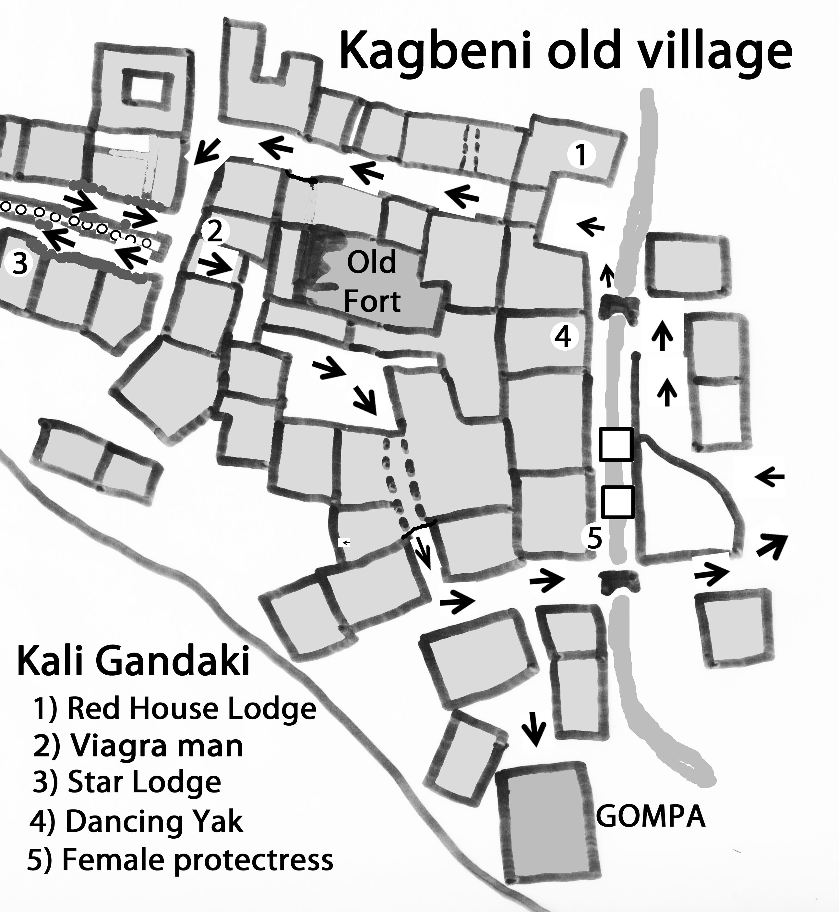
Kagbeni has many fields, which are irrigated by the Jhong River as it comes down from Muktinath and flows through the centre of the village. The northern part is formed by an enclosed village section with only three entrances. As you come from the river you will see the entrance on the right side below the Red House Lodge. Enter the small lane and go till the end where you turn left. A few meters later you see on the right a very long prayer wheel wall. Always walk on the left side. At the end you have a good view into Upper Mustang and you can see clearly the village of Tiri a little bit above the river.

Here is also the starting point, if you want to go up to Jhong and Muktinath. In August 2011 a signboard still stated that it is forbidden to go further without the special Upper Mustang Trekking Permit. This is wrong! You are definitely officially allowed to go up the road to Jhong and Muktinath, to make a day trip to the village of Tiri and to climb up to the SherDhak viewpoint on the other side of the river. You are also allowed to climb up to the nearby stupa which overlooks the entire area. Going back (again on the left side) you will pass the ACAP office. At the end of the prayer wheel wall continue ahead and you come to the old protector of Kagbeni. To show potential bad spirits that he really was a strong man they left no doubt about his sex. I call this statue Mr. Viagra Man. Continue through some tunnels to the little central place. Above it, one can still see the ruins of the former Dzong of Kagbeni. Take the west lane at the end of the place and you will reach the third entrance. Near to it there is the counterpart of the Viagra Man, a very clear woman statue. The lane leads to the Kagchode Thubten Samphelling Gompa. You will have to pay an entrance fee but it is well worth it. Some people are quite content just to take some photos from the roof with its fantastic views. Have a look at the cute little wind mill prayer wheels.
Return from the Gompa to the river and cross it. Going down you come to the jeep parking station and the long suspension bridge. On the other side of the river the trail will go to Tiri and the view point. But even if you don’t want to go there, it is worth crossing the bridge and going about 100 m north for the splendid view of Kagbeni above the cliffs and in the background Thorung La. The best time for a photo is in the late afternoon. On the south side of the river is the more open part of Kagbeni. From the little bridge Kagbeni’s shopping street will bring you to an old and beautiful old stupa. Continue later on this way to reach Jomsom.

Lodges: There are several lodges in Kagbeni so that you should always find a place to stay. Normally I don’t recommend lodges, but for Kagbeni I make an exception: Near the entrance to the old village you find the Red House Lodge. This very old house has a private prayer room with an old Buddhist statue and offers a beautiful view over old Kagbeni. If you like basic lodges have a look at the Star Lodge beside the prayer wheel wall. In this old style house there are three basic rooms and the didi has a beautiful smile. There is no solar shower but you have a great view of the village from the roof. The third recommendation is for the Annapurna Lodge at the south end of the village. This newly-built lodge with spacious rooms offers some special menu items unique on the whole trek. If you stay there try the sesame potatoes or their cabbage rolls with béchamel sauce. Both are delicious. But to be clear, the other lodges are also very good places to stay and I never heard any complaints about any of them.

51. Half-Day Trek Kagbeni-Tiri** m:2-3 hrs.
About 30 min north of Kagbeni sits the little village of Tiri (2800) on the western bank of the Kali Gandaki. Until a few years ago it was in the restricted area and access was forbidden. Now that you are allowed to go there during the day time, it is one of the highlights of the new AC. Tiri lays on a fertile stretch of soil reaching out to the Kali Gandaki riverbed. In the dry season you simply cross the river going down from the long prayer wheel wall at the north end of Kagbeni on some little temporary wooden bridges.

Climbing up the river bank the road is clearly visible. This road will continue above the wall, which protects the fields of the village. When there is too much water to cross over Kali Gandaki on foot, then you can cross it on the suspension bridge at Kagbeni.

At the end, you can turn to the right to enter the village. After 100m, there is a little place with two fountains. Take the tunnel on the left which leads you to the northern part. On the right side of the place there is a red house containing a huge prayer wheel. Just afterwards is the Norling Restaurant in a classical Mustang house. The didi grew up in the Annapurna Lodge of Kagbeni and is now married to a man from Tiri village. She will gladly serve you tea or some food. On the way back, just continue on the lane, climb over a little wall at the end and find a trail through the fields.

The Samdup Choeding Monastery ** in Tiri: This beautiful Gompa is perched high above Tiri. It was built around 860 Years ago when Lama Lungzin Palsang saw the Lord Buddha in a dream and was told to build a Monastery on a spot where there was a rock in the shape of a human heart. After a long search he found the place above Tiri. It was one of the oldest Gompas in this area but was destroyed by fire. After being rebuilt many monks and nuns practiced there but after a time, all monks and nuns had left and the Gompa was abandoned. In 1986 the monk Lama Dukta from Dolpo began to visit the Gompa and performed many pujas there. Asked by the people of Tiri to stay there, he accepted. Together they started to rebuild the monastery. Lama Dukta is also an Amchi, or Buddhist monk doctor, and practises Tibetan medicine.
How to go there: A trail goes up near some big chorten. As you see the Gompa above Tiri you will easily find it. From above you have a great view into Mustang but also of Kagbeni with Nilgiri in the background. I highly recommend this side trek! When you are above, try to find someone with the keys for the Gompa and also ask to see the well-organized pharmacy. Lama Dukta has collected many of the medicines himself but also exchanges some with other Amchis or buys them in Kathmandu. It’s very impressive to see the hundreds of glasses full of dried plants, minerals or dried insects.

The golden hill opposite Kagbeni
Cross the river on the suspension bridge and head north on the main trail till you reach and ascend a very steep little trail. This will lead you to a viewpoint of which Kagbeni’s people are proud. It may take you 3-3.5 strenuous hours and would explain why not very many people go there. My choice would be to go to Tiri and look from the gompa viewpoint.

52 Going up from Kagbeni to Muktinath
Red/White marks: If you are going up from Kagbeni, it makes sense to stay in Jhong as it is a little bit lower than Ranipauwa so you have fewer problems with altitude.
Go to the north of Kagbeni and leave it along the long prayer wheel wall. Just ahead you will see a stupa high above the ridge. Climb up from the road. After a short ascent, there are two possibilities. The left path goes on the river side, the right one climbs up through a spectacular gorge. At the stupa is a fantastic viewpoint. Continue from the stupa in the direction of the road and follow the road for about 2 to 2.5 hours. Watch out carefully till you see some marked rocks on the right side leading to a stone pile.
Descend to a small suspension bridge going over a deep ravine and continue along a long stone wall protecting the fields of Putak. Finally you will climb up a trail with trees till you enter the gate of Putak. Putak is a lovely little village in the style of upper Kali Gandaki and looks very much like a Tibetan village.
The "main" road will take you to the centre of Putak. There you have to turn to the left and ascend on a trail above the houses. After passing a Mani wall you climb up to the road, which you follow till the next village of Jhong with the ruins of an old fort (Dzong) which gave the village its name. Jhong has a beautiful Gompa** which you should not miss and from its roof you have one of the best views on the Muktinath valley, the mountains and the Thorung La.

To go there take the path which climbs up to the ridge. On the way up you first come across the Jhong Viewpoint Top Lodge. From its dining hall you have an excellent view of Thorung La and the village. If you would like to stay here, ask someone to call them in the morning to see if there are rooms available (mob. 9746715799 or 9847670320) as there are only 8 beds.

Continue by going back and then taking the Jhong Avenue on the left with many Mani walls and a chorten. At the end, rejoin the road. Passing a grey school you will soon see on the right side high above a ridge some houses of the village of Chongur. To go there take the trail to the suspension bridge. After crossing it, don’t follow the signpost to Muktinath but take the trail to the right, and reach a chorten. Turn to the left and go down to Chongur where many houses are painted in the tradition of Buddhist Sakia sect.Continue at the end of the village and soon you will see the houses of Muktinath Ranipauwa.

From Kagbeni to Jomsom
If you are heading to Jomsom you can either take the 2.5hrs. long way along the barren valley of Kali Gandaki or take the high route by Phalyak with offers spectacular views of the mountains and picturesque villages, but takes between 6 - 8 hours. I must say it was one of the most beautiful trekking days of my 2011 AC when I first walked it.

53. Kagbeni – Jomsom standard route on the road
2.5hrs...In this part of the valley of Kali Gandaki you will face a very strong wind blowing up the valley every day starting around 10 a.m. and becoming by late afternoon to a real wind storm. This is why you should start from Kagbeni by 8 a.m. at the latest. After 12 AM the wind may grow to a storm, not only blowing sand from the dry riverbed into your face, but even little stones. And it is very hard and exhausting to walk against the wind. If you can only leave later, you might arrange a jeep ride to avoid this hard and dusty stretch.

Start from the southern end of Kagbeni and leave along the scarcely used road. After 20 min you can descend to the right on a nicer trail (look for the red/white marks) on which you will reach Eklebhatti, a small settlement of 4 lodges including one named the Hilton hotel!
Short after Eklebhatti there is a long suspension bridge over the Kali Gandaki and leading to the villages of Pakling, Phalyak and Dhakarjhong. Continue on the road till you reach old Jomsom, where the jeep parking station welcomes you. Going along a small lane with shops, restaurants and some lodges, you reach the first wooden bridge over the Kali Gandaki. Just before the bridge, a signpost is pointing to Thini, the next destination of NATT trail on the way to Marpha. If you start in the morning you can reach Marpha on the NATT trail in the afternoon.
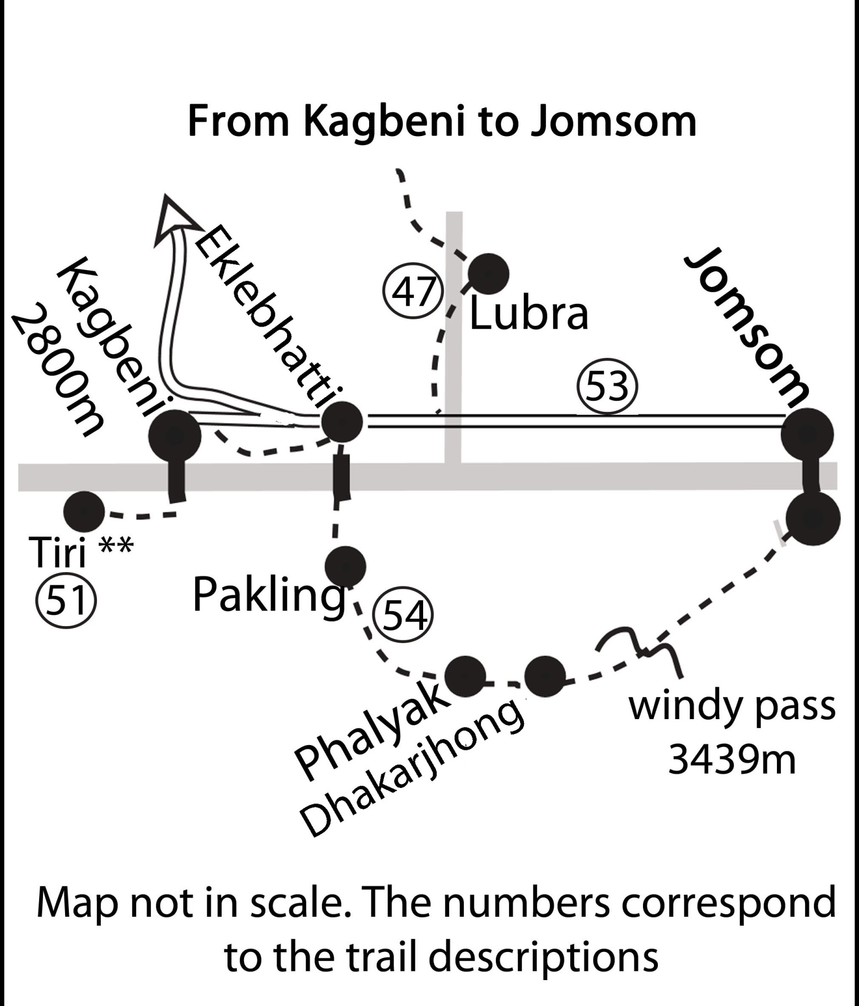
Map : Kagbeni to Jomsom

54. High route from Kagbeni to Jomsom ** 6-8 hrs.
(Blue /white marks): This beautiful but arduous trek starts at the bridge of Eklebhatti. Follow the trail going up. When you reach the village of Pakling make a little tour through it. You will be astonished how large the fields are. The huge agricultural area lies on a large terrace which you cannot see at all from the road below, where it only looks like a barren and arid hill slope. A signpost "Phalyak" will guide you up to the road again. Follow this road up and you will reach the long wall protecting the fields of Phalyak. Passing it on the left, you will see a large chorten above you on the right. This is the entrance to Phalyak. Right at the beginning of a little plaza is a big white house on your right where you can ask for cold drinks or food. Phalyak is a beautiful village where you can see already a little the influence and style of Dolpo and it is worth wandering around for a while and taking advantage of the photographic possibilities. We ordered dhal bhat and I was happy to have to wait 45 min so I had plenty of time to walk around. It is such difference to be in an authentic village rather than in a lodge settlement.

To continue take the lane going up on the left end of the place. A picturesque lane will trigger your photo desires until you reach the old little Gompa. Here you have to turn left, but you could do some more sightseeing going up the lane ahead in the direction of Dolpo and then returning to the Gompa.

Near the Gompa pass under a house in one of these tunnels so common in this windy area. Coming out of this tunnel, you already see across on the other side of the little river the village of Dhakarjhong. Walk down to the river and climb the hill again to reach it. Watch out on the left for another tunnel which leads you to a very small lane. Turn right there and climb up the trail till you reach a little pond with a chorten in the middle. Behind this pond there are more of the houses of Dhakarjhong. Just a little bit further from the pond turn to the left into a lane between houses in direction of the telecommunication tower on the ridge; it is a steady and long ascent.

From the pass “Batase Bhanjyang” (3435 m), appropriately named since it means “Windy Pass”, one has a superb view from the left of Upper Mustang, Thorong La, Tilicho peak, the Nilgiri, Dhaulagiri and Tukuche peak. When we were there, the force 7 winds blew my glasses off my face, but the view kept us there for half an hour while the storm raged on.
Continue straight ahead on a descending trail that will soon be very clear. It will take you about 2.5 exhausting hours to reach Jomsom on the right side of the river.

Jomsom (2720 m)
Old Jomsom (Jeeps to Muktinath): Jomsom is located on both sides of the Kali Gandaki. Coming from Kagbeni you will first enter Old Jomsom on the left side of the river. Most people will not even realize how big old Jomsom is as they will continue along the lane leading to the bridge and pass by several shops and some restaurants and lodges. In fact, Old Jomsom is not that interesting, so you will not miss a lot. The reason is that most houses are hidden behind high walls to protect them from the wind. Old Jomsom ends near the northern wooden bridge. Further south on this side of the river you will find many governmental offices, since Jomsom is the headquarters of Mustang district. There are two basic lodges close to the bridge, in one of which Jimmy Hendrix once stayed. It is there that the NATT- trail turns left to Thini and Marpha. If you don’t need anything in New Jomsom, you can just stay on this side.

New Jomsom: (ACAP office, Police check post, safe drinking water station, internet, airport)
Crossing the Kali Gandaki wooden bridge you are at the Bus station where the buses depart for Ghasa and Tatopani. One bus leaves at 9 a.m. and others during the day when there are enough passengers.
New Jomsom has a big military training centre and many hotels were built near the busy airport. Because of the strong winds flights are often delayed so it is wise and good for the nerves to leave at least three days in reserve.

If one is only trekking in the Mustang area it’s better to take the flight to Jomsom and walk back as you can much better control your time schedule, but nowadays one can also reach Pokhara from Jomsom in two days by bus. All companies flying Pokhara to Jomsom have an office in Jomsom. (There are no flights from Jomsom to other destinations than Pokhara.). New Jomsom has greatly benefitted from the growing numbers of Indian pilgrims. They fly in, go to Muktinath the next day by jeep and return to Jomsom that night. As flights are very often cancelled, this means additional days staying in the lodges. Hoteliers like this very much and earn a lot of money. They also like Indian tourists because they visit throughout the year and not only in the peak trekking season.
At the south end of New Jomsom you find the Mustang Eco Museum and a 5 star Hotel with its own swimming pool.

Jomsom to Tatopani

55. Jomsom to Marpha by road 1-1.5hrs..
If you are in a hurry, you can reach Marpha in about 1.5hrs. Depending on the state of the riverbed after the monsoon you might also be able to walk on it instead of the road above, but this will be rather windy and dusty. About one km after leaving Jomsom the dirt road climbs up a little bit and in a big bend descends to a river. After the bridge you can walk up to the traditional village of Upper Syang *hairo*,
definitively worth a detour of 30 min. From below you can see only a very few houses but if you reach the flat plateau it appears to be a large village. It rivals with villages like Marpha and Tukuche for its beauty and is not spoiled by many new houses and lodges. Continuing on the road you reach some houses with a big Mani wall and soon you enter Marpha through a big entrance arch.

60. Jomsom to Marpha via Thini and Dhumba Lake
(the new NATT Trail)

Map Jomsom to Marpha
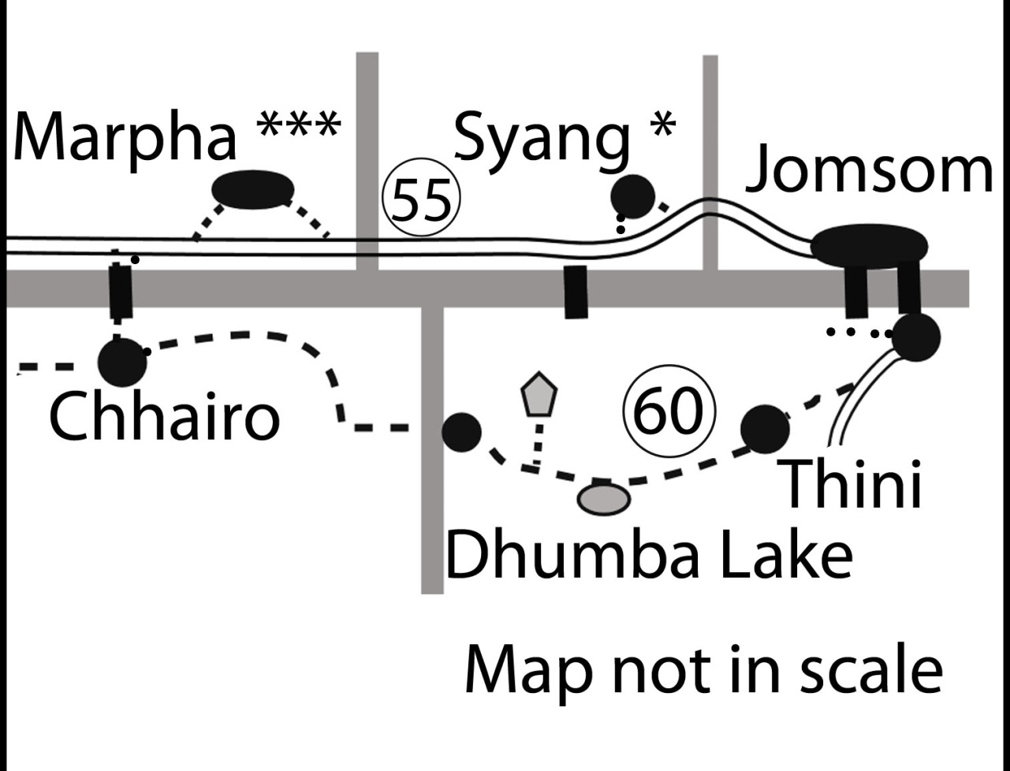

The trail goes over Thini and Dhumba Lake** (red/white marks) 3.5 to 4.5hrs..This trek is very nice and will lead you through the nice Thakali village of Thini and a wonderful juniper and pine forest with good views of the Dhaulagiri and other mountains.

Start from the left side of the Kali Gandaki in Old Jomsom just opposite the northern wooden bridge and take the stairs beside the Annapurna Lodge. Follow the lane and you will walk on a gravel road above the fields of Jomsom protected by a long wall. When the road starts to climb up the hill, look out for a trail going down near the wall and continue. At a junction take the left trail heading left and soon you will see the white painted houses of Thini. Climb up to the village, making use of the red/white marks. You will have to leave Thini by the west at a big chorten.

From above you will see the bridge. Cross it and continue on the trail. Turning around the rocks you will see some houses. Climb up and you reach Dhumba Lake, which is a fenced private property owned by a fishing co-operative. However, the door is often not locked so you could try to enter and take some nice photos or a have a relaxing picnic by the shore.

After Dhumba Lake there are two possibilities: you could continue on the road till the ridge. Up there you will see a gompa and it’s a great place with perfect panoramic views** to the north and south of the Kali Gandaki Valley. From the entrance Gate of Hutsatemgo Gompa you have to walk up the ridge to the main area. A visit is highly recommended. To continue track back on the ridge road till you can go down to the right (south) on a large trail/ dirt road or take some short cut right after the entrance door. The steep short cut will lead you down faster but it is a little bit difficult. I prefer the longer main trail. You will rejoin the main trail leading in direction of Kali Gandaki to the Dhumba main village.

The second choice would be to take the left trail directly after the fence and climb up to the ridge. After the windy ridge you will first pass through a prayer wheel gate and descend in the direction of the Kali Gandaki in the side valley.

Dhumba Village
When you get to Dhumba, the next village, turn to the left at a signpost and go down to the riverbed of the side river.
Already you can clearly see on the other side a bigger trail and many smaller ones, which make it a little bit confusing going up.

Be aware that many of the trails will go straight up to the forest to collect wood. The trail to Marpha is contouring the hill above the cliffs high over the Kali Gandaki and offers splendid views of the valley and Marpha. At a place with some prayer flags overlooking Marpha you will start a long descent. Finally you will reach the former Tibetan refugee camp at Chhairo, where many Tibetans are still living. At the end of this village a new lodge and restaurant with 14 beds is being built. It might be a very good idea to stay there and to visit beautiful Marpha without carrying your heavy backpack. It would also save about 20 min of your time the next morning.

From Chhairo a path goes to a suspension bridge. After this Bridge, you have to go back for around 20 min to the centre of Marpha, but only a half of it is on the road, as the motor road contours the old village of Marpha. Quite a few trekkers leave their backpacks in one of the lodges along the road below Marpha and return after a visit to Marpha.

Marpha ***
(internet, safe drinking water station, money changer)
Marpha is one of the places you should not miss and is worth spending some time exploring. So don’t mind if you have already arrived at 3 or 4 p.m. and enjoy it. All the houses are painted with bright white colour and the lanes are paved with spotless clean stone slabs.

Marpha is the centre of the apple-growing area and it was in the agricultural research centre of Marpha that the apple story began. Now you will find apples in all possible forms: Fresh apples, apple pies, apple cider, dried apples or apple brandy and apricot items as well. The apples bring a lot of wealth to the region and apple farmers have greatly benefited from the cheaper transportation on the new road. Most lodges will offer you at least two different apple pies and some more cakes during the trekking season.

The lodges of Marpha are excellent; most of them are inside old and large Thakali houses. It is just a pleasure to stay there. The big Gompa was renovated and enlarged in 1996 and it is certainly worth a visit. Above it is a new meditation centre with some hermitage cells behind it. You can walk to the huge natural stone chorten overlooking the village, from where you have a wonderful view.

61: Marpha - (Tukuche) - Kokhethanti Eastern NATT trail
partially marked with red/white signs 8-9 hours

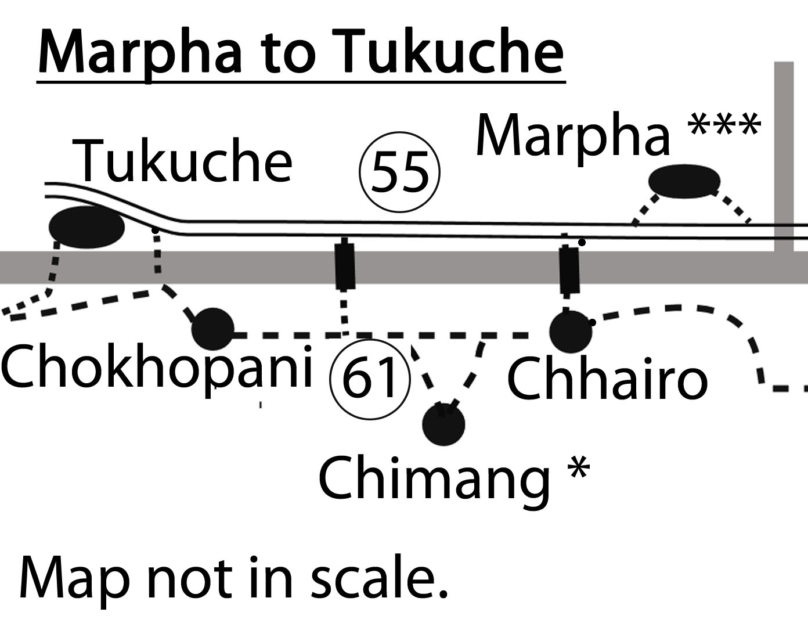

This is a very long day. You can take a break in the beautiful Thakali village of Tukuche and walk the rest of the day on the road, but you should take this eastern trail even if you want to go to Tukuche. It is much nicer than the road. This part of the New Annapurna Trekking Trail was completely rebuilt by ACAP, which constructed a perfect trail with breathtaking views of Dhaulagiri through a nice pine and juniper forest. The new trail is much better than the old one, which has now become a dirt road.

The trail starts at the bridge some 20 min south of Marpha leading to the Tibetan settlement of Chhairo. Go till there and turn to the right before you reach the village. Walking through a small forest, you will join a trail going south. After passing the ruins of the former Tibetan refugee camp you will reach the houses of lower Chhairo with a school and old stupa. At the end of the village turn to the left and follow the trail along the main valley. You will come to a junction where the trail divides, with one path going left to a bit arduous but rewarding detour up to Chimang and the other path on the right goes directly to Chokhopani, which means “clean water”. If you are in a hurry you can take the short cut to Chokopani, which will take you around 45 min.

The lower direct trail: with red/white NATT signs on a dirt road through a forest and passing two houses with apple gardens. One of the sites is called Lucky :-) At a place with three signposts! You have to cross a little stream on the right and continue till you join again the trail coming from Chimang.
Chimang*: Far more rewarding is the left trail over the village of Chimang. The trail will lead you to some pastures below cliffs, as Chimang is situated on a plateau 100 m above the valley. Climb up the stairs of the scenic gorge, at the split in the road take the right stairs and you will reach the fields and apple orchards of Chimang with beautiful views of Dhaulagiri, Tukuche peak and the lower Mustang valley.
Every meter you have to climb and every drop of sweat is definitively worth this side trip. Just before the entrance door there are three huge Tibetan-style ladders, as the people of Chimang keep the doors closed, preventing their cattle from roaming into the fields. One can cross the lower part of the village and descend by a long staircase but the village is special and very beautiful so it is advisable to go up till the end and then go down by a scarcely used road. In the middle you will find the Chimang Hotel and Restaurant with 11 basic beds.

On the top of the village turn right and descend along the road. After having passed the village you can leave the road in a turn by just continuing straight on a larger trail. After a small wooden bridge about 80 m further you can descend to the river on a very idyllic path meandering down in the forest. Cross the road below and then the bridge over the river and continue on the other (south) side.
Continue on the trail, which will enter the main Kali Gandaki valley. Soon you will see on the other side of the river a huge Buddhist painting on the rock wall, shortly after a suspension bridge which spans the Kali Gandaki.
After crossing it will take you about 30 min on the road to Tukuche
In the dry season (normally the end of October / early November to May) you also can cross to Tukuche on wooden planks, which will serve as small bridges over the then -numerous small arms of Kali Gandaki just after Chokhopani.

Continue on the marked trail, taking care not to enter the military area on the right. Take the left trail passing by a small Ganesh shrine. After crossing a very large area, where the river deposits new rocks and pebbles every year and there is no possibility to keep a marked trail, you will see the few houses of Chokhopani. Now you will have to search for a trail in the general direction. After some trails you can see the few houses of Chokhopani and three trails going up the mountain; yours will be the lower one on the right.

Chokhopani (2585m)
Enter Chokhopani and turn right into the village lane. In the Thakali language Chokhopani means “clear water filtered by the mountain” and is called Martsang Kju. It is believed that the water coming from Nilgiri is filtered by the mountain gold on its way through the mountain. And if a Thakali Person dies, it is the duty of the son-in-law to get some of the holy water and also some Junipers from Chokopani for the cremation. When the buck wheat is in blossom Thakali people are cremated. As many wealthy Thakalis now live in Kathmandu or even abroad it is a pretty difficult task to organise fast transport, and sometimes bottles are even sent to the USA. Fortunately one can reach Chokopani very quickly from the Jomsom Airport.

There is one basic restaurant where you should eat if you don’t want to cross to Tukuche. Leaving Chokopani you have two choices. Either you continue on the eastern side of the river to Sauru or you cross the Kali Gandaki on small wooden bridges to Tukuche. This is only possible during the dry season.

Eastern trail: Chokhopani to Sauru (2-2.5 hrs..): If you want to continue without crossing the Kali Gandaki and bypass Tukuche you will have to climb some 200m to the top of the trail above the high cliffs. Ascend the trail which begins near by the river. It will lead you through a fragrant-smelling lush pine and juniper forest which many birds have made their home. Quite often you can see Dhaulagiri in all its splendour peeping through the trees. Be sure to have enough space left on your camera sensor, as you will surely need it. This trail was newly constructed by ACAP and is just perfect! The top of the trail is at 2785m, and then it descends to finally reach the village of Sauru.

Sauru has some stone houses on the hill slope but also several wooden huts in the plain of the river delta. In the season you should get some tea and I was told that two of the new buildings will be lodges. Not so bad because there are still 2.5 hrs. to walk till Kokhethanti and you might prefer to stay here if it is already late..

Eastern trail: Sauru to Sirkung and Kokhethanti (this part of the trail is not marked) 2.5 - 3 hrs. From Sauru continue walking south crossing a little side river. The trail will go along and above the river with some up and downs. After some time, the trail changes to a bigger road-like trail made by bulldozer. It leads first to some houses of Sirkung and then further in the direction of Kokhethanti.
This road-like trail, which is not in used for traffic, will pass near the bridge over the Kali Gandaki, leading to Larjung on the other side of the river, and continue straight in 15 min to Kokhethanti.

Kokhethanti (2500m) has 3 basic lodges and is stretched along the trail. From Kokhethanti you can continue climbing up to Dhampu and then reach Kalopani in around 40 min. Kalopani has better lodges but the main road is passes through the village. You’ll have to decide what you prefer.

62. Crossing the Kali Gandaki from Chokopani to Tukuche in the dry season.
There are three reasons why I do recommend this alternative. First Tukuche is an impressive Thakali village and the perfect place to have a good lunch. You can cross again the river after Tukuche and join the main eastern NATT trail. Secondly, you don’t have to ascend the entire 200 m and even with a sightseeing tour you will be nearly as fast. The last reason is that one can make a beautiful side trek on the western side of the river, described later in a later chapter.
At the end of the village of Chokopani continue to the river. In the dry season the people of Tukuche build small wooden bridges over the Kali Gandaki River as they will collect wood from the forest on the other side of the river. Some people of Tukuche also have apple orchards in Chokopani. As the Kali Gandaki changes its riverbed every monsoon season the place for the wooden plank-bridges will also change. Watch people crossing the river and look for footprints. It might be that you will also see some poles guiding you. I recommend crossing to Tukuche if there is a possibility.

Tukuche:
Have lunch in Tukuche or just make a sightseeing tour of this old Thakali village. Tukuche was the toll station for the salt trade with Tibet and you see still the large houses used formerly as caravanserai. On the ground floor there was place for the animals and goods while the people stayed on the first floor. One can evaluate the wealth of Tukuche by looking at the beautiful carved wooden windows. These days four of these old caravanserais are used as lodges and are definitively worth visiting.
Given that for hundreds of years the men were gone for many months of the year on trading tours, often going with their caravans up to Tibet, it was common for the women to run “home” businesses like tea houses. Thakali women are therefore by tradition very proud and self-reliant.

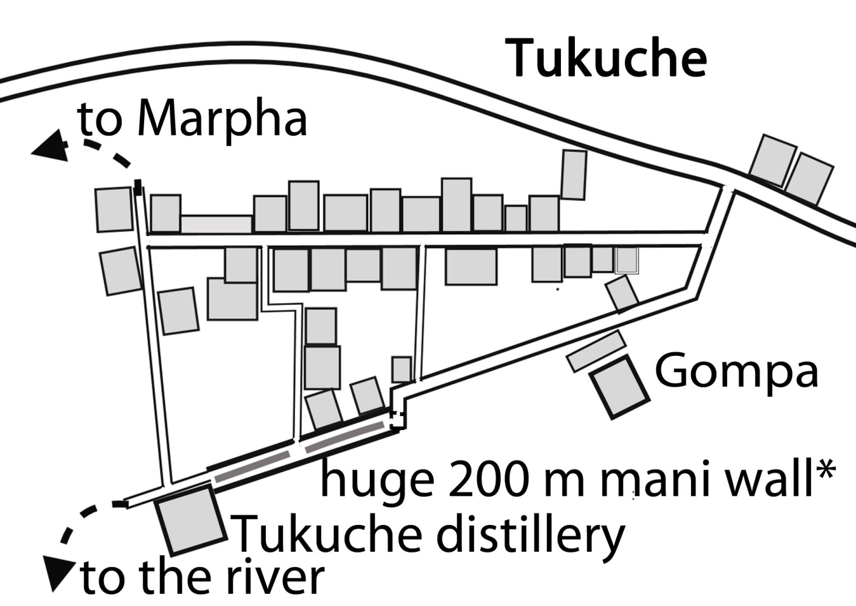

There are several newer lodges north of the old village centre along the road, which fortunately bypasses the old part. When the road was built, investors built fancy new lodges in hopes of making lots of money. However, now there are far fewer people staying in Tukuche than before the road was built even though there are three times more lodges. And the owners can wave at the buses passing by. I always prefer to stay in one of the old lodges in the old village centre. Like Marpha, Tukuche is right in the middle of the apple country so enjoy the many tasty pies! On the southern end near the river is the Tukuche Brandy distillery. I learned that they don’t distil the apple brandy from fermented pure apple juice but use a lot of sugar where they add some apples. A visit is interesting.

In Tukuche you can again choose on which side of the river you prefer to trek. Either you cross again the Kali Gandaki to the eastern trail or stay on the western side. On this side you will have to walk approximately two hours on the road to the next village of Khobang but it gives you also the opportunity to visit beautiful villages like Khobang, Larjung and Naurikot and to make a side trip to two beautiful little lakes with great mountain scenery.

Eastern NATT trail: Tukuche to Kalopani on the left (eastern) side of the Kali Gandaki in the dry season
Like on the north side the people build small wooden bridges to cross the Kali Gandaki. Follow the blue/white NATT signs in the old village. Just before Sunil Lodge turn left to a little prayer wheel house and walk along the longest prayer wheel wall I know. You will come to the Tukuche distillery where the famous Tukuche apple brandy is distilled. Pass a little gompa and continue on a trail with stone walls on both sides which later turns down to the river. On the opposite riverside you will see two little houses in ruins. The trail over the Kali Gandaki will somehow go to these houses. After climbing to the land turn right and follow a blue/white marked trail along the river. After 20 minutes you will rejoin the main red/white NATT trail going to Sauru.
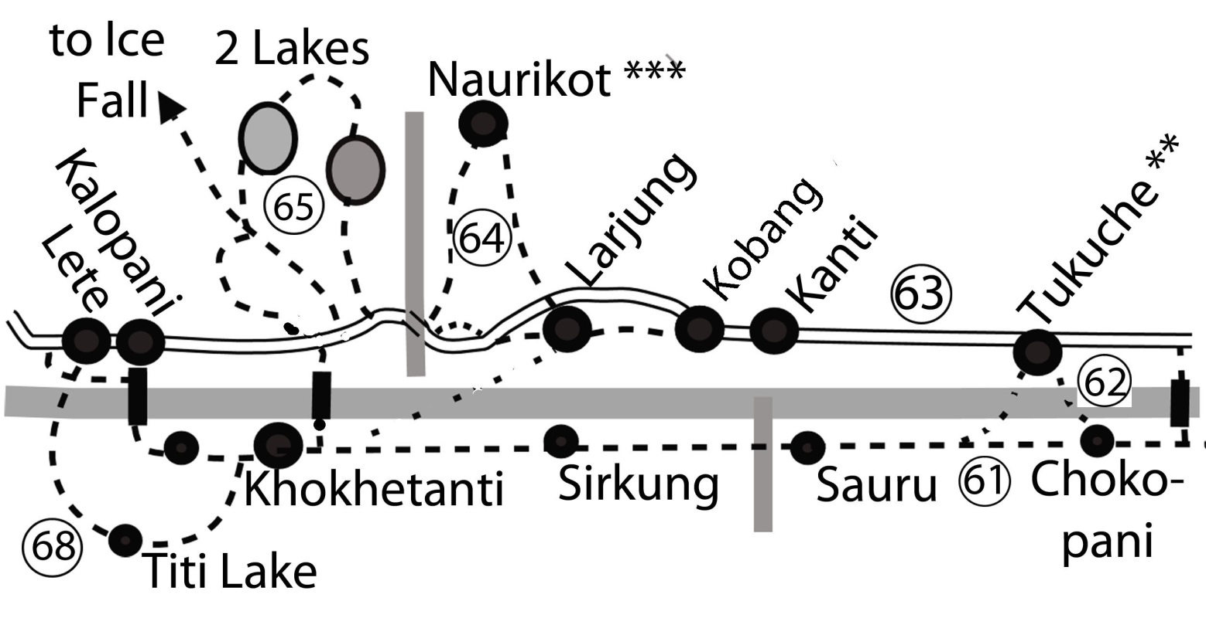

63. Western Trail Tukuche -Khobang-Larjung (right riverside)
The western trail will lead you in about 2-2.5 hours to the little villages of Khobang and Larjung. The next day you can make an awesome side trip to the scenic village of Naurikot and the two nearby lakes and then rejoin the main NATT trail in Kokethanti on the left river side.

Continue to the southern end of Tukuche and leave this interesting village through a gate. You will have to walk around 1.5 hours on the road. In the dry season the vehicles prefer to ride on the riverbed instead of on the road so you might not be disturbed very much. But in some years the Kali Gandaki chooses a riverbed touching the rocks below the road and then everyone will drive and walk on the higher dirt road. Luckily there is not very much traffic to be annoyed about on this little stretch of road. The dirt road will turn up to the right in the village of Kanti so that you then will have again a beautiful trekking trail without any traffic till Larjung.

From here to Larjung follow again the blue/white NATT signs. The villages of Kanti, Khobang and Larjung are more or less one stretched-out and connected settlement and in each village you will find lodges. From Larjung you can continue directly to Kokhethanti on the main trail. It is a 1.5h trek mainly on the dirt road. If it is the dry season, ask in the village if the short cut trail over the Kali Gandaki is walkable. But a very rewarding side trek will lead you to Naurikot and then pass by the two lakes.
You also could just visit Naurikot without luggage or skip Naurikot but visit the two lakes. Naurikot and the two lakes are also an excellent day trip without luggage and the lodges will gladly prepare you a lunch box.

64. Western Kali Gandaki trail: Naurikot***
Naurikot is an old typical Thakali village high above the Kali Gandaki valley. It is a wonderful place with one of the best mountain panoramic views I have seen on the Annapurna circuit. You have to climb several meters, but I guarantee that every meter you climb is worth the effort.
Start in the middle or at the end of Larjung at the last lodge called Larjung Lodge where the trail starts to the right at the fountain. Follow the blue/white NATT signs and climb up. You will twice cross the road going up to Naurikot and pass two little gompas standing side by side. Often the trail leads through a fragrant pine forest. Entering Naurikot you first come to the upscale Lodge Thasang Village, where you have a marvelous 360°view with Dhaulagiri, Tukuche peak, the Kali Gandaki River and the Nilgiris in full splendor. So if you want to experience a bit of luxury and a relaxing day or two this is a beautiful place - but expect much higher prices than in the normal lodges of the area (www.lodgethasangvillage.com).
Naurikot is built on a long ridge and soon you will come to the first houses. The basic lodge Guru Sangbe has a roof terrace with an even better view than the Lodge Thasang Village but charges the cheap rates of local lodges. They are actually starting to build a new building and already have four rooms available.
Continue to climb up on the right side but watch for signs as you have to turn left in the upper part of the village. You will think that you have to continue in direction of Dhaulagiri through a gate door but you have to turn back to the Nilgiri side and go down on the right southern side. Soon you will come to a bigger trail and again turn right to descend the switchback trail through a wonderful smelling pine forest.
You will finally come back to the main road near the big bridge over the Boksi Khola. Here one can see some walls near the river. In spring time the people erect yak tents on them and during a big festival, that lasts nine days, the people gather to drink fresh yak blood from living Yaks and then go to Serkung Lake where they will probably drink even more raksi. The yaks recover fast from this "blood tapping" when they go up to the pastures full of abundant fresh and tasty new grass and herbs. You can either return by road to Larjung or continue to the two lakes.

65. The two beautiful lakes below Dhaulagiri:

This is either a day trip from Larjung and the lodges will gladly prepare you a lunch box or you carry your backpack with you and continue directly to Kokhethanti on the main trail.
Buddroso Lake. This lake is within a famous and ecological wet land and will take you about one and a half hours from Naurikot to go there. After crossing either the motor bridge or the suspension bridge you have to go down along the dirt road for a few hundred meters till you see a torn signboard. The trail is marked with blue/white signs. After a steady climb through a beautiful pine forest, you will reach the lake which is embedded in the forest below Dhaulagiri. Find your way on the right/northern side and enjoy the enchanting surroundings. You’ll think that you’re walking in a fairy tale! When you reach the opposite (i.e. west) side continue straight in a westerly (Dhaulagiri) direction. Coming out of the forest you will see the Bukkosi River in a ravine. There is no way to cross it right here, so you will have to go up for a while before you can cross it to the other side. Seeing the huge rocks which have been moved like little children’s building blocks one can image the devastating power of the unleashed stream in the monsoon season.
Climb up to the other side of the ravine and soon you will see the second lake called Sekung Lake.
Sekung Lake sometimes spelled Sokung
The beautiful emerald Sekung Lake is situated in a natural hollow surrounded by some forest and with breathtaking views of the high mountains. It is one of the very beautiful lakes and much larger and nicer than Titi Lake which van be visited going from Kokethanti to Kalopani on the east river side)
On the south end there is a big ACAP sign board and blue white NATT signs marking the trail going down. You will reach a big flat area with pastures, a small yak herder’s hut and several walls in ruins. Until 35 years ago this was the location of the village Sekung. When it was destroyed by avalanches the inhabitants moved to safer places like Naurikot or Larjung.
From this place you can take 4 different trails: 1) going down to Larjung, 2) going down to Kokethanti 3) climbing up to the Dhaulagiri Icefall, and 4) going up to Sekung Lake.
1: going down to Larjung (1.5h). Following the blue/white signs, take the trail near the little hut. This serpentine trail will lead you through a pine forest down to the road. Follow the road 2 km to the north till you reach Larjung.
2: Going down to Kokethanti (45 min). This trail also starts near the little hut but more to the south in a pasture a little bit lower. Go to the right end of the pasture and behind some trees you will reach a larger clear trail with blue /white signs which will also wind its way down to the road just 150 m south of the bridge leading over the Kali Gandaki to Kokethanti. If you come from Kokethanti watch for a rock marked with the blue/white NATT sign and the words “Ice Fall”.
66. Climbing to the Dhaulagiri Ice fall (3-4 hours). The trail starts from “Sekung village place” in a westerly direction, It was marked with blue/white signs by the owner of the Dhaulagiri Icefall Lodge in Kokethanti and the Jomsom representatives of ACAP. If you enjoyed the hike, you might thank him later for his contribution.
4) Going up to Sekung Lake (15 min). Ascend in a northerly direction. As the trail will continue to the Budrossolake, a big stone is marked with “lakes”. This is only relevant if you started from the road bypassing Buddroso Lake.
Suggested combinations-

67. Roundtrip Larjung- Naurikot-Buddroso Lake- Sekung Lake
This perfect day trip starts in Larjung. First climb to Naurikot and enjoy the 360° views. Then descend to the bridge and walk a few hundred meters to go up to the Buddroso Lake. Return by the Sekung Lake to Larjung. This day of amazing views will not soon be forgotten. Ask your lodge to prepare a packed lunch and have a picnic near one of the lakes.
Larjung to Kokhethanti and Kalopani by the two lakes (3-3.5 hours)
If you don’t mind climbing up with your backpack some extra meters this alternative route avoids much of the road and offers splendid views. Count about two extra hours compared to the road trail.

68. Kokhethanti to Kalopani or Kokhethanti - Titi Lake, Taglung - Kalopani

Most people will just continue on the road trail to Dhamphu and then to Kalopani ( 30-40 min) If you have enough time, the day-long trip by Titi lake (5 - 6 hrs. red/white marks) is recommended, as it will lead you through some beautiful landscape, nearly looking like the Alps with pastures and with a great view of Nilgiri. Starting just 100m after the end of Kokethanti, turn to left and take the road up. While it is a road there are rarely any vehicles using it, so you can walk up in the morning enjoying the shade provided by the beautiful pine forest. In Germany we would call this a quiet "Waldweg" or forest trail. The top of this trail is at 2700m, thus 200m higher than Kokhethanti. Descending with some minor ups and downs you'll find the village Titigaon on the left side at 2675m. You’ll find there the new Titi Guest House with its 14 beds.
Just past the village is Titi Lake, which should really be called Titi Pond, given its small size. According to the ACAP Board, it’s categorized as an important marsh zone for the water birds in the Mustang region.
It takes you around 2 hours from Kokhethanti to reach Titi Lake. Some 25 min later, you reach a pasture with three chortens, piled up with grey stones. Shortly after this the trail to Taglung goes down on the left side. At the end of Taglung turn right and descend to the school and the village of Kunjo. Here you will find the Sangam Hotel
and a didi with a big welcoming smile who cooks an excellent dal bhat.
After going down through the village turn to the left after the ACAP signboard. The road will bring you down to the white shining riverbed of the Bhuttro Khola, which comes down from the Nilgiri slopes.
Go through the village of Chhoyo and cross the Kali Gandaki on a huge suspension bridge.
After the bridge turn to the right and keep right. Follow the trail with red/white marks. Climbing up a little bit, you will come to a fully- painted rock with sign pointing in three directions. The situation in Lete/Kalopani is a little confused. The two villages, Lete in the south and Kalopani in the north, are stretched over 4 km and are just separated by some fields.
Unfortunately the motor road goes right through these two villages. Therefore, ACAP built a parallel NATT- trail around 100 -150m below the village and far away from the road noise.
Several smaller trails connect the upper village parts and the lower trail. At the coloured rock you must decide where you want to go. Turning left leads you to Ghasa in 3.5hrs. But there is only one lodge on the way. If you want to continue the next day to Ghasa, Lete will be a good choice. The trail left of the coloured stone leads to south Lete with four Lodges, turning to the right brings you to a second junction with the trail going to Lete or Kalopani. Kalopani is about 30 min further away and there are many decent lodges.

Kalopani / Lete
(safe drinking water station, museum): Kalopani is stretched along the road, which unfortunately goes through this village. There are many lodges, the first being Kalopani Guest House of Mr.Romy Gauchan Thakali, an influential politician for the Nepali Congress Party who has even been Foreign Affairs Minister. Going up the road you find many other lodges with a good standard. One of the best dal bhat meals I ever had was in Kalopani at the See You Lodge.

Kalopani is a splendid place to see the mountains. It’s one of the very few places where you can see Annapurna I on the AC and it is definitely the best one. As you cross the bridge over the Kali Gandaki you can already see in the east the north face, along with a few lower peaks. The highest at 8091m is on the right side of the ridge. More to the south you see the Bharha Chuli /Fang and then Annapurna South. On the west you see directly the south east ridge of Dhaulagiri (8167m). Enjoy the sunset on Annapurna chilling on your lodge roof terrace and the sunrise on Dhaulagiri at breakfast. Make sure you see them both from the lodge you end up choosing. You might also take the 30-min. trip up to the viewpoint of Dhulu Danda; the trails starts near the Kalopani Guest House.

Lete: After the top of the road begins the village of Lete, just separated by some fields and also stretched along the road. In Lete you will also find several lodges but the mountain views are not as nice as those from Kalopani. At the south end of Lete the road will turn to the left, but a large trail continues straight ahead and you can climb down to the road on a steep trail which is a nice shortcut if you are already in Lete.

69. The NATT- trail bypassing Kalopani and Lete
red/white marks: I must admit the new NATT trail is not so easy to describe and it can be a little bit confusing. In fact, it took us a whole morning to find a way to mark it. ACAP has constructed a really beautiful parallel trekking trail about 100 -150 m below the village, completely avoiding the traffic . This trekking trail is linked to the main village road by several little trails so that you will have to choose on which one you want to descend to the trekking trail.

Coming from Kokhethanti / Dhampu you climb up to Kalopani to cross the Kali Gandaki on a suspension bridge. The Kali Gandaki is very narrow here. The first time I crossed it without realizing at all that it was the big Kali Gandaki and not just a smaller side river.

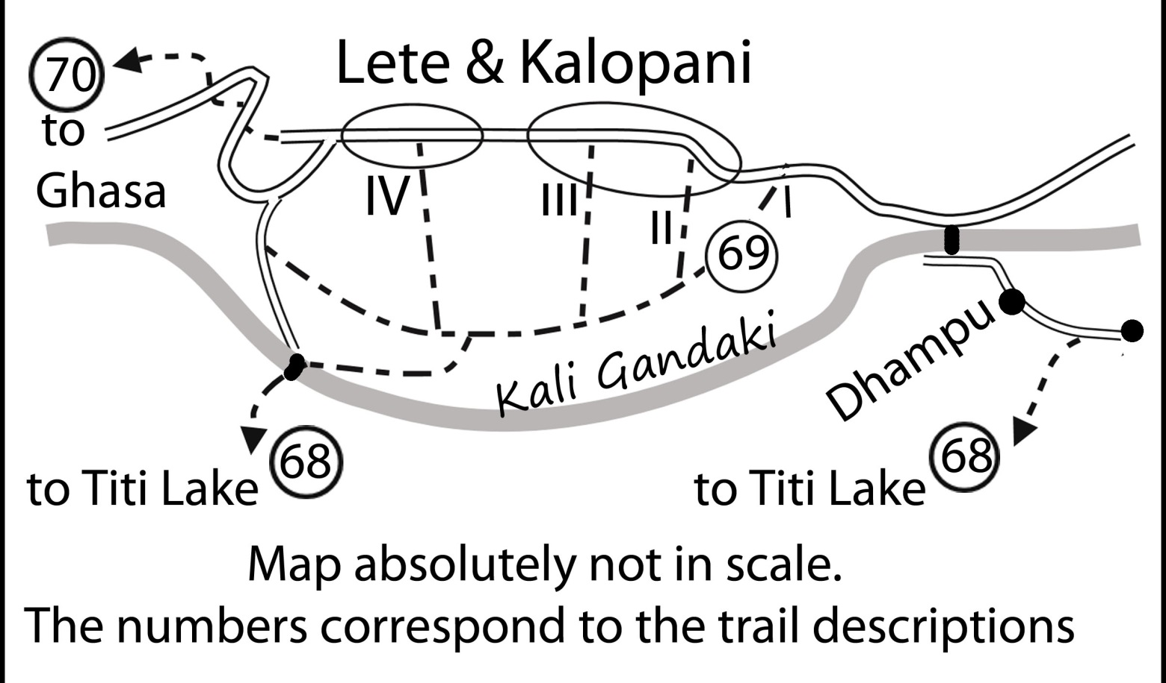
Map Kalopani and Lete and the various exit point from the road to join the beautiful NATT Trail

When you enter Kalopani you have several possibilities:

- You just had Breakfast and need nothing from Kalopani/Lete: Then take the exit (I) to the left and enter the forest. Follow the red/white signs and you will avoid completely the village and the traffic.

2. You would like to stay overnight in Kalopani and find a lodge at the top of the village. Continue on the road and the next morning take the exit (II) which is just behind the Kalopani Guest House right opposite to the Angel Guest House. Enter the forest on a trail leading to a small house. Just before this house turn to the right and follow the marked
trail.

3. If you want to get water from the safe drinking water station or want to stay in one of the many hotels further up stay on the road. To continue take the Exit (III) on the top of the road but near the fountain; it will lead you back to the forest.

4. You can go further up to Lete, using another trail going down near the police post.

5. You may even take another exit near the health post but then I would suggest continuing on the road and taking the straight trail after the road turns left to descend.

From the forest the parallel trail passes through the fields between high stone walls and later leads to more open terrain.
You reach a big stone with many signs pointing to three directions, which I call the painted stone. Continue by following the red/white trail marks. After passing a tiny farm house the trail becomes a small path that turns right into a beautiful forest before re-joining the main road. At the junction follow the main road to the left. After some time you can see on the left a long suspension bridge over the Lete Khola with the former Namaste Lodge. Don’t go down to this bridge, even if you remember that this was the old trail. Instead continue some 200m and cross the Lete River on the second suspension bridge. The road makes a long turn crossing the river some hundred metres further on the third bridge.

70. The forest trail from Lete to Ghasa* (4 hours-red /white marks)
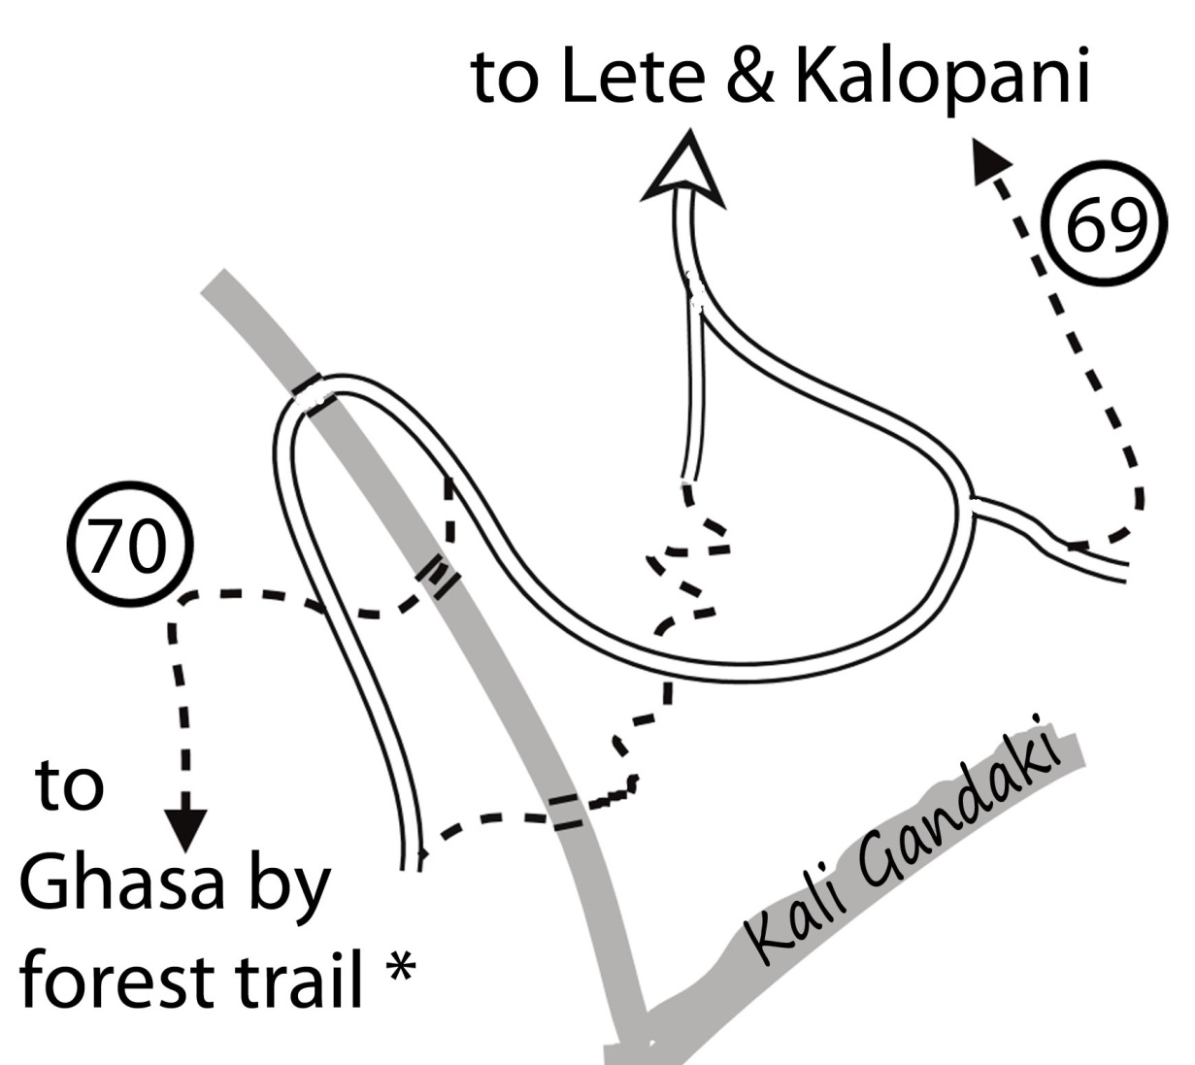
After crossing the river climb up the hill and when you reach the road cross it and continue climbing on a little path just a few meters more on the right. This beautiful new trail has been finished by ACAP in July 2011 and replaces the last section where one had to walk on the road. It’s a marvellous jungle walk on a soft forest trail. You will love it. Most of the time the trail will be high above the road so that you scarcely can hear any traffic noise. With your left ear you will hear the sound of the river and with your right ear the twitter of the many birds. At the start the trail heads south with some ups and downs near some electric poles. Later these poles plunge down and you just continue through the pristine forest. After coming to a more open pasture with a beautiful view the trail will drop to the main road at Ghumaune. Just walk some 100m on the road till you reach the Green Forest Guest House. Right opposite to it the trail will climb up again on stairs passing by a little hut. Follow the trail with up and downs till you will descend again to the main road just before the little village of Kaiku, only a twenty- minute walk from Ghasa.

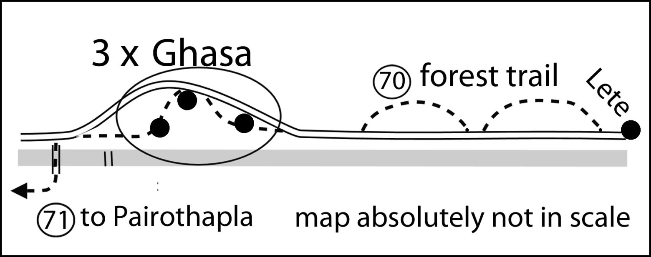

Ghasa 2010m:
When you are trekking in the later season, Ghasa is the first place where you are out of the frost and smell once again flowers and the green nature. The village has three distinct parts. You will first enter the upper part with several lodges. Going down you will leave it through an entrance chorten and rejoin the road for a while. In middle section of Ghasa you can turn left and follow the trail going down in the direction of the River. There is at least one lodge in this part. Coming to lower Ghasa you will find the Eagle Nest Lodge. Continue on a trail above the river till you meet again the road and cross the river on a long suspension bridge just a few meters further on near a house with a fountain.

71. Ghasa to Tatopani (8 hours)
7. Ghasa - Pairothapla - Kopchepani - Bhalebas - (Dana) -Tatopani 8 hrs. Red / White signs.

Climb up to Pairothapla (one lodge + a few tea shops) and descend in a former landslide area to upper and then lower Kopchepani. Coming down to lower Kopchepani you can already see the trail which climbs up the hill alongside some electric poles. After Kopchepani keep left and climb 90m up the hill to the village of Bhalebas, which offers a perfect view of the Rupse Chhahara waterfall on the other side of the river. Then descend to the village of Ghadpar, Narchyang Bensi, etc. If it is afternoon I suggest that you cross the Kali Gandaki and stay overnight in Dana. Otherwise you will reach Tatopani tired in the evening and may find it difficult to get a place in a lodge. It is much better to arrive in the morning and have the rest of the day for relaxing at the wonderful hot springs of Tatopani.

Dana
Dana is a beautiful village and was very rich when it was a toll place for the salt trade just like Tukuche. Again, there are three village parts with several lodges. In the middle part you can see some houses with beautiful carved windows worth looking for. You’ll find many little water mills lined along the river. If you have some time for sightseeing turn left at the houses at the end of the water mills and find your way through this nice village part, proud of its cleanliness and the fact that every house has a toilet. In fact, these things greatly improve the health of the villagers. After making a tour of the central village, you return to the river with the water mills.

Dana to Tatopani 1.5-2.5hrs. red /white marks
The trail continues on the left (i.e. eastern) side of the Kali Gandaki and you just follow the general direction and the marks. In the village of Charap you will find a small restaurant, which plans to build some rooms. A little bit later you come to the hydropower plant, which produces the electricity for the whole Kali Gandaki Valley. Not much further you will have to climb a little bit to the left hillside and later up a ridge. On the other side you cross the Miristi Khola, which comes from Nilgiri and Annapurna, on a suspension bridge.
When you cross the Miristi River you have two possibilities. The lower route turns right, passes a school with a little temple and then joins a dirt road. In 2012 this road was still under construction so there was no traffic. But as soon that the two bridges will be finished one can expect heavy trucks coming as this road is meant for a bigger hydropower project. After a while you will reach a little bridge; turn right there and go down the road. The second possibility (and for me the better choice) is to make the fifteen-minute ascent to the plateau. You will come to the beautiful village of middle Narcheng* with a dramatic waterfall just above it. There are three villages called Narcheng. The lower, middle and high Narcheng which is 2 step and hard hours! climbing further up on the ridge on the way to Khopra.
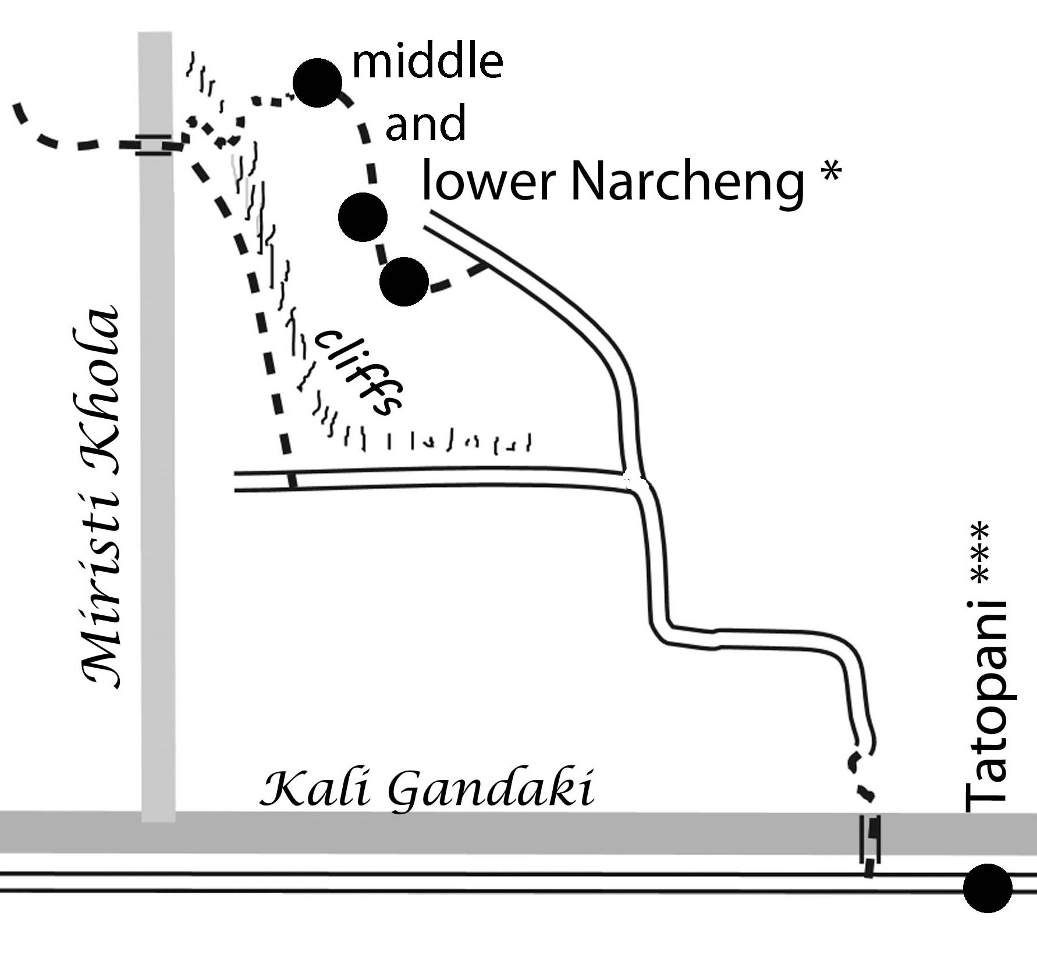
As soon that you reach the plateau you come to a pink building with prayer flags. It is the school headmaster’s house and you can get cold drinks and food there as well as a home stay. This may be a good idea if it’s already afternoon since you might have problems finding good accommodation in the high season in Tatopani. As of 2012 there was another lodge under construction. Follow the little trail into the village. It is worth a visit. Then follow the signs to lower Narcheng and cross a little bridge and go down along the road. This trail will take you an extra fifteen minutes to ascend and you can spend another fifteen minutes exploring the village on this pleasant and rewarding detour.
Both the lower and upper trail will rejoin the dirt road near a little village. From there you can already see the bridge over the Kali Gandaki. Cross it and there are just 500m left which you will unfortunately have to walk on the main road to reach the pleasures of Tatopani!

Tatopani ***(1200 m - Check post, money changer).
Tatopani is famous for its hot springs and the good food. This makes it a perfect place to relax after doing most of the Annapurna Circuit. Many people will end here their trek an drive to Pokhara the next day.There are several lodges in Tatopani; however, since many people each day arrive from the AC or from Ghorepani, it can be difficult to get a bed in your favourite lodge if you arrive in the late afternoon. One of the most coveted places is the Dhaulagiri Lodge with its especially nice orange garden.
The hot springs are near the river and are just protected from the road by a wall. There are now two pools which are cleaned daily. For this service you have to pay a small entry fee. Please wash yourself outside the pool before getting in. The hot water coming out from the hill is so hot that they need a second pipe with cold water and this water is added to the pool. Therefore the temperature of the water depends on the place where you are sitting. In the little stall you can get food and drinks so there is no need to hurry and you can stay many hours.

Tatopani – Pokhara by Bus or Jeep
Many trekkers will end their tour in Tatopani and then drive back to Pokhara. A bus leaves in the morning from the road below the village. There is no exact departure time since the driver waits until there are enough passengers. But be there at 8 a.m. at the latest. There might be more buses going; otherwise, there will be Jeeps driving, as soon as there are enough people. The busses and the jeeps are only drive to Beni where you have to change to the buses driving to Pokhara. It takes between 2 to 3 hours from Tatopani to Beni, with the Jeeps being a little bit faster. The price is around 250-350 NPR.

In Beni buy a ticket (400 NPR in August 2011) on the left side of the big bus parking station. The counter is situated in a detached building. The busses start every hour so you might have breakfast or lunch first. You can also walk to the south end of Beni and cross the river for a very nice view. It’s near the bridge that during the civil war the military camp of Beni was attacked by Maoists. After more than 10 hours of fierce fighting throughout the night the Maoists had to retreat with very heavy losses. I think that battle showed both sides that they would not be able to win the conflict by force and later they started to search for a non-military solution. It takes 5 to 5.5 hours for the ride to Pokhara’s new bus station. From there you can grab a cab to the lake area.

72. From Tatopani to Ghorepani and Poon Hill ***
Tatopani > 2.5h > Ghara Birauta 1 h > Ghara > 2.5 h > Shikha >2h > Chitre > 2.5-3.5h > Ghorepani

An alternative to the bus drive is to continue along the classic Annapurna Circuit as it was before the building of the road. You’ll need another 2 to 5 days to get to Pokhara via Ghorepani. As Ghorepani is at 2860m, this means climbing 1670 m! While this can be done in one very long and hard day, on my recent treks I chose to have a relaxing morning in Tatopani (1200m) and, starting after lunch, got to either Ghara (1700m) or Shikha (1935m). Then I continued the next day to Ghorepani. My personal favourite is the Hindu village of Ghara with the typical red white houses in the style of the Nepali hills. So I normally stop here, even if I would have enough time to make it to Ghorepani.

Continue in Tatopani to the south. Just before the end of the village turn left and go down to the police check post where your ACAP and TIMS permit will be checked. Continue for about 15 min on the road and cross the Kali Gandaki on a long suspension bridge. At various places the strong metal floor plates have been twisted and damaged by falling rocks. Follow the trail and cross the next river on a much simpler and older suspension bridge. This is the old suspension bridge model without the stabilizing side cables. As a result this bridge is a little bit more movable but this will just add some fun.
After the bridge you have to go up. Before this was a strenuous but beautiful trail all the way to Ghorepani but like elsewhere in Nepal new dirt roads pop up like mushrooms in autumn. Unfortunately, they also started to build one here with no consideration of existing (trekking) trails. Follow up the road for a while till you can turn right in a sharp angle and climb hundreds of stairs. At a chautari near a Hindu temple the trail will be even and lead to some houses. Turn there to the left trail and soon you are on a two km. stretch of very dusty dirt road. Shortly after the pass with the Hilltop restaurant branch off to the left to a nice NATT trekking trail. From now on, parts of old trail and road will alternate. Look for the red/white signs. When you walk on the road be vigilant not to miss the trekking trail which is often hidden, as they bulldozed just over it and it is often very difficult to find any good rock on which to put the NATT trail marking. But the road is not that bad for walking as there are hardly any vehicles using it. In March 2012 we did not meet a single one on the whole day we climbed up to Ghorepani! Most of the time the road feels just like a large trekking trail within a beautiful landscape.
First you come to the village of lower Ghara/Birauta which two basic but lovely lodges. It will take you around one hour to reach main Ghara, a very beautiful village which all houses painted in red and white in the typical style of Hindu hill villages. There are also two basic lodges if you choose to stop here for the day and enjoy the architecture and the views in a leisurely stroll around the village.
Continuing your ascent of the valley you will reach the village of Shikha. The houses here are much different from the ones in Ghara. Most of the villagers are now of the ethnic group Magar. In Shikha there are perhaps ten large lodges. Many trekkers stop here and continue the next day to Ghorepani, as opposed to climbing up all the 1650 m in one day.
Two more hours of climbing and you reach Chitre. Here a trail diverts to the left and goes up directly to Deorali (a settlement of 2 lodges between Ghorepani and Tadapani) but you would miss Ghorepani and Poon Hill. This side trek is rather difficult to follow and goes for hours through the forest without any lodge on the way. From Chitre you will reach Ghorepani, which means “horse water” in nepali , in about 2.5-3.5 hours. In October and November all lodges might be full by late afternoon, yet another reason to stop in Shikha or Chitre so that you arrive in Ghorepani early in the afternoon. From Ghorepani, you can do the regular Poon Hill trek or the Ghorepani-Ghandruk-Landruk Loop trek, for which see the following section.

Part 2: Trekking South of Annapurna:

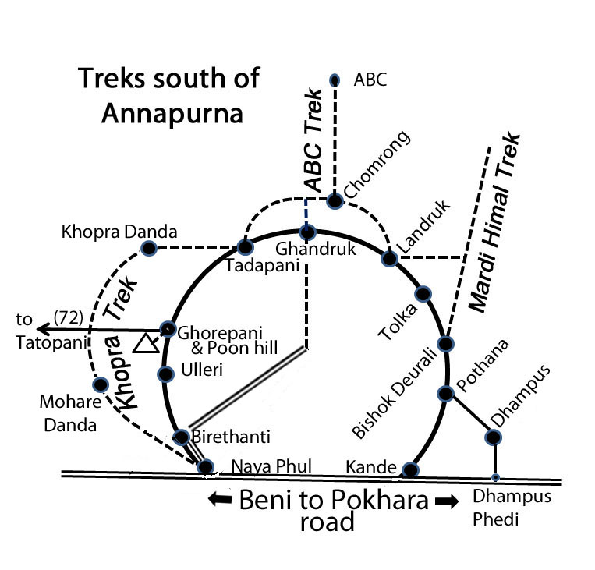
Trekkers visiting South of Annapurnas (Annapurna Panorama trek, Moharedanda, Khopra Danda Ridge, ABC, Poon Hill and Mardi Himal) are sure to be smitten by the mystical cultures, quaint villages, massive glaciers, mysterious forests and beautiful exciting trails with vistas. All will leave with a renewed inspiration for life; there is something very uplifting about exploring some of nature’s most magical areas.

The people living south of Annapurna
Like elsewhere in Nepal also the Annapurna region is populated with several ethic groups which make a trek even more interesting.

1)The Khas People
In the lover part who will find Hindu caste people like Brahmins/Bahun and chetris. They speak nepali as their mother tongue. Their houses are often painted in red and white. The law treats nowadays every person equally, but still that cast systems has a strong impact on the social position.
Brahmins are the highest cast and live in towns, the Terrai and lower hills. Brahmins a strict concept of ritual purity, pleas never enter Brahmin house without prior invitation. Especially the kitchen is seen as a holy area. Brahmins are often teacher, political leaders or civil servants.
Chetris a descendants of the warrior caste, but will work often as farmers, shopkeepers and other occupations.
Craftsman belong to specialized low casts like Kami = blacksmith, Sarki = making products of animals like leather goods, Damai = tailors. You will often find one or two families of these casts even in a village of the upper hills.

2)The hill ethnic groups.
In the middle and upper hill you will find more and more people with mongoloid faces and belonging to various different ethnic groups. To understand the differences, it is important to know that each ethnic group has its own language and customs for marriage and funeral tradition. While the Hindu Caste people speak a language of indo –Aryan origin the hill languages are part of the Tibetan-Burmese family. It is absolutely unusual that hill people will marry into a Hindu cast but within different hill groups this is sometime possible. But most of the time they will marry someone of their own group. The differences between various groups are as distinct as between the people of European countries but in Nepal, several cast and ethic people will live in the same villager- each with his own mother tongue! It’s like if in a village Scottish and Sicilian people would live door to door.
Nowadays all children learn the lingua franca Nepali and so everyone will understand his neighbors. I have three friends of rai community, as they speak three different Rai dialects they speak Nepali with each other!
The Gurungs
The main Living Area of the Gurung is the Annapurna and Manaslu region. The Gurungs live in higher villages than the Brahmin and Chetris. Many Gurungs served as soldiers in the British and the Indian Gurkha regiments and the pensions are still an important revenue for many households.. Gurungs can be Hindu or Buddhist. The Gurung houses are often painted in white and have carved roof –legs. One of the nicest Gurung villages is Ghandruk.
Tamang
The Tamang are spread all over Nepal and are supposed to come from Tibet, and Tamang means hors people in Tibetan. The main settlement area is around and north of Kathmandu. Tamangs are mainly Buddhist. There are a few villages in the Annapurna area with Tamang inhabitants. Tamang often have houses made of wood.
Magar
The main settlement area of the Magar is east of the Annapurna Area. But some of the villages around Ghorepani are mainly populated by Magars. Chitre below of Ghorepani is a typical Magar village.

The Trails

There is a dense grid of trekking trails in this area offering you a multitude of combinations depending on your ambitions and the time you want to spend. The starting point is Pokhara, which is also a great place to unwind after the trek. All the treks offer some breathtaking views of high mountains like Dhaulagiri, Annapurna South, and Machapuchare.
Most of the treks will start from one point or the other from the Annapurna Panorama trek, which is also often called partially the Poon Hill trek. This trek is especially beautiful during the months of March and April when the blossoms of the rhododendron trees, which grow as tall as 15 to 20 m, cover the hills with red and pink fire. This trek can be walked either clockwise or anticlockwise. The Annapurna Panorama trek is like a big circle line in the Gurung area south of Annapurna. This trek is the starting point for the following treks:
- West is the new Khopra Trek, which is getting to be “the” new trekking trail of this area
- North of it is the famous Annapurna Base Camp trek
- East of it is the Mardi Himal trek, leading to the Mardi Himal viewpoint/base camp.

The Annapurna Panorama Trek/ Poon Hill trek clockwise (75-79)
When you do this trek clockwise, you will have to climb the notorious stairs to Ulleri. This is a climb of around 500 m – one step after another -often in the burning sun. If you are trekking in spring you should always inquire where the rhododendron is in bloom. If it is already flowering above Ghorepani, start clockwise to be there earlier. This is especially worth considering if you go to ABC as it will make a few days’ difference. Highlights are Poon Hill, the great view from Tadapani or Ghandruk, and the beautiful old village of Ghandruk.

75. Pokhara to Nayapul- Hille/Ulleri Ghorepani (1.5 to 2 days)
Catch the bus at the northern bus station in Pokhara or share a taxi. It will stop in Nayapul, where many little shops are stretched along the main road to Beni. Go down and walk to the little village of Birethanti (1020m) and its many lodges. From there turn west and walk the gentle ups and downs to the villages of Hille ( 1430m) and Tikhedhunga (~1500m) , where you will find lodges.

After Tikhedhunga start the infamous staircase going up to Ulleri (2010m) with 500 m of steep climbing on high natural stone stair steps. At the end of this ascent you will feel every muscle of your leg- even ones you never knew existed. In all warm months it is a good idea to stay the night in Tikhedhunga and start very early in the cool of the morning. There is one lodge half-way up the staircase which looks a little bit like an eagle’s nest on the steep hill slope, and it offers a beautiful view. You will be relieved when you finally reach Ulleri, a nice little Gurung village. From Ulleri you will still have to climb 800 m but you’re done with the steps and the trail leads to the valley of the Bhurungdi Khola coming from Ghorepani. You walk in a dense forest and more and more you will notice the rhododendron trees. In the lower parts they have red flowers, but the higher you go the more you will find pink and even white flowers. The paler species are more resistant to the cold. Just before the pass you go by the original village of Ghorepani, while all the lodges are above at the pass.

Ghorepani 2860 m:
The meaning of Ghorepani is “water for the horses”. Most houses in the village are painted in blue; there are several good-quality lodges available. In the daytime many beautiful souvenirs are on display, waiting for the right buyer! One of the most beautiful times to visit the region of Ghorepani is from the second half of March to beginning of April. During this time the huge rhododendron trees are in blossom. First the trees at lower altitudes will be full of red flowers. Later the trees at higher altitudes will flourish with pink flowers and the ones at the highest will be mostly white.

Poon Hill *** (3193m + 7m tower! )
This hill gave the name to a whole trek. Most people will start around 2 hours before sunrise and climb up the hill with their headlamps. On top they will find a huge view-tower and the sunrise view they seek. In fact, climbing the tower might make you might feel a touch higher but it doesn’t really add to the view. The hilltop is a fabulous place to watch Dhaulagiri and also the sunrise on the Himalaya range in the north with the Annapurnas and Machapuchare. Enterprising locals from Ghorepani bring up warm drinks like coffee, tea and hot chocolate in thermos so that you can warm up. Returning back from this tour you will be pretty hungry and absolutely love your breakfast.
Ghorepani to Poon hill 1,5h + /-15 min

76. Ghorepani to Tadapani / Ghandruk 5-6hrs.
Ghorepani > 2h > Deorali > 1.5h > Banthanti > 2h >Tadapani
Climb the trail heading up the hill north of Ghorepani. Many places give you the same beautiful views as those from Poon Hill so you could skip the frenzy of Poon Hill and just set out in the early morning. Start at the little place in Ghorepani on the side of Dhaulagiri Lodge. On the wall a huge arrow points the way to Tadapani. First you will climb up to the ridge through a rhododendron forest. Then you walk past three chautaris (sitting places). Near the last one there is even a little tea shop. On several occasions you will have perfect views of the Dhaulagiri Range, the Nilgiris and Annapurna South. From the top of the ridge descend to the two lodges of Deorali, where you will also find many knitted hats and other souvenirs on display. In the wintertime till the end of March the trail can be very icy. From Deorali descend a narrow valley till you reach the 5 lodges of Banthanti.
After Banthanti you a little ascent will warm up your legs. After passing two more lodges you will again have to go down steeply to a little river – and then regain every meter of your descent and even a little bit more in a long and steep climb up to Tadapani. No worries- there is a reward coming!
Tadapani (2590m **; 8 lodges, beautiful scenery)

In Tadapani you have several lodges and from this natural balcony you will enjoy a breathtaking sunset and sunrise with the Annapurna South and the Machapuchare peaks almost at your fingertips. If you want to continue for another 1.5h or so, you can reach Ghandruk before nightfall. If you want to continue to the Annapurna Base Camp trek (ABC), continue to Chomrong (2170m), where the trail starts.
Tadapani-Ghandruk 1.5 h
Go to the right end of Tadapani and take the red white marked trail. Walking in a huge rhododendron forest you will come to a trail fork. The left trail going down has a sign board pointing to paradise lodge. This is not the main tail to Ghandruk. Take the trail on the right. After a little pasture the trail soon plunges down stone stairs to the two lodges of Bhaisikharka. This step descent will continue till you cross a little bridge. After the bridge the trail is no longer as steep except for some occasional little ups and downs.
Finally you will come across a big ACAP signboard with a list of all the hotels of Ghandruk and the different trails. Right here divert and take the trail to the left, going down a newly-built and very long set of steps. First you reach a little temple. From there you can already see the old village of Ghandruk.
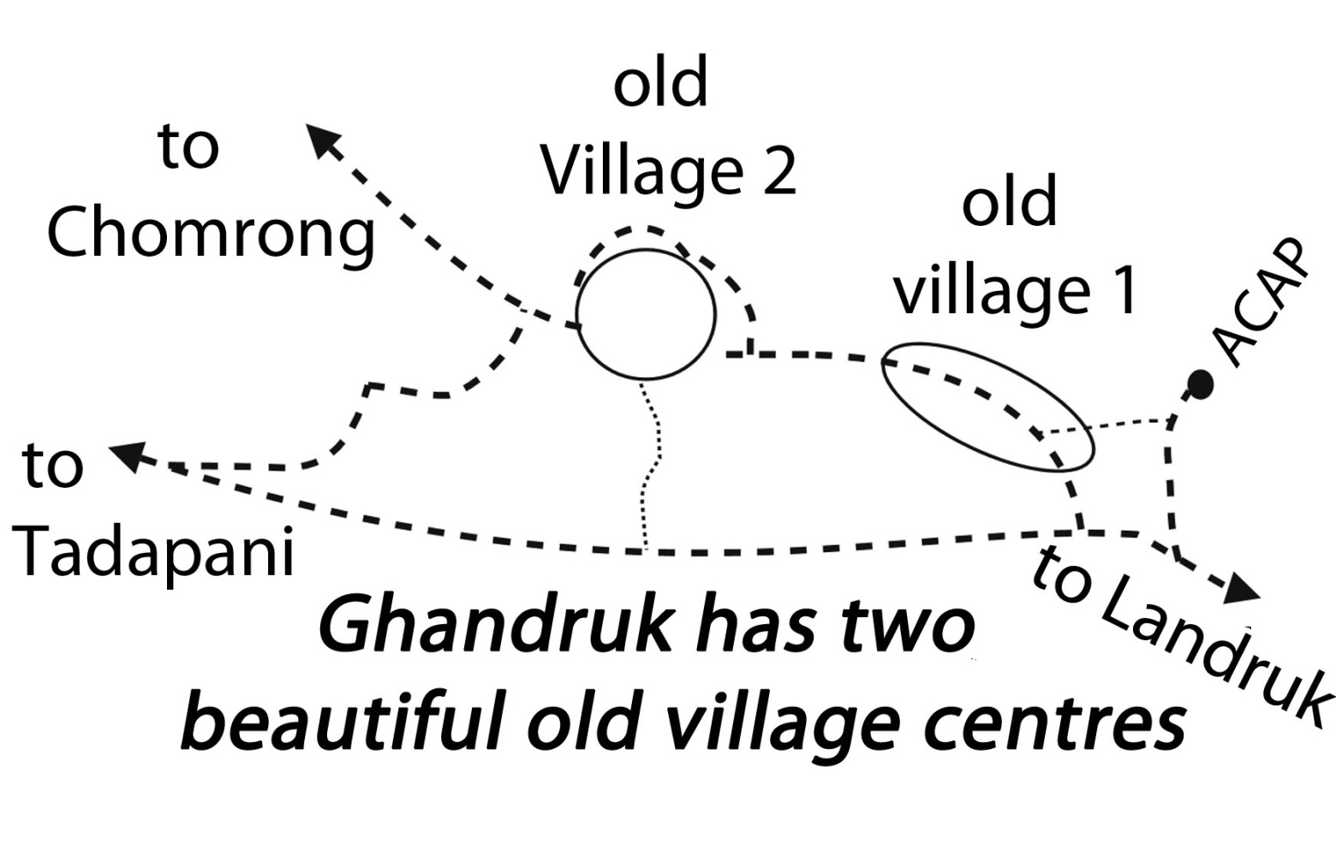

Old Ghandruk ***
Until the 1990’s the main trail went right through the two old village parts of Ghandruk. But then a new trail heading to Tadapani was built which bypassed the old village. This was sad as Old Ghandruk is one of the most beautiful and picturesque villages of the whole area on the south side of the Annapurnas. So while trekkers may have seen many mouthwatering postcards, most have never seen it with their own eyes. I twice looked for it in vain and when I had realized that I had missed it, I was already more than 100 meters below on the way to Landruk and did not want to climb up all the way back. On the third try I took a postcard with me and asked the people to lead me there and was completely enchanted with the real 3D version of my postcard! In the meantime, many bigger lodges were built on the new trail and they had no interest in the trail going once again through the old village. However, ACAP finally built the long staircase at the end of the old village to the trail to Tadapani and made it the main trail again. So don’t miss the two old parts of Old Ghandruk
We marked a trail going right to it. It will pass the first part of the village. Here there are two lodges where one can stay. The trail will then continue through fields and reach the second village part after a while. This second part is also beautiful. Here one can find the ACAP Office of Ghandruk.
From Ghandruk directly to Nayapul or in an extra day via Landruk
You can either go directly to Birethanti and Nayapul, where you can catch a bus or a taxi. The second possibility is to descend to the river and climb up on the other side to Landruk. From there you can easily reach Pokhara the next day.

78. Ghandruk – Birethanti – Nayapul 3 to 4 hrs. The normal trail will go down to the river. But shortly after the end of the village you can take a trail to the right with a signpost which will bring you down to Birethanti and Nayapul where you can take a taxi or the bus.

79. Ghandruk – Landruk –Tolka –Bishok Deurali – Pothana –
Red/White NATT- signs
The trail will steeply descend to the river passing by some teahouses and farmhouses. When you approach the river, have a closer look at the rock wall on the other side of the river. You will see many huge hives of wild bees. Some of them are more than 1 meter tall It was here that Eric Valli took the photos for his famous book Honey Hunters of Nepal and I had always thought that he had taken them in very remote area. These wild bees migrate to Chitwan in winter and come back in the spring. To this day the Gurung people harvest the honey.

After crossing the river you have to climb up again a few hundred meters. Landruk has several lodges, many of them with fine views of the mountains. From Landruk it takes around 30 min to reach Tolka. Continuing with some ups and downs and passing several little villages and teahouses, the trail takes you up a forest-covered hill to the pass of Pitam/Bichok Deorali. On this steep ascent you can take a break or even stay at two basic lodges.

In Pitam /Bichok Deorali there are also lodges and a good view of the mountains. Like Landruk, this is a wonderful place to enjoy sunrise and sunset. In Deorali you can start the side trip known as the Mardi Himal Trek which is described separately at the end of this chapter.
From Deorali it is only about 30 - 40 minutes to the lodge village of Pothana. Here you will find many comfortable lodges. After Pothana you will again have two possible ways to go to Pokhara. The shorter way joins the road at Kande, while the longer one goes over Dhampus.

80. Pothana to the road and to Pokhara
Pothana > Australian Camp > Kande. 2-2.5 h Bus/Taxi to Pokhara

Shortly after Pothana a trail diverges to the right with a signpost and Red/White NATT signs. At the Australian Camp you will find several comfortable lodges with excellent views. Continue and descend though a nice forest till you reach the fields of Kande. Here you can take a taxi or a bus on the main road which goes from Pokhara to Beni. The bus passes every hour.

Pothana Dhampus- Phedi –3-3.5 h -Taxi/Bus to Pokhara
From Pothana you can already see the Gurung village of Dhampus. At the trail-fork just continue straight to walk down. In Dhampus there are still some basic lodges and again you have a beautiful view for both sunrise and sunset.
There is now a dirt road going down to Phedi on the main road, so there might be buses or taxis. Otherwise, it is a long and step descent to Phedi, where there will be taxis waiting or where you can take one of the hourly busses. The taxi drive to Pokhara will take around 30-40 min. (Cost in 2013: to/from Kande Rs. 1,500/- and Phedi Rs. 1,000/-)

The Annapurna Panorama Trek/Poon Hill Trek anticlockwise

81. Pokhara to Pothana
There are two possibilities: going on the Pokhara-Beni road till Phedi and then taking the trail to the old Gurung village of Dhampus or starting a bit further along the main road at Kande and then heading up to Pothana. I like more the Kande part so I start with it.

a) Pokhara 820m – Kande 1770m -Australian Camp 2060m Pothana (2:45 -3 hrs.+ Bus or Taxi ride)
There are two transport options: if you want a cheap ride then you would go to Baglung bus station ( the new bus park) and catch a bus to Kande, which costs around 2 Euros, but it would take more than two hours, because the bus stops at many places to collect passengers.
The other option is to hire a taxi or car; it would bring you to Kande in 1 hr. maximum. In 2013 it cost around 1500 Nepali Rupees for a one-way drive.
Kande is a small town with little tea shops, restaurants and cold stores. In the middle of the town, there are some NATT signs painted with red/white on the stone wall and a wooden electricity pole, which you can easily recognize.

If you go by cab or car, ask the driver to drop you right at the starting point for the Pothana trek. It is easy to find. You turn to the right hand side and slowly continue further, through small villages and houses; soon you will start ascending and enter the bushes and forests of rhododendron and red sandalwood with beautiful southern views. You will reach Australian Camp, a very beautiful little village. From there you can see the Annapurna mountain range, and a little of Manaslu and the Dhaulagiri range including Fishtail Mount and Pokhara valley to the south.

There are good campsites and four nice lodges. My choice would be to sleep here, but for a first day the trek to Pothana is also nice. Australian Camp is famous around Pokhara for a picnic spot with easy access and a beautiful mountain scene. This place is surrounded by red sandalwood and rhododendron forest.

Australian Camp – Pothana 1950m (20 – 25 min)

The trail begins with a beautiful and pleasant short descent through the red sandalwood forest, and then, let’s say, it is “Nepali flat” all the way to Pothana. At Pothana, there are 6 nice basic lodges, 2 little bhatties (teahouses) and a big new lodge about to be built. There is also an ACAP permit check point + tourist information centre. Please make sure that all your necessary permits are arranged in Pokhara beforehand.

b) Pokhara 800m- Dhampus 1650m- Pothana 1890m 3,5hrs.

You start again at the northern Bus Park with a bus to Beni or you might take a taxi. Get out at the taxi stand in Dhampus Phedi where you will start to climb a very steep trail up to Dhampus. Try to start in the morning as it can get very hot as the day progresses. Dhampus is an old Gurung village but getting increasingly modern since it was connected to the main road. If you want to avoid the climb try to get a place in a jeep or bus going up to Dhampus.

82. Pothana –Pitam /Bishok Deurali 2100m Tolka-Landruk(4-6 hrs.).- Pothana to Pitam Deurali (45 min) is a wonderful hike through a red sandalwood and rhododendron forest with some little open land between, known as buffalo pasture. After a few minutes on the flat there is a slow, gentle climb up and then a bit more uphill until the flat resting place at Pitam Deurali. In between you will see some ACAP signposts and our NATT- logo in red/white. If those signs are taken away, you have to continue straight ahead; do not turn either left or right.

At Pitam Deurali, there are two basic lodges and one bhatti. The Mardi Himal Trek starts here, right behind the lodge on the way to Landruk. (See trek description 100). Continuing to Landruk you go down through a forest, pass two little teahouses, until you come to the fields of the Tolka area. It takes another 1 hour to reach Landruk. From Landruk you have a perfect view of Annapurna South, Himal Chuli and Machhapuchhre and can look forward to a beautiful sunrise and sunset. In Landruk you can either continue to Chomrong and the ABC Trek (see trail descriptions 100-110) or turn west to Ghandruk on the Panorama Trail.

83. Landruk-Ghandruk***1940 m-Tadapani** 2654m
In the past there have been a few assaults on the forest trail between Ghandruk and Ghorepani, so it is advisable not to trek alone. If you are a single trekker try to find a companion for this part.

When you come to the end of Landruk turn down to the left. Your enthusiasm might sag when you see the distance you have to go down till the river only to have to climb it up all again on the other side. In fact, Ghandruk is even a few hundred meters higher than Landruk. Cross the river and have a look back to the rock wall on the Landruk side of the river. You will see the beehives of the already-mentioned location where Eric Valli took the photos for his famous book “Honey Hunters of Nepal”. After what may seem like an endless climb you will arrive at the first houses of Ghandruk. Years ago a new main trail was built, bypassing on the left (the western side of the hill) the old village of Ghandruk. Be sure not to take this short cut, as you would miss one of the nicest villages of the whole area!

Ghandruk***.
The village of Ghandruk has two separate village centres which are both absolutely worth a visit. When you enter the village, look for the NATT- marks on the right side. The path leads through houses first in the direction of the ACAP main offices in Ghandruk. From there you have a nice view on the first part of the old village. On the way to ACAP the main trail will climb up on the left side to the hill. There are also beautiful houses in this area, including a little museum of Gurung culture. Continue and you will leave the first village part. In the middle of fields, the trail will then descend a little bit to the right and then reach the second village centre. Long ago the main trail used to pass through but with the new trail it can be difficult to find. Having missed it twice, it was only when I went yet again with a postcard that I could ask people to show me the way. There are two lodges in this old part. My favourite is the Excellent View Lodge above the village; it has a big garden full of flowers and a wonderful balcony view overlooking the Annapurna mountains and Machhapuchhre.

You continue on the other side of the village. After 10-15 minutes you get to a place where a huge staircase climbs up the hill on the left. This is the trail to Tadapani. If you continue straight you will come to the village of Komrong on the way to ABC. (trail description 92) After countless stairs you first reach a little temple and then you join the bigger main trail. From this point the trail takes you through forest.

If you are tired in the afternoon you may decide to stay in one of the two lodges of Bhaisikharka, a village about 1 hour before Tadapani. But the views of Tadapani are so great that it is better to make the effort to get there. Tadapani lays like a balcony just before the Annapurna range and from one of its many lodges you will be rewarded with a marvellous and unforgettable sunset – and a repeat at sunrise the next morning.

From Tadapani you either can continue to ABC (see trek description 94) or the panorama trek to Ghorepani.

84. Tadapani to Ghorepani 6-8 hrs.
The trail is easy to follow. It starts directly behind the village and leads down to the river. After climbing up a steep hill you pass by places with little lodges and later come to the five lodges of Banthanti. From now on it’s a long climb up in beautiful rhododendron forest- which is particularly unforgettable in spring, when all the trees are in blossom. You will pass the two lodges of Deorali and after some more climbing you reach the pass and descend to Ghorepani.

Ghorepani 2860 m:
In Ghorepani most houses have blue roofs. There are several good-quality lodges. In the daytime many beautiful souvenirs are sold.
Poon Hill ***3193m + 7m tower
This hill gave its name to a whole trek. Most people will start around 2 hours before sunrise climbing up the hill with their headlamps and meet again on top where people of Ghorepani have constructed a huge view-tower. If you climb it you will be seven meters higher, but the view does not really get any better. It is an awesome place to watch Dhaulagiri and also the sunrise on the Himalaya range in the north with the Annapurnas and the Machapuchare. People of Ghorepani bring up some coffee, tea and hot chocolate in thermos so that you can warm up. On returning from your early-morning walk, you will be pretty hungry and will absolutely love your breakfast.

Ghorepani to Poon hill (ascent 1.5h + /-15 min , descent 30-45 min)

85. Ghorepani to Birethanti and Nayapul to Pokhara 7- 8 hrs.
It is possible to go down via Ulleri and Hille to Birethanti in one very long day. However, if you already did the Poon hill in the early morning, you may choose to stop somewhere in between. The trail is obvious and the main problem is the descent of nearly 500m by stone stairs after Ulleri. Halfway down the stairs there is an eagle nest-like lodge with a beautiful view. At the bottom of the stairs is the village of Hille with its many lodges.

When you reach Birethanti it only takes 45 min to reach the road settlement of Nayapul. All along the dirt road you will find many shops and even more garbage so you will clearly realize that you are reentering “civilization”. In Nayapul you can either take a taxi or the bus to Pokhara. The bus stops about once an hour.

The ABC Trek /Annapurna Base Camp Trek

Going up to ABC
The Annapurna Base Camp is situated south of Annapurna I in a huge Mountain arena with breathtaking views of several mountain peaks higher than 7000 m. Sir Edmund Hillary, a man who definitively knew mountains, called the Annapurna sanctuary one of the best mountain sites of the world. The ABC trek is a perfect trek on its own but if you have 4 weeks’ time, it makes a perfect addition to the Annapurna Circuit Trek.

Seasons:
You can go up throughout the year. Sometimes in winter the trail is blocked for a few days but I have done the trek several times around Christmas or New Year without any problem. In the spring months avalanches can be a serious threat; this will be explained in more detail later on in the text. The summer months from June to September are not recommended. During the dry season the main wind comes down mostly from Tibet with dry and cold air. But around the end of May the general weather system changes and warm and humid air masses will come up from the Indian Ocean. This leads at the end of June to the monsoon. But even much earlier the southern winds will push up warm and humid air from the plains to the Himalaya Mountains where it will condense into fog and clouds and later rain. You can see these clouds creeping up like a big fat worm when you are in ABC, and soon you will be surrounded by the fog without any mountain view. In summer this fog will often not disappear even in the night, so the chances for mountain views are low while those for rain are very high.

Except for the months of November to February, you should therefore always plan to stay at least one night at ABC itself to get clear views at sunrise and quite often in the evening. Unfortunately, many people miss the great mountain views because their trekking agency insists on staying at the lower Machhapuchare Base Camp with only a daytrip to ABC. The agencies prefer a night stay MBC because the dangers of Altitude sickness are lower and the whole trek is faster and therefore cheaper. I agree completely with the altitude concerns and suggest a stay of one night in Deurali or at Machhapuchare Base Camp before going up to ABC. The key is to plan enough time for a one-night stay below and one at ABC!!!
Lodges: ACAP does not allow the construction of any more lodges above Chomrong so that the existing lodges are often very full. In the peak season of October you might have to sleep in the dining room if nothing else is available.

The main trail to the ABC starts in Chhomrong and there are three different ways of getting to Chhomrong. When you do the ABC trek from Pokhara on you would either come straight up from Landruk on the east side or begin clockwise with the Ghorepani loop in Birethanti. When you are combining the ABC with the Annapurna Circuit you always will start from Ghorepani/Tadapani.

Equipment
Generally the equipment will be the same as for all other trekking tours. During October and the spring months I always take a small umbrella with me, since I find this much more comfortable than walking in a tight poncho, especially when faced with steep hills for a long time. If you are planning to do just the ABC tour taking a down jacket is definitely recommended; it can be rented for little money in Pokhara. People discuss at length the advantages of a down jacket versus several layers of fleece without any final conclusion. But for the ABC it is rather clear cut - take a down Jacket.
ABC will be very cold at night. (My thermometer once recorded a -19°C!) It is already difficult to get out of your sleeping bag at the crack of dawn - and then you have to go out into the freezing cold. It could be one of the best moments of your life when slowly the mountains get clearer and clearer and you would like to stay there for at least one and a half hours just absorbing the beauty of the surroundings. Those with just fleece layers, no matter how many they might have, usually decide after 15-20 min that they want to go back to the warmth of the lodge but the ones with down jackets generally stay outside the whole morning with shining eyes and big smiles all over their faces. I also loved sitting outside later in the early morning sun having my breakfast in such a breathtaking spot. One morning I spilled some coffee on the table and it was frozen within 3 seconds ;-)

Heading For ABC starting from Pokhara- general remarks

The first option - to do only the ABC Trek -will take you between seven to nine days. A second option - to combine it with the Poon Hill/Annapurna Panorama Trek – would require a total of 10-14 days. This combination trek offers magnificent mountain views in a relatively short time. The combined tour can be done either clockwise starting with the Annapurna Panorama trek in Birethanti or anticlockwise starting going first to Landruk, with neither way being more recommended. If you are trekking in March/ April you should ask if the rhododendrons are blossoming. If it has not started yet in Ghorepani you should go anticlockwise to reach the rhododendron area later after doing the ABC. If you are told that the rhododendrons are already full in flower in Ghorepani, then a clockwise route would bring you to them sooner.

There are three Starting points from which you can reach Chomrong:

A) Landruk (see trail description 91)
B) Ghandruk (see trail description 92)
C) Tadapani (see trail description 94)

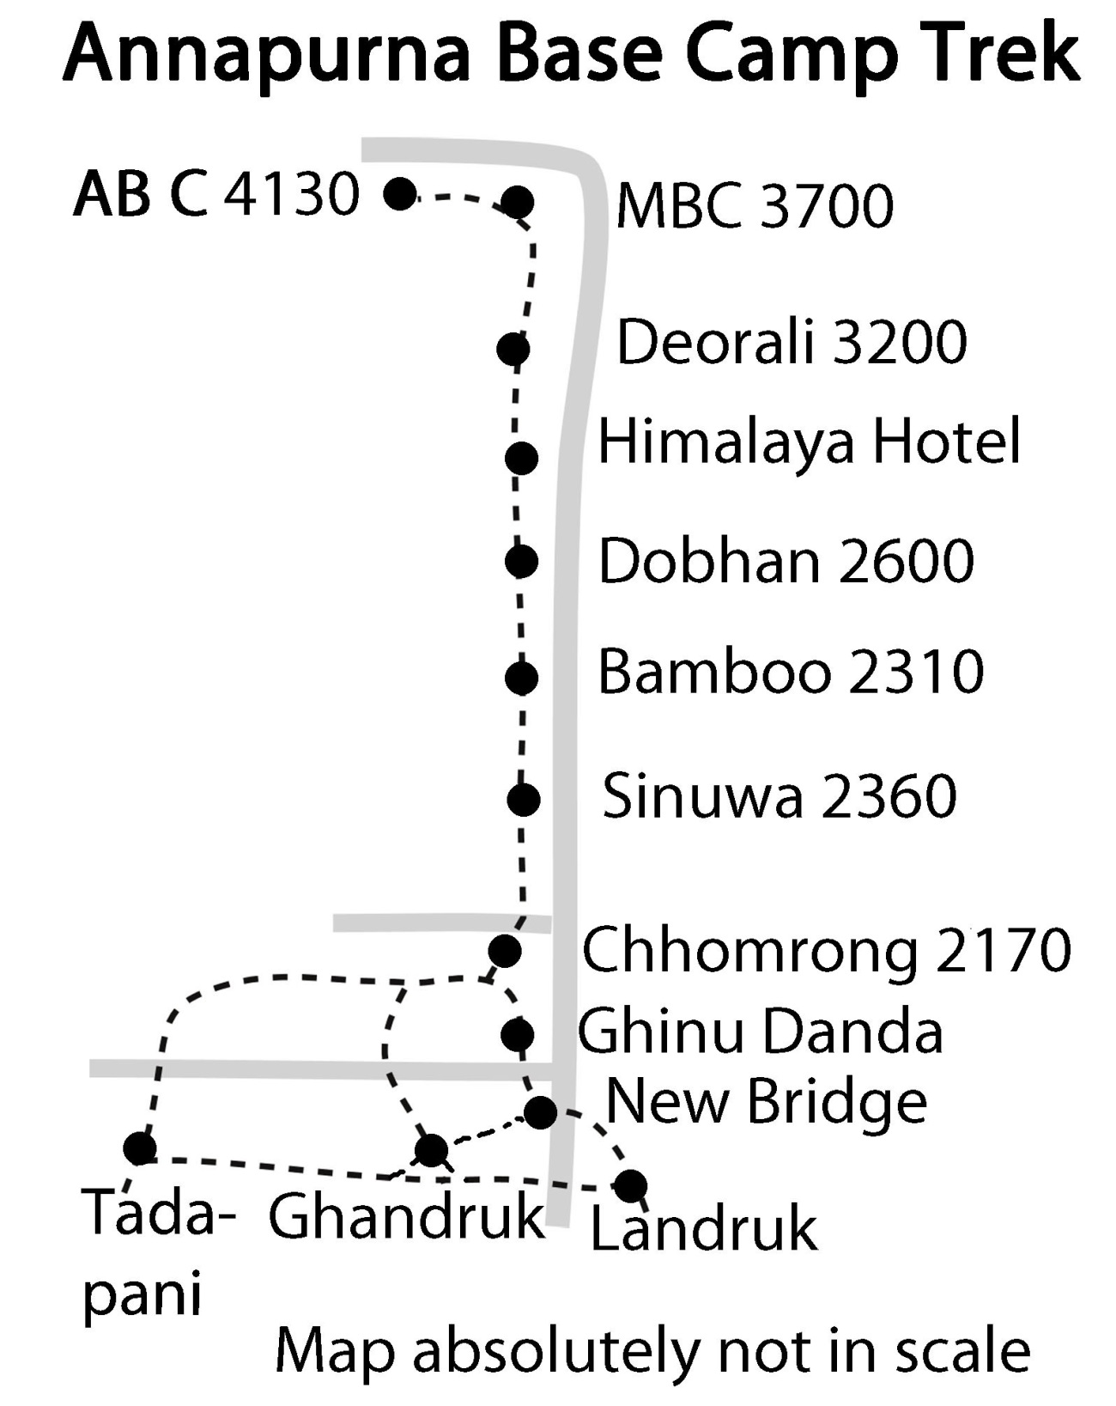

91: Landruk-Chhomrong (See Pokhara to Pothana to Landruk trail description 81 &82)
At the end of Landruk one trail turns to the left down to the river and then to Ghandruk. Spare a compassionate thought for the poor trekkers heading there, since they first have to plunge down to the Modi Khola only to have to regain hundreds of meters on the other side.
Continuing from Landruk to Chhomrong is fortunately less strenuous. The trail leads straight ahead along the hillside to reach the Modi Khola at New Bridge (1460m). On the other side you will find some lodges. From there it is back to climbing. You go up on the hillside, cross the Kimrong Khola and climb further up to Jhinudanda (1710m) and its cosy lodges. In Jhinudanda you will also find hot springs, which are easy to recommend, especially if you have been up to ABC.
Walk down some 20 min to the Modi Khola to find the water basins within a pristine forest. There are two big pools and a fountain to take showers in. You might leave your backpacks at a lodge and even order some food in advance. The hot springs are much smaller less famous than the ones at Tatopani but definitively worth visiting. The return walk will take you some 30 min so figure on 1.5 to 2 hours in total. The entry fee to the hot springs is 50 NPR per person (2013).

After Jhinudanda the trail leads up on a very steep trail with many stairs and in the heat you might feel like a roast chicken on the grill. After 60 minutes or so of hard climbing you reach the houses of Taulung and in another 30 min you will be happy to be approaching Chhomrong (2170m) with its safe water drinking station

92: Ghandruk- Chomrong 4-5h
The starting point is the second old village center of Ghandruk. Take the trail leading to Tadapani. When you reach the branch –off stairs just continue straight till the village of Komrong on the ridge. From there it is a step descent to the Kimrong Khola and a steep uphill climb up the opposite hillside where you will join the main trail Tadapani to Chomrong. After passing the houses of Taulung you soon reach the first big lodges of upper Chomrong.

94. From Tadapani to Chomrong. Total 5 - 7 hrs.
Descending to the river Tadapani to Chuile (2230m) to Ghurjung (1800m) (3 hrs. approx.) Turn a little bit to the left at the end of Tadapani and then descend below the Hotel Grand View down to Chuile, entering the dense forest by going down the steps from this hotel. Cross the river and pass the village of Ghurnung. You may still follow some blue/ white signs, though the trail is clear and it is easy to find all the way down to Discovery Lodge & Restaurant at the top village of Chuile. You still have to descend a long way to the suspension bridge over the Kimrong Khola at the end of this village (45 min). On the other side of the river, there are steep steps to be climbing as the trail goes steadily up to Ghurjung. There you will find a primary school, lodges and picturesque Gurung houses and terraced fields. Even in December and January it will be very hot and you will often feel like a poor chicken being roasted on the grill. If you start early from Tadapani you can make it to Sinuwa but it is a long day.

Climbing up from Ghurjung to Taulung 2180m to Chomrong (2 to 3 hrs. approx.)
From the last lodge of this village, you climb upwards through steep scrub and come to a tea shop. From here you have to take the lower trail and a descend to a small stream and then walk the flat trail all the way to Taulung. This is the first village of Chhomrong. After 20 -25 min you reach the second village Chhomrong called Nayagaon (New Village) with many big hotels (20 – 25 min) often with beautiful gardens and awesome mountain views. It is here that most tourists will stay.

The original village is around 15 min further on the way down and also has some good-quality lodges. Old Chhomrong is a beautiful Gurung village and it is worth your time to take a closer look at the farmhouses spread between the fields. This is the reason why I prefer staying in the old village center. From now on, the lodges will be much smaller and less fancy.
From the village you will continue a steep descent with many stair steps and then cross a little side river coming from the left (only at 1870m!). Coming back, it will take around 45 min to climb up from the bridge to upper Chhomrong!

95. Chhomrong-Bamboo-Dovan 4.5-6 hours
Continuing on the other side you will again be on that grill during your steep climb in the burning sun! Therefore, it is wise to start early in the morning. It will take you 1-1.5 hours to get to the large lodge Sherpa Guest House in Bhanuwa (2070m) and another 45 min of intense climbing to reach the three basic lodges of Sinuwa (2340 m) which are perched right on a little pass. There you will have a great view back to Chhomrong and the Modi Khola valley with the hills on the horizon. If you are looking up the valley you can see the houses of Dovan and even Deurali. If you start in Chhomrong in the afternoon, first ask a lodge owner in Chhomrong if he would make a phone call for you to one of the lodges, as they are often full in peak season.
After Sinuwa you will continue along the hillside high above the river. But even when you are not gaining much altitude, you will have many up and downs through a dense forest. Even the more open parts have high bamboo bushes which are sometimes more than 10 meters tall. Except for the cold winter months of December and January this is a paradise for nature lowers with many birds and butterflies. From Sinuwa it will take you around one hour to come to some open pastures with a house of the former village of Khuldighar. Then there is a thirty-minute descent to the five lodges of Bamboo (2310m) which are situated in a big clearance of the Bamboo Woods. Be aware that from now on until MBC you are in an avalanche-prone region! The most dangerous period is between March and May.
Avalanches on the way to the ABC
In early March of 2002 an avalanche killed three Germans and their Nepali guide as they made their way back from MBC. In April of the previous year this happened to an Israeli and two Australians.
Till now, this is the most serious threat to trekkers, far more dangerous than all the Maoists I have that used to be an issue during the recent civil war.
The most dangerous part is definitely the stretch between Deurali and MBC, but avalanches can come on the trail all the way to Bamboo. Since you are walking in a deep gorge and don’t see any snow mountains at all, it is difficult to even think about snow. But up above the steep slopes of the Hiunchuli are full of snow. If an avalanche starts some thousand meters higher, it will be funneled down to the valleys below and suddenly fall down over the wall.
There are two potentially dangerous situations. The first situation is if there has been heavy snowfall, for example, in the winter months. Then you should consider staying one or more days at the lodge where you are, waiting until all possible avalanches have come down. It is crucial that you include this extra day in your time schedule from the very start when plan your trek. These avalanches can come down at any time of day. The second situation is in the warm spring months. As the sun gets stronger, it will warm up the snow on Hiunchuli. These avalanches normally come down after 10a.m.
Steps To Minimize the Danger:
1. Ask for information from locals and groups coming down. If they tell you not to go, don’t go. Since the Nepalese tend to be quite fatalistic and don’t worry too much about possible dangers, if they say: Don’t go!” it’s really dangerous. In Deurali ask which trail you should take up to MBC.
2. If there have been avalanches in the past two weeks, start very early in the morning.
3. Be aware that the small snowfields you encounter on the way are not children’s playgrounds but the remains of former avalanches! In these places the chances are high that a new one will come down. These tiny little snowfields are the most dangerous parts of the Trek! Cross them very quickly without making a single stop.
4. When travelling in a group, keep a distance from at least 50 meters between each trekker when crossing the snowfields. Most of the avalanches are not very large, so that only a part of the group would be hit and the others can quickly step in to help. The group I was with in April 2001 followed this procedure for most of the trail between Deurali and MBC.
Bamboo to Dovan (2500m) 1.5 hours
You just continue on a forest trail till you reach the three lodges of Dovan. They are lined up beside the trail and each offers a nice sunny spot.
96. Dovan to Himalaya Hotel (2820m) to Deurali 1.5 hrs..
In Himalaya Hotel you find two basic lodges which can be full in the peak season. The surroundings are less sunny than in Dovan. Since the next lodges are another 1.5 to 2 hour walk away in Deurali, it might be wise to take a room if you arrive in Dovan in the late afternoon instead of pressing on..
Himalaya Hotel- Hinku Cave-Deurali (3160 m) 1.5 to 2 hours
After Himalaya Hotel the forest will be less dense and the terrain becomes more and more alpine. You also have to cross more often the treacherous snow fields which are in fact the remains of old avalanches. After 1 to 1.5 hours you will come across a stunning huge overhanging rock. It is so big that in the past it offered shelter for up to 50 porters carrying the material for the first expeditions in the area. It was also a well-known meeting point. There was even a little teahouse below it, but it was destroyed long ago. From this point it is another 30 min to the three lodges of Deurali. You can already feel the impact of the higher altitude and the thinner air.
97. Deurali to MBC and ABC 4-5hrs.
If you want to stay overnight in ABC it is best to sleep one night in either Deurali or at MBC. Remember that for altitude acclimatization it is mainly the sleeping altitude which is crucial and ABC at 4000 m is already high enough that you can experience serious problems.
If you come to Deurali in the afternoon it would be best to find a room in Deurali as it is a nice place to stay. It would also mean that a very early morning departure the next morning would get you through the most avalanche-exposed stretch before mid-morning. There are now two trails continuing from Deurali. The old one is riskier when it comes to avalanches. The second one is more on the eastern side of the valley and is supposed to be avalanche free. However, in case you have to cross even a single snow field, remember that it might be the remains of a former avalanche. To take the second trail go down from the Deurali lodges to the river and cross it on a bridge. The trail continues through alpine surroundings and crosses back to the main trail on the west side of the Modi Khola. It will take you around 2.5 hours to reach MBC with its several lodges.
In the spring months I always choose to overnight in Deurali. The net morning I cross the dangerous stretch before 9 a.m. and soon afterwards am having a relaxed breakfast in MBC! Another two hours after your break and you are in ABC. When I reached ABC around noon the clouds were already creeping up and we had no view at all. But in the late afternoon suddenly they disappeared and we got to enjoy a beautiful sunset.
The five basic lodges at ABC are located on the side of the huge border moraine and if you climb to the ridge you see the enormous glacier flowing down like a stone river. Like most of the Himalayan glaciers, it is covered with a thick layer of boulders and rubble in its lower and flatter part.
To the north you can see the huge rock wall of Annapurna I but the other mountain peaks rival it in majesty and form a huge circle around ABC. Inside this Amphitheatre you see in the center the Tharpu Chuli /Tent Peak (5695m) and behind the Singu Chuli / Fluted Peak (6501m). Both are trekking peaks for which you need alpine climbing experience, an extra few days, the proper equipment and a permit. Another trekking peak is Hiunchuli (6441m) just south of ABC which you can summit in a three-day expedition via the pass between it and the Annapurna south.
As you ascend a little bit along the moraine you come across a little stupa in memory of the famous (ethnic Russian) Kazakhstani climber, Anatoli Boukreev. He was the lead climbing guide of the Mountain Madness expedition team led by the American Scott Fisher. There were many teams climbing Everest in May of 1996 when the weather dramatically deteriorated and tragedy struck, leaving eight climbers dead on the slopes of Everest. It is this story that John Krakauer tells in his book “Into thin Air”. Boukreev’s version of the events later appeared in “The Climb”, partly written to correct some of Krakauer’s negative account of his role in the rescue efforts.
In December Boukreev planned to climb Annapurna I in a winter expedition together with the Italian mountaineer Simone Moro and his Russian cameraman Dimitri Sobelev. Boukreev and Moro had already summited Lhotse together earlier that year. Knowing the avalanche risk of the south wall of Annapurna in winter, they were considering a new route on the eastern side. However, since no avalanches had occurred in the previous month and a half on the south wall, they decided to make it their route to the top.
On the 25th of December 1997 Boukreev and Moro where just fixing ropes in a couloir when high above them a huge cornice broke off and tumbled down the couloir. Simone Moro was swept along and later was able to free himself from the avalanche debris just above their tent. He survived and is still an active mountaineer. The bodies of Anatoli Bukrejew and Dimitri Sobelev were never found.

98. Going back from ABC
You can go down to Chhomrong in two days. If you want to go to Pokhara you could even go to Jhinudanda (see trail description 91) and spend the evening relaxing in the hot springs. Then it would take one more day to get to Pokhara.
Chhomrong to Nayapul (Road to Pokhara 4-6 hours)
Go down to Jhinudanda and continue to New Bridge. In New Bridge continue on the valley trail on the banks of the Modi Khola with its many ups and downs. In Sewai you may already be able to get a seat in a vehicle heading to Birethanti and Nayapul. Nayapul is on the main Pokhara-Beni road . You’ll find many Taxis looking for customers. You can also wait for one of the many buses heading to the Bus Park at the north end of Pokhara.
Chhomrong to Ghandruk
There are two possibilities:
1 Climb up via the small trails from New Bridge
2. Turn right in the village of Taulung (after Chomrong) on to the main trail to Tadapani/Ghorepani. Near a teahouse turn left and descend to the Kimrong Khola. The trail then goes back up and to Ghandruk. You will enter by the beautiful old village. See more information in the section Tadapani-Ghandruk. Warning: It is a pretty demanding climb! However, you should be in fine shape by this time. Maybe you’ll just look back down and say “No problem”! ;-)
Chhomrong to Tadapani and Ghorepani.
Turn to the right in the village of Taulung just at the end of Chomrong. Follow the trail till the village of Ghurjung (2069m), cross the Kimrung Khola and climb up again some 550 m through fields and forest. From Tadapani you could continue for 10 days on the Khopra Danda (Ridge) trek.

100. The Mardi Himal Trek (written by Prem Rai)
This is a beautiful and rich nature trail, best thought of as a “Ridge trail” because most of the time you hike along the ridge. It begins as a branch off in Pitam/Bishok Deurali which you reach in two days on the Annapurna Panorama Trek ( see trek description 81 and 82) Following this ridge north, you will gain significant altitude by the time you arrive at Mardi Himal Base Camp (4500m).

You hike through just a few villages in the beginning, and near the end of the trek some particularly beautiful ones. 80% of the time you will be walking in dense pristine forest! This is a very quiet and peaceful trek – we only met one Italian tourist with a guide during our whole trip. It is best to do this trek with at least two people or for a solo trekker with a Nepali guide, given its isolation and distance from any village.

This fascinating trip is a mixture of adventure and tranquillity and sheer wonder. When you reach high camp (3900m) or the upper view point at 4450m, the views are breathtaking. The snow- capped peaks include Annapurna I (8091m), Annapurna South (7219m), Himchuli (6441m), Annapurna Fang (Baraha Shikhar) (7647m), Khangshar Kang (rock noir) (7485m), Gangapurna (7454m), Mardi Himal (5553m), Machhapuchre’s (fish tail), both peaks (6997m – 6993m) and the beautiful sloping landscape to the south.

It is easy to get confused since there are many trails into the dense forest. Many of the small trails have been made by yaks and sheep, and they may look similar to the main trail. The Mardi Himal Route was built as an official trekking trail and set open for the trekkers, but still you often don’t believe it when you are in the dense forest on some narrower paths above high camp! They still look only just like some small animal path. In my experience there are many places along the trail which need to be fixed and provided with more signposts, poles and metal bars. Originally it was made for yak and sheep and their herders. Seasonally, lower villagers go up to the forest and the sloping fields of grass to gather plants like bamboo, dhakai (an edible wild vegetable), wild mushrooms, various Himalayan herbs and the famous caterpillar mushroom Yarsa Gumba (cordycepssinensis) .

The Mardi Himal trek: Start Point/End Point
Day 1: Pokhara 820m to Pothana 1950m (3. 25 – 4 hrs.)
Day 2: Pothana to Pitam Deurali to Forest Camp (Kokar) 2550m (5 – 6 hrs.)
Day 3: Forest Camp (Kokar) to Low Camp (Humal) 3000m (4 – 5 hrs.)
Day 4: Low Camp (Humal) to High Camp (Kew) 3900m (4 – 5 hrs.).
Day 5: Day trip to Upper View Point 4450m (7 – 8 hrs. round trip)
Day 6: High Camp (Kew) to Forest Camp (Kokar) 2550m (5 – 6 hrs.)
Day 7: Forest Camp (Kokar) to Landruk 1560m (5 – 7 hrs.) if you want to continue to ABC or Ghandruk and Ghorepani
Day 7: Forest Camp (Kokar) to Pothana 1950m (4 - 5 hrs.) if you want to get back to Pokhara

101. Pitam Deurali – Forest Camp (Kokar) 2550m (5 – 6 hrs.)
Pitam Deurali is branch off point of the Mardi Himal Trek from the Annapurna panorama trek (see trail description 81 and 82). Leaving behind the Trekkers Inn Lodge, you will see an ACAP signpost saying Mardi Route (Forest Camp). We painted blue /white NATT signs on Going up the steps, you immediately turn to the right and then go straight, entering the scrubby forest, following the blue/white trail signs. Most of the trail markers are on trees as there were only a few opportunities to mark on rocks. You climb gently and in 15 – 20 minutes you reach a little area of open land, which serves as a buffalo pasture (although you might not recognize it as such). There you will notice a larger blue/white mark on the rock. The approach to the pasture can be confusing but if you look carefully, there should be no problem finding it.

After the pasture you enter a dense forest and you will gradually ascend for two to three hours. Then most of the time you hike on a flat forest trail with a few ups and downs. Finally, after a short, gentle descent you reach Forest Camp. Along the trail between Pitam Deurali and Forest Camp you will have the chance to see vistas of Dhaulagiri and the Manaslu range. Make sure to bring a packed lunch or something to eat and plenty to drink as there are no lodges, restaurants, villages or water en route- only dense and very quiet forest.

Between Pitam Deurali and Forest Camp there are more than two signposts showing directions to Lwang village on the other side. Do not turn left or right, just keep on going straight, following the directions of the blue/white trail markers.

At Forest Camp (Kokar) there are three nice basic lodges which are open the year round. You might make a reservation before you arrive- ask some lodge owner in Pitam Deurali

- Hotel Forest Camp & Restaurant at Forest Camp
Mobile No: 9804141348 or 9846169320
- Hotel Mardi and Restaurant Forest Camp
Mobile No: 9806635881
- Hotel Green View & Restaurant Forest Camp
Mobile No: 9806536904

This little village is surrounded by beautiful green forest. They have nice campsites as well. From Forest Camp there is also a trail going down via Sidding, Lwang and Pokhara. On the western side you can see Ghandruk and surrounding villages and the Modi valley.

102. Forest Camp (Kokar) – Rest Camp (2700m) - Low Camp (3000m)

Forest Camp to Rest Camp (45 min – 1 hr). The trail begins behind the Hotel Forest Camp and Restaurant with an easy uphill start indicated by the blue/white marks on the trees. After about ten minutes, you will turn right and walk straight, going gently up and down. A final brief ascent brings you to Rest Camp, where you will find a basic teahouse with a few bedrooms and restaurant.

Rest Camp – Low Camp (Humal) 3000m (2 ½ to 3 hrs.).
The trail continues from the teahouse with more blue/white marks visible on the tree bark. Most of the time it is a gradual ascent. After a few meters the trail turns right and then continues straight with some uphill and “Nepali flat” sections before gradually ascending into the dense rhododendron forest. In twenty minutes or so you reach a flat trail which takes you to Low Camp.

Low Camp is a very tranquil spot surrounded by a rhododendron forest. Nice views of Machhapuchhre and Mardi Himal can be had.
As well as a camping area, there are two basic teahouses. They are closed from mid-May to the end of July, but if you make a phone call a few days before your arrival they will open the restaurant and rooms for you at any time.

Hotel Laligunras Garden & Restaurant Low Camp (Humal) Mobile No: 9846183583 or 9846087626
From Low Camp there is a trail which goes down to Sidding and other villages as well.

103. Low Camp (Humal) – High Camp (Kew) 3900m (4 or 5 hrs.)
Following the blue/white signs, the trail enters the scrubby rhododendron forest with a gentle ascent of 10 to 20 minutes, and then starts going up into the dense forest till reaching the lower viewpoint (3289m). This will take 1 ½ – 2hrs. Now begins a grassy slope. From here you can also see many wonderful mountain views, especially at sunrise and sunset.

Now, you continue further up to High Camp, hiking mostly on the grassy slope, up steep and occasionally narrow paths and into some little rhododendron forests. Sometimes you may find it difficult to see the trail makrers because larger rocks at the right distances were not always available. The small rocks we sometimes put the markers on may be hidden when the grass grows.

Good weather will make the walk along the yak-beaten trail on the open ridge a memorable one with great mountain views: the Annapurna range, Machhapuchre, and the lush green landscape to the south; below can be seen the very deep Modi river valley and the villages of Ghandruk, Chhomrong, Sinuwa and Dovan.

At High Camp, there is only one teahouse at present (though another teahouse is about to be built soon).
Hotel Trekkers Paradise & Restaurant (mobile 9846087624 or 9846087625 or 806691496

Its owner, Mr.Sudip Gautam, has played an important role in promoting the Mardi Route). It has nice basic rooms and can sleep a total of 24 people. It also has a wide and beautiful campsite.
This place itself is a natural viewpoint tower! In all directions you can see breathtaking mountain views and down to the Pokhara valley! Often there will be a number of yaks around.

104. High Camp – Upper View Point 4450m – High Camp (7 – 8 hrs.)
An early start is advisable for this section of the trek - but do not start in the dark if you don’t know the trail. The blue/white NATT markers continue to Upper Viewpoint. After you have hiked 20 to 30 minutes, further on to the trekker’s paradise of High Camp, there is a trail junction at the bottom of a high hill. Though it seems the real trail goes directly up the dangerously steep hill, (and yes, some crazy trekkers and locals do take it because it is shorter!), for safety reasons it is not recommended.

At this junction on the right you will see a flat, wide place, looking like a little dried up pond which you will walk through. On the rocks you will see the blue/white trail markers. Hopefully they will last, even though it was not always possible to find the most suitable and best rocks.

Further along you can see more marks and then continue straight for 15 – 20 minutes. After that, turn left, going steeply upwards. In another 15 – 20 minutes, you will reach a little pasture. Then turn towards the left hand side and trek continually and gradually up the grassy slopes. In 15 – 20 minutes, you will arrive at the junction with the trail coming up through the dangerous terrain. Keep following the blue/white marks, before reaching the Upper View Point; for some hundred meters the path is very narrow. When it is covered with snow, it will be especially difficult and slippery, because both sides are very steep and you hike just along the ridge.

From here you have an excellent view of the mountains around Annapurna Basecamp, both peaks of Machhapuchre (6993m – 6997m), Mardi Himal (5553m), Machhapuchre Base Camp, Deurali, Dovan, Sinuwa, Chhomrong, Ghandruk and the southern slope, including the Pokhara valley and Mardi Himal Base Camp (4500m). To go from the upper view point to the Mardi Himal Base Camp will only take about 30 minutes.
Coming back down to High Camp Hotel takes from 3 to 4 hours. Except for some hundred meters of narrow path, it is not that difficult, as long as there is no snow on the way. This day trip is a memorable one filled with epic views and incredible photo ops.

Forest Camp / Kokar – Landruk (5 – 7 hrs. approx)
After a few minutes on the same trail you came up before, you will see a trail junction with the blue/white trail marker on a big tree. It indicates Pothana as straight on and Landruk to the right, going down.

After you descend for about 15 to 20 minutes, there is a steep and narrow path for about five hundred meters, which you will descend. Soon you will see the village of Landruk just below you and with more very steep steps to deal with. The trail drops down to a little stream, which you will cross and then continue on for a few minutes until you turn left and follow the stairs down and enter the village of Landruk.

"Prem Rai:My special thanks to Ms. Chris Panks of London, who helped in the editing of these texts."

The Khopra Danda Trek (Written by Prem Rai)
The Khopra Trek in the region south of Annapurna is one of Nepal’s last Himalayan jewels; a glittering array of panoramas, gigantic peaks and peaceful nature awaits the adventurous explorer. However, as magnificent as the mountains are, it is perhaps the people of Nepal that are its greatest asset. In this new trekking area, there are several newly-built community lodges and homestay facilities, so that you can go without carrying a tent with you.

Khopra Trek clockwise

110. Day 1: Pokhara-Nayapul-Purnagaun (5-7hrs. including driving)
Note: Book your rooms at Purnagaun at least one day ahead. Contact person: MR. RANA BAHADUR PURJA, mobile 9847771337 or 990670001

Pokhara (820m) to Nayapul (1070m) – 2 hrs. or less
There are two transport options; if you want a cheap ride then go to Baglung bus station (the new bus park) and catch a bus to Nayapul. The cost in 2013 was about 250 Nepali rupees, but sometimes the journey can take more than 2 hours, because the bus stops often to collect passengers.
The other option is to hire a taxi or car; it would bring you to Nayapul in an hour and a quarter. The fare (2013) was around 1500 Nepali Rupees for a one-way taxi ride which is not so bad if you can share it with some other trekkers.

Nayapul to Deupur Maidan (1520m) – about 3 hrs.

Recently work on trail markers began at Nayapul. The trail starts at Tallo Chouk (the lower junction) near the Hotel Buddha, where there are also some local restaurants and shops. This is about 300 meters west of the first Nayapul bazaar.

At the hotel Buddha turn right and will see the blue/white signs painted on the wall on the side of the road. Continue walking on the dirt road for about 200 meters until you enter Nayapul’s second and bigger bazaar. It is a few hundred meters below the highway.

Soon you will see another blue/ white sign on an electric pole. Now you turn left, descend the steps and pass some houses, after which you cross a high suspension bridge over the Modi River. Continue to follow the blue /white signs. You gently climb up along the side of the wall protecting the fields against the Monsoon River and, in a few minutes, you connect with the dirt road. Follow it till you come to Aate village (1030m), and keep following the road for 25 minutes until you reach Kalyani Ridge (1080m). Within another 25 minutes you will reach Makha village (1170m.). From its top end (1245m), you ascend steps to Deupur Maidan (1.20 hrs.) through the scrubby forest, passing a few villages with beautiful surrounding views of forests, neighboring villages and farming landscapes.

At Maidan you will find a school, a temple, some local shops, electricity, and a couple of basic homestays with outside, communal toilets. The Didi (Manageress) can cook Dal bhat, noodle soup and other local foods for you. There is a proper drinking water supply.
This village is mainly populated by Gurung and Hindu cast people.

Maidan to Purnagaun (1705m) – about 45 min.
Near the public water fountain, you will find a blue /white trail marker on the wall of a house. Follow it and, in the next twenty minutes, you will reach Deupur Jogithum (1600m), where a nice homestay is available. It can accommodate up to 14 people and has a communal toilet and shower outside. It is also possible to cook food yourself in the private kitchen if you want. For that, you need to contact Mr. Bishnu Prasad Subedi (mobile: 9756700217 or Safe 9847623685). You will find safe drinking water and electricity.

Another 30 to 40 min along the dirt road and you come to Purnagaun. A few minutes before reaching the village, you separate from the road and climb up steps till you reach a school. Next to it are a few teahouses and grocery shops. Accommodation for up to nine people and food is available at one of the teahouses. There is a communal toilet and bucket hot shower provided on request. The owner of this lodge will soon put up a signboard - Purnagaun Guest House & Restaurant. The contact is: Mr. Rana Bahadur Purja, mobile: 9847771337 or 990670001 (he is chairperson of this village).

Most people in this beautiful village are Hindu and Buddhist, with some Christians. Beside Hindu Cast people and Gurung , you will find some Magar, who are later the main ethnic group in Chitre and Ghorepani.

111. Day 2: Purnagaun to Lespar

Note: Book your rooms at Lespar at least one day ahead. The contact: 9847717301 or 9805177583 (Mr. Narasing Pun) or Laxmi Hotel & Restaurant (9847734200).
You will need to bring water and pack a lunch for this day’s walk.

Purnagaun to Langdi 1810m. (1 hr. approx)

From the last house of this village you hike for 10 min on the dirt road and come to a chautari (a resting place), where you will see a blue/ white trail marker. From here you can take the beautiful, lower, classic trail to Langdi. In the monsoon season you would need to take the upper trail on the road to Langdi.

At Langdi there is a basic homestay, sleeping a maximum of 5 people. The communal toilet is outside of the house. The Didi can cook for you. You will find a post office, temples, electric light and beautiful Gurung-styled houses. There is farming on terraced land with high surrounding green hills and fine views of the neighboring villages.

Langdi to Lespar 2015m. (5 - 6 hrs.)
The road passes through the middle of Langdi village and it continues to Ghurunga, the next village. But at the trail junction, just below the temple and high trees in the middle of the village, a blue/ white sign will be visible on the rock. There the trekking trail crosses over the road and goes up the steps. In a few minutes, you will come to a trail junction near the last house. Now you follow the lower flat trail instead of climbing the steps and, after 15 to 20 minutes, you gradually enter the forest and climb gently up, with a view of southern villages, landscapes and high green hills to the north. In an hour and a half, you come to Dhad Kharka (1970m) with its little ruins. You continue further on the dense rhododendron forest trail, and reach Ghurungalek (2120m) in 2 hours. Now you can clearly see the beautiful village of Lespar with its shining roofs and blue doors and windows frames. Keep hiking at the same altitude in the dense forest, past some streams until you arrive at a little village called Chhupeni (2215m); there are 3 little empty houses. You go further on and gently descend, make a long contour and you reach the school or lower village of Lespar. The blue /white markers will be noticeable.

The school is the centre point of both Lower and Upper Lespar. From the school if you turn left and walk for 5 minutes down the steps, you come to the Laxmi Hotel & Restaurant (mobile: 9847734200). It can accommodate ten people in 5 rooms. Try the local sisnu soup made from nettle leaves.

At Upper Lespar Mr. Narasing Pun, the chairperson of this village, can provide homestays, and if this accommodation is not sufficient, he will manage homestays in other houses. He can be reached at: 9847717301 or 9805177583.

Lespar is a huge and well-managed village. It is very clean and all the houses are beautiful, with slate roofs. In this village most people are Magar.
Facilities include a health post, post office, internet service, phone, proper drinking water supply and electricity.

112. Day 3: Lespar to Nangi 2260m. (6 – 7 hrs.)

Note: Book your rooms at Nangi at least one day ahead. The contact person is: Mr. Chitra Pun (mobile: 9857622028) or Nangi Community Lodge (mobile: 9847649801 or 9847703341).
Again, remember to take plenty of water and a packed lunch with you, as there will be no teahouse en route.

From the middle part of the village, you hike on a well-paved trail via the upper village, amidst scenic beauty. Slowly you bend towards the right and come up far above the school. Soon you reach a chautari (a resting place) - cross it and, a few meters further on, you come to a trail junction. Now you have to take the upper trail (left) which leads you gently up into the forest. Later on you climb up more hills, sometimes steep, and then finally arrive at a little pass at Chautari (2450m) in about 2 hrs. Now, follow the flat left trail with the blue /white signs and, in 30 to 40 minutes, you will reach Gaira Kharka (2495m). Here there is a small house and a couple of buffalo shelters.>You can already see a beautiful view of the Mt. Dhaulagiri range, the surrounding high and dense forest hills and Shalija village.

You still have to go a long way to Thadako Danda, a little pass at the Chautari (2520m) (2 to 3 hrs.). It is sometimes steep and it can be confusing to find the right trail; the blue/ white signs should help. From this pass the views of Annapurna South, Himchuli and Nilgiri are breathtaking, especially if you are here in April with the rhododendron flowers in full bloom!

Be careful not to turn left or right now, from whichever direction you arrived, from Lespar side. You just have to cross this pass through the Chautari and come down on the other side. Now the dense forest trail to Nangi is clear and well-made and goes down the steps till the dirt road is reached 1.5 km. before the main Nangi village. After reaching the road, you turn right and walk on it. Soon you come to a temple (looking like a chorten) at the first village of Nangi. Continue on the road and 8 to 10 minutes before main Nangi, you separate from the road and take the upper trail. Finally you reach Nangi Community Lodge with its red roof and windows.

This lodge has 10 rooms and 20 beds with communal toilet and solar-heated shower inside the same building. There is a big dining hall. Food is on a menu system. If these rooms are not sufficient, they can provide other cottage rooms nearby the school. A few basic homestays are also available. It is very important to reserve rooms by phone one or two days earlier: MR. CHITRA PUN mobile: 9857622028 or 9847649801

Nangi is a beautiful place with views of the Dhaulagiri, Nilgiri and Annapurna range, including vistas of high green hills and the surrounding villages. The majority of the residents are Magars. Most of these people are Hindu and some are Buddhist.

At Nangi, there are a higher secondary school, a handmade paper factory, women’s handicrafts, a group of women who make plum jam, a telephone service, a proper drinking water supply, electric light and a “tele-teaching” service.

Dr. Mahabir Pun, a Ramon Magsaysay Awardee ( The Ramon Magsaysay Award is an annual award established to perpetuate former Philipinne President Ramon Magsaysay’s example of integrity in government, courageous service to the people, and pragmatic idealism within a democratic society. The Ramon Magsaysay Award is often considered Asia’s Nobel Prize. The prize was established in April 1957 by the trustees of the Rockefeller Brothers Fund Based in New York City with the concurrence of the Philipinne governmen) and his team have introduced an innovative concept in that they have built community lodges at a variety of different places such as Nangi, Moharedanda, Danda Kharka, Swanta, Chistibang, Khopra Ridge and Bayeli Kharka. Two years ago, they also brought 156 yaks into the Khopra region. They also established a cheese factory at Pawdar, so they can supply yak cheese and meat to the restaurants in the villages of the region. All profit made goes to support the schools of those communities.

Brief information about “tele-teaching”
Today, thanks to internet connectivity and Dr. Pun’s “tele-teaching” network, the teachers in one school instruct students in others. Local health workers use Wi-Fi to consult specialists in Pokhara and Kathmandu. Once-isolated students are now able to surf the Net and they are learning global skills. Among the villagers’ local products are buffalo meat, honey, tea, jams, women’s handicrafts, sold through the e-market and the web is used for drawing payments.

113. Day 4: Nangi to Moharedanda 3300m. (~7 hrs.)
Note: Book your rooms at Moharedanda at least one day ahead. The contact person is: Mr. Chitra Pun (mobile: 9857622028)
*Bring with you plenty of water and a packed lunch* - again no tea house en route.

The trail begins directly at the Community Lodge where you should also see the blue/ white signs and arrow. From the chautari you climb up the steps and soon you will enter the forest. Flat at first, the gradient trails up in the dense forest. Continue climbing up more steeply until you reach a little pass, ~2 hrs. Go down the other side, where the trail is a bit flat. Then there is a more strenuous climb up to Humpal Pass (3098m) ~2 hrs. Over the pass is a shelter with a red tin roof. Now you descend a bit on the other side, walk along a flat trail walk, and then go up into the forest. There is a steep, grassy path along the ridge and finally you come to see the houses of Moharedanda. Still continuing, hike along the ridge with Dhaulagiri and Annapurna and Manaslu for sunset vistas and views of the surrounding forest and the southern landscape.

Moharedanda is a good place to take an extra day’s rest! Moharedanda itself is a perfect natural towering ridge. It offers a spectacular 360-degree mountain view through the Dhaulagiri range ((8167m.) high, Annapurna range (8091m.), Manaslu Himal (8163m.) Vistas of deep magical landscapes and magnificent sunrises and sunsets over the mountains. To see all these views you don’t need to wake up at 4 o’clock as at Poon Hill! You can even view them from your bedroom or fire- heated dining hall or you just can step out of the door to see them.
There is a Community Lodge with 10 rooms and 20 beds. There are also a newly-built porters’ house and two yak shelters. The Lodge has a fire-heated dining hall, the food is on the menu system, and Wi-Fi internet and solar light are available. There is a communal toilet and a hot bucket shower is available on request.

114. Day 5: Moharedanda to Swanta
Note: Book your rooms at Swanta at least one day ahead. The contact person is: Mr. Chitra Pun (mobile: 9857622028)
Moharedanda to Phulbari 2835m. (1.30 – 2 hrs. maximum)
From Mohoredanda you gently descend into the dense rhododendron forest with vistas. Follow the blue/ white signs and in about an hour you come to Chautari with its small pond and a temple in the left corner (3040m). After finding the trail arrow marker, cross through for some minutes till you reach grassy open land, where the trail becomes more confusing. The absence of any large rocks or trees meant that the trail markers- arrows and blue /white signs – were placed on some small rocks. You should not turn left or right, but cross here directly and enter the forest. Keep going down through the scrubby forest to some open grassy slopes. Again the trail becomes confusing: look carefully down and you should see the little red and white flag on a high wooden pole. Go down to it, more steeply, and you will reach Phulbari Guest House, a private lodge at Phulbari (2835m.). (45 mins, 1 hr). There are 5 rooms and 10 beds, a communal toilet and hot bucket shower, available on request. It has a fire- heated dining hall and the food is on the menu system. This is a beautiful place to stay, with gorgeous mountain views and peaceful green forest surroundings. The phone contact is: 069 680460 or 9746041157

Phulbari to Danda Kharka 2750m. (10 – 15 min)
After10 – 15 minutes’ walk in the rhododendron forest, you will come down to Danda Kharka (2750m.); there is a Community Lodge with 8 rooms and 16 beds. The food is on the menu system, and there is a fire -heated dining hall, communal toilet and bucket shower outside.
This place is a trail junction leading to Swanta/Khopra, Tatopani, Ramche/Nangi and Phulbari-Moharedanda.

Danda Kharka to Phalante 2270m (4 hrs.approx).
Now you hike on the flat and clear trail in the dense forest and, in 20 minutes, you come to a shelter for buffalo herders. Continue on a long hike and you will arrive at a little pass with chautari (Nakako Bisaune) (2670m.). Cross it and come down on the other side and continue further into the dense forest. After a flat walk, you go gently down and reach a house with well-protected fields and a view of Dhaulagiri in the background. From here, you immediately descend by a grassy slope to a chautari, entering a scrubby forest: now the trail is more confusing. You can already see Phalante, still continue downhill, come to another chautari, and descend the steps. Finally you will reach a big wall protecting fields. Cross it on a wooden ladder and follow the blue/ white signs you will see on an electric pole and house wall. Go through the fields and join the dirt road near the village of Phalante’s Sharada Primary School.

Phalante to Swanta 2260m (1 hr approx.)
The school is a very important landmark as it marks the trail junction leading to Swanta/Khopra, Tatopani/Jomsom, Ghorepani/ABC, Moharedanda/Nangi and Nayapul.

There are a couple of basic lodges and restaurants. After the gate of this school, you still descend and continually follow the trail marked with blue/ white signs, through villages, forest and steps leading steeply down to the suspension bridge over Kholang Khola (30 – 40 min.), then you climb steps on the other side to Swanta village which takes about 30 min.

At Swanta, there are two nice lodges: Swanta Guest House with 10 rooms and 21 beds, and Hotel Trekker’s Sanctuary Lodge with 7 rooms and 15 beds. Both lodges have a communal toilet, hot bucket shower, menu system food, a warm dining hall and electric light.
Swanta is a very beautiful village with its farmed terraced fields, beautiful surrounding high green hills and villages, and views of the Dhaulagiri mountain range, Tukuche peak and Annapurna South.

At Swanta, the residents are 100% Pun Magars. Most of the men are working in the British and Indian Gurkha Army and Singapore police. These people are kind and friendly; they are mostly Hindu with a few Buddhists too. There is a primary school and temple in the middle part of the village. The phone contact is: 9846200616 or 9745037663 (Swanta Guest House) and 9847675240 (Hotel Trekker’s Sanctuary).

115. Day 6: Swanta to DhanKharka/Chistibang
Note: Book your rooms at Chistibang (Dhan Kharka) at least one day ahead. The contact person is: Mr. Chitra Pun (mobile: (9857622028).

Swanta to Aahal Kharka 2600m (3 – 4 hrs. maximum)
Begin hiking through the school’s grounds and go behind it, and then follow the blue/ white signs alongside the fields. Cross by a big house and enter the forest trail. The trail slopes up into the dense forest, and then climbs more steeply up. Then there is a gentle descent to the beautiful Dhaste Khore Khola. Cross over a well-built wooden bridge (2.30 – 3 hrs.). Now turn a bit to the right-hand side and climb up the hill, reaching Aahal Kharka 2600m, (30 – 45 min).

There is a beautiful cottage, Ever Green Rest Cottage, with a nice terrace, dining hall and kitchen and a communal toilet. The welcoming cottage owner (Mr. Hem Bahadur Pun) can also serve you dal bhat, boiled potato, mushroom items, plain rice + nettle leaf soup (sisnu) , various kinds of tea, and coffee. This is a perfect place to have lunch. All vegetables are fresh and organic from his garden. Sleeping space is not available yet, but alternative accommodation may be arranged. Mr. Pun’s phone contact is: 9846288449.

Aahal Kharka to Dhankharka/ Chistibang 2950m (1.30 hrs. max.).
The trail climbs up via a steep hill into the oak and rhododendron forest. It is easy to find but you have to look for the blue/ white signs as well. Chistibang is a nice and peaceful place with surrounding green forest and a view of high grassy hills. Two lodges are open for business: Hotel Rockland & Restaurant is a privately-owned lodge with 9 rooms and 18 beds. The phone contact is: 9847603971. The Community Lodge has 10 rooms and 20 beds. Both lodges have menu system food, fire -heated dining hall, communal toilet and hot bucket shower available on request. Solar light is available.

116. Day 7: Dhan Kharka /Chistibang to Khopra Danda 3660m (3 – 4 hrs.)
Note: Book your rooms at Khopra Danda at least one day ahead. The contact person is: Mr. Chitra Pun (mobile: (9857622028).
The word “Danda” means “ridge” in Nepali. On the main maps the name is printed in bold letters as if it were a big village. Don’t be surprised when it is not a big village at all.

You begin to hike near the Community Lodge and follow the blue/white signs. Walk some way on the flat trail, and then follow the trail up into the forest; it gets steeper until you reach a kharka (pasture). Cross it, entering a scrubby forest; again climb steeply up and you come to a trail junction with a small, man-made pond for animals to drink water from. This leads to Khopra Ridge, or Bayeli Kharka and Chistibang, coming from the other direction. There are many blue /white signs and arrows on the rocks to guide you. Now veer towards the left and continue further on. You first climb up steeply on a grassy slope with a view of beautiful mountains and landscapes. Soon you cross the ridge and come to a chautari, then you hike at a similar altitude to Khopra Ridge! This is what you had been dreaming of for a long time!

This is the last point for lodging on this trek, at the time of writing. Mountain views are stunning: they include the Dhaulagiri range (8167m.), Tukuche peak, Thapa peak, Nilgiris, Barahashikhar and Annapurna South. We had beautiful sunset and sunrise views of them and the landscapes to the south are breathtaking!

At Khopra Ridge, there is a Community Lodge with 10 rooms and 20 beds. If these rooms are all taken, tents are available. It has a nice dining hall, communal toilet and bathroom inside the building and a hot bucket shower available on request. Food is on the menu system. Wi-Fi internet service and solar light are available. The lodge is open the whole year round. There are also a couple of yak shelters.

In July hundreds of Nepali tourists come to take part in a special event called the “Yak Fresh Blood Drinking Festival!” The participants believe that drinking the fresh blood of living yak once or twice a year is a very good treatment for gastritis and also increases energy and sexual power and has many other advantages. This festival lasts for five days. Then the yaks will go up to the high lush pastures with fresh grass and quickly recover from the blood tap. A similar festival is found near Larjung on the Jomsom trek.

117. Day 8: Khopra day trip
It is a very good idea to stay here at least two days; you can take a beautiful day’s hiking trip to Khayar Lake at 4600m. This, however, is not recommended for every trekker, because trekking to the lake and returning on the same path to Khopra makes for a very long day. It takes a minimum of 9 hours as a round trip. A less ambitious but rewarding walk would be to go as far as Thanti (around 4200m. high) and then come back. At Thanti, there are some shelters for yak herders and shepherds to stay in during the monsoon season.

Khayar Lake is a famous Hindu site; on the occasion of Janaipurnima, around the full moon of Saaun (July-August) the high-caste men ( Brahmin and Kshetri) must change the janai, which they wear looped over their left shoulder. So Janaipurnima brings crowds of pilgrims to this sacred Khayar Lake with many from India as well. There they garland a statue of Shiva and throw coins at a temple and into the lake. There are two places to make pooja, seven minutes before this lake and a temple, where hundreds of sheep and goats are sacrificed on the same occasion.

The pilgrims sleep one or two nights at Thanti, where they use the yak herders’ shelters to sleep in, but those are not enough for all these people. Therefore, large tents are set up to accommodate the sudden influx of pilgrims. After they go up to the lake, making pooja, they come back to Thanti and stay overnight.

If you don’t mind bringing a light tent, a warm sleeping bag, cooking gear, some noodles and dry food, it would be fantastic to take the Khayar Lake trip. The views of nature’s beauty are mesmerizing!!
At the present time the trail between Khopra and Khayar Lake does not have the blue/white trail markers but given its heavy usage, the trail should be very obvious.

From Khopra Danda you can go down to Tatopani in a long descent.
The phone contact is: 9745039392 (Khopra Ridge).

118. Day 9: From Khopra Danda to Tatopani
Some tourists go down to Tatopani (1200m) as well; there are two trail options to take, either via Pawdar village and Tatopani or Upper Narchyang - Narchyangbesi and Tatopani. It is a very long and strenuous descent! But in Tatopani you can recover in the hot springs!

119. Day 9: Khopra Danda (Ridge) to Bayeli (Bayeli Kharka) 3460m (4 – 5 hrs.)
Note: Book your rooms at Bayeli Kharka at least one day ahead. The contact person is: Mr. Chitra Pun (mobile: 9857622028).

From Khopra you return down to the trail junction with a small pond, where you have to follow the blue/white signs and arrows pointing towards Bayeli. 80% of the hiking is at the same altitude on the grassy steep, bamboo scrubby and rhododendron forest, and the remaining 20% of the hike is a mixture of down and uphill trail with southern green slopes and sky touching grassy mountain views in the north. The trail is somewhat narrower than normal, but it is beautiful to walk on it. Today you cross mainly through three different pastures; there are shelters for yak herders at the first and second pastures. The last pasture has a ruin, and just before and after this point it is quite confusing to find the trail. Look for the blue /white signs right near this ruin. Make your way straight through and enter the rhododendron forest, walk some way on the flat and in a few minutes you will come to a chautari, trail junction. This leads up to Bayeli, then down to Chistibang in the opposite direction to Khopra. After crossing through this chautari, you gently climb up in the rhododendron forest and arrive at Bayeli.

At Bayeli, there is a Community Lodge with 8 beautiful rooms and 16 beds. Mt. Dhaulagiri and the view of the landscape through your window are awesome! If those rooms are not sufficient, they provide you with tents to sleep in. There is a warm fire-heated dining room and a nice kitchen. The toilet and bathroom are communal and hot bucket showers are available on request. Bayeli is a very beautiful and peaceful place to stay and, if you have an extra day to rest, it would be absolutely worthwhile to do so. From here you can also trek to Hidden Lake (Tojibaraha Tal –as a day trip. It takes 4 to 5 hours to get there and coming back the same way to Bayeli would take an extra 3 to 4 hours. Mr. Lok Bahadur Pun’s phone contact is: 9846208067 or 9846200799.

120. Day 10: Bayeli Kharka to Tadapani
Bayeli Kharka to Dobato 3426m (2 hrs. maximum)
From the lodge, you first go up to the ridge for 10 minutes, then descend down a steep, grassy slope on the other side and continue further on the flat until you come to a high ridge. You bend down along this ridge with breathtaking views of mountains. Soon you enter the forest, on a path varying between flat and steep, until you reach Dobato. There are three lodges: Hotel Lucky Guest House (5 rooms and 10 beds) is already open. The other two lodges, of similar capacity, are about to open soon. All lodges have communal toilets outside of the building and hot bucket showers available on request. They have warm dining rooms and the food is menu system.
Annapurna South, Himchuli, Machhapuchhre, Annapurna II and IV, Lamjung Himal and surrounding high green hills all provide stunning views.
Someone in Dobato may suggest that you trek to another viewpoint called Mulday Ridge (3600m.) (4 hrs..approx to get there and 3 hrs, minimum to get back). Some may find this wonderful to do, but in my opinion, having walked Moharedanda and Khopra Ridge, it does not provide any dramatic new views. Still, you may want to do the day hike just to see for yourself! The phone contact: 9746064385

Dobato to Isharu 3137m (1.30 hrs. approx)
The trail in the beginning is flat, and then it goes gently down into the rhododendron, bamboo and pine forest. Keep descending further and enter a narrow gorge, following the blue/white signs. Then come out of the forest and bend a bit towards the left, for a few minutes, climb up to cross a little pass with a tin-roofed temple and come down a grassy steep, and soon you reach Isharu.

There are two lodges already open and another about to be built soon. Hotel Isharu Green Hill Point has 6 rooms and 12 beds and the other lodge has 4 rooms and 8 beds. Both lodges have communal toilets, a warm dining room and bucket showers available on request. The food is on menu system. It is a sunny place. People here also may advise you to make it to Mulday Ridge viewpoint, but my advice to you is the same as for Dobato. The phone contact is: 9746064649 or 9846258589 or 9816127074 (Mr. Bishal Rai).

Isharu to Meshar 2930m (45min. – 1 hr)
Now you walk in the dense forest, mostly downhill, sometimes steep and sometimes flat. Given that the trail is wide and obvious, you will notice only a few blue/white markers. At Meshar, there is a basic, newly built lodge, which is ready to run with 4 rooms and 8 beds; the toilet is outside. There are also two tea shops about to open in time for next season.

Meshar to Tadapani 2590m (1.45 hrs. approx)
You still descend in the dense and peaceful forest, with a mix of flat and steep gradient, and finally you reach Tadapani. There are more than 7 big lodges with restaurants and a few tea shops (bhatties) and a newly-built porters’ house.
This place is a very important trail junction, leading to Chnomrong/ABC, Ghandruk/Nayapul, Ghorepani/Jomsom and the starting point for Khopra Trek (near the Hotel Grand View).
The combination of the surrounding mysterious rhododendron forest and the beautiful landscape of the Annapurna mountain range and Machhapuchre is a magnetic attraction for trekkers!
The Hotel Grand View phone contact is: 9756000881 or 9846257686.

From Tadapani you can either continue to ABC (see trail description 94), take the Annapurna Panorama trail to Ghandruk (see trail description 76) or go to Ghorepani/Poon Hill (see trail description 84).
It will take you at least 2 additional days to return to Pokhara.

121. Trekking the Khopra Danda Trek anticlockwise.
The starting point is Tadapani behind the Hotel Grand View. Follow the blue/ white signs painted on the tree bark and enter the forest and continue climbing uphill.
You start with the Annapurna panorama trail till you reach Tadapani which is 3 hrs. after Ghandruk on the way to Ghorepani.

Day 01: Pokhara 820m – Kande 1770m – Australian Camp 2060m (4 hrs.approx); trek description 81,

Day 02: Australian Camp – Landruk 1565m (5 hrs.approx), trek description 82,

Day 03: Landruk – Ghandruk 1950m (4 – 5 hrs.approx),

Day 04: Ghandruk – Tadapani -Isharu 3137m (7 hrs.approx),

Day 05: Isharu – Bayeli Kharka (Bayeli) 3460m (5 – 6 hrs.),

Day 06: Bayeli – Khopra Ridge 3660m (4 – 5 hrs.),

Day 07: Excursion day……

Day 08:Khopra Danda/ Khopra Ridge – Chistibang (Dhan Kharka) 2950m – Swanta 2260m (5 – 6 hrs.),

Day 09: Swanta – Phalante 2270m – Danda Kharka 2750m or Phulbari 2835m (7 hrs.approx),

Day 10: Danda Kharka or Phulbari – Moharedanda 3300m (2 – 3 hrs.). You will be in time at Moharedanda today, so you will have enough chances to take a longer rest with sunset view at the mountains!

Day 11: Moharedanda – Nangi 2260m (5 hrs.approx),

Day 12: Nangi – Lespar 2015m (6 – 7 hrs.approx),

Day 13: Lespar – Purnagaun 1705m (5 – 6 hrs.),

Day 14: Purnagaun – Nayapul 1070m – Pokhara 820m (5 – 6 hrs.approx),

"Prem Rai, my special thanks to Ms. Chris Panks, in London, who helped in the editing of these texts."

Pokhara ***
Pokhara at 800 m altitude is a wonderful place to relax after your demanding trek. It is one of the growing and bustling industrial towns of Nepal but you will not notice this in the tourist areas of Damside and Lakeside. For tourists Pokhara mostly offers relaxation, as there is not much ancient culture, at least compared to the riches of Kathmandu valley.

There are many hotels and Guesthouses so you always will find a place. My personal preference is the area west of the royal pavilion where you will find many cosy and inexpensive Guesthouses and nice restaurants. Just go up the side streets and chose the one which suits you best.
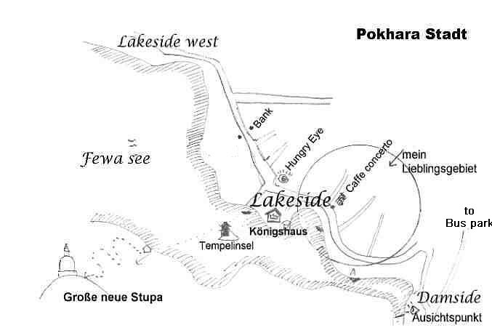

The centre of Lakeside is now very busy with hundreds of shops, agencies, restaurants and discos. It is to the east of the Hungry Eye Restaurant. Several restaurants have a large garden stretching down to the lake, which makes it an excellent place to relax. Some of the restaurants have Nepali Dance shows in the evening. For many years I thought this is just some tourist trap, till I was invited to go to one in the Restaurant Boomerang. And I really loved it. Since then I never miss one of the shows when I’m in Pokhara.

What to do in Pokhara?
Paddle on the Phewa Tal**: You can rent little boats and row on the lake (tal). The rent for the day is not much more than for one hour, and you will normally enjoy it for at least 2.5 hours.

The Tal Barahi temple* on the island in the Phewa Tal:
You either can visit on you own by renting a boat or taking a boat ride from the main boating gate in Lakeside. This temple is worth visiting and many families come there to make their offerings.

The mountain museum **: Unfortunately it’s a little bit far away and the taxi ride is rather expensive. I first visited without expecting much, but instead of a brief visit we ended up staying until the museum closed 2.5 hours later. You will see not only things related to mountaineering but also a lot about mountain and Nepali culture. A visit is definitely worth your time.

Going up to the Freedom Stupa**: High above Pokhara on the southern ridge there is the beautiful Freedom Stupa with absolutely fine views of the breathtaking Mountain range. Take a boat to cross to the other side of the lake and climb up. Be aware that there have been several robberies in the past so never go alone and leave valuable things in the hotel.

Gupteshwore Mahadev Cave: This cave south of the hill with the Freedom Stupa is a Hindu temple for the god Mahadev. You can combine it with a long walk on the way back from the stupa and continue to Devi Falls. On the way you will also pass a little Tibetan refugee camp.

Devi Falls * South of Pokhara is the strangest waterfall I know. When I first went there, I was looking in vain for some waterfall as all the terrain was just flat. The little stream coming from the Phewa Tal just plunges in a deep hole and disappears.

Tibetan Village north of Pokhara*: Many people like the Tibetan atmosphere of this former Tibetan refugee camp.

Sports and recreation
Just relaxing. Pokhara is the perfect place to relax after a long trek. There are plenty of nice restaurants and handicraft shops so even when you have no plans you will never be bored.

Paragliding **: Pokhara is now a paradise for paragliders and it’s an excellent opportunity to try once a tandem flight in your life. There are plenty of specialized agencies in Pokhara.

Ultralight flights **: you can book round flights in little ultra light planes above Pokhara. The planes are based at the airport.

Mountain biking You can hire bikes at many places and plan your own mini-tour. Several trekking agencies also offer guided tours around Pokhara.

Motorbike. You can hire motorbikes and explore the surroundings of Pokhara.

The zip fly. It is a long cable line which comes down from Sarangkot on which you reach speeds above 100 km/hr. It is not that cheap and you can get tickets in many agencies in Pokhara.

Music and dance shows *. Many restaurants offer a dance and music show in the evening. For years I thought it was something just for tourists till I was invited to one by a Nepali partner and found out how enjoyable it was. The musicians and dancers are very dedicated and put on a lively show. Since then I always take in at least one performance when I visit Pokhara. Mostly I go to see the show in the garden of the Boomerang restaurant.

Massage **: After a long trekking tour there is nothing better than a nice massage. There are many massage centres in Pokhara. One of the authors of this book, Prem Rai, operates a massage centre called Stairway to Heaven with his wife Maina. My 80-year-old mother looked and felt at least ten years younger after a few massages and other tourists were also very happy. The massage centre is situated just opposite the Meera Hotel. To enter you have to go up a step stair. But heaven is waiting for you ;-).
Also within 100 m of the Hungry Eye restaurant,

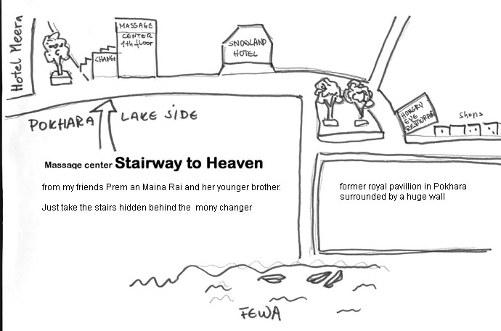
Also within 100 m of the Hungry Eye restaurant in western direction you will find the Seeing Hands massage center, where blind people get an opportunity to work.
Continuing from Pokhara:

To Kathmandu: You can get tickets for the bus ride in your hotel. The bus leaves from the tourist bus parking lot at 7 a.m.. If you would rather fly, most hotels will gladly arrange a ticket.
To Chitwan: Buses to Sauraha also start from the tourist bus parking at 7 a.m. and you can get the tickets in your hotel.

Postlude

We hope that you had a great trek and that our guidebook helped you to find your way on the new trails away from the main road. If you have any comments or suggestions for the next edition we’d love to hear from you:

Andrées de Ruiter: namaste@nepal-dia.de

Or

Prem Rai: premmainarai@hotmail.com

Thank you!

One request to our readers: When you have done the trekking tours described in this book please and share your experience for example by writing a review at amazon.

Acknowledgement
The first edition of this book was written rather fast so that people could find the information at the beginning of the trekking season.
Prem and I are not English native speakers so one could find many mistakes.
In the second edition several people helped us to edit the manuscript or parts of it.
Petrus ( arkienkeli@gmail.com) and my mother reviewed and edited the AC and the Annapurna panoramic trail section.
The text of the Khopra Danda and Mardi Himal trail section was edited by Ms. Chris Panks of London.

Our special thanks go to Mr. Peter Albinger from Canada who reviewed, improved and carefully edited at the end the whole text. He suggested that I should add more maps and pointed out where they would help to understand better the text. So when you like them credit them mainly to Peter. He has also a great blog site www.albinger.me

Andrées and Prem

